MEDICAL LIBRARY ASSOCIATION, INC.

PHILADELPHIA REGIONAL CHAPTER, INC.

POLICY AND PROCEDURE MANUAL

2004-2005

JULY 2004
TABLE OF CONTENTS

I. INTRODUCTION 3
Incorporation Documents 4
Officers, 1951-present 9
Award Recipients 15
II. IMPORTANT DATES AND DEADLINES 18
III. THE MEDICAL LIBRARY ASSOCIATION, INC. STRUCTURE 19
MLA Structure 20
Chapters and Their Relationship to the MLA, Inc. 21
MLA, Inc. Organizational Chart 28
IV. MLA-PHIL BYLAWS 29
V. LONG-RANGE PLAN 37
Strategic Plan 38
VI. BOARD OF DIRECTORS RESPONSIBILITIES 41
Board of Directors 42
Board of Directors Responsibilities 45
Executive Committee 46
Interim Motions 46
Formation of Standing Committees 47
Memorial Gifts 51
Correspondence 51
VII. OFFICERS 52
Chairperson 53
Chairperson-Elect 55
Immediate Past-Chairperson 56
Updating the Policy and Procedure Manual 57
Secretary 58
Treasurer 60
Bank Accounts 61
Bill Payment 62
Internal Control Procedures for Financial Activities 63
Financial Reports 65
Tax Exempt Status 68
Certificate of Insurance 70
VIII. CHAPTER COUNCIL 92
Chapter Council Representative 93
Chapter Council Alternate 94
IX. PARLIAMENTARIAN 96
X. COMMITTEES 97
Nominating Committee 98
Election Procedures 99
Ad Hoc Awards Subcommittee 107
Awards 109
Chapter Achievement Award 111
Certificate of Appreciation 115
Honorary Lifetime Membership 115
Robert Preston Lee Memorial Award 120
Recognition of Recently Retired Chapter Members 124
Beatrice Davis Education Award 125
Grant Program for Professional Development 128
Program Committee 131
Meetings 132
Guidelines for Programs 134
Joint Program Meeting Guidelines 136
Honoraria and Expenses 137
Archives Committee 138
Archives Policy 140
Submission of Documents to the Archives 142
Oral History Program 142
Archives Files 144
Bylaws Committee 146
Communications Committee 147
The Chronicle 148
MLA-PHIL List Owner 151
Chapter LISTSERV: MLA-PHIL@HSLC.ORG 152
Chapter Web Site 154
Web Policy/Guidelines 155
Education and Credentialing Committee 156
Continuing Education Programs 157
Government Relations Committee 161
Membership Committee 162
Membership Recruitment 163
Dues 163
Membership Application 164
AHIP Representative 165
Development Coordinator 166

INTRODUCTION

The Policy and Procedure Manual was initially produced in the Fall of 1986 in an effort to compile and systematize the organization of the Philadelphia Regional Chapter, Inc., a Chapter of the Medical Library Association, Inc., hereafter in this policy and procedure manual known as the Chapter.

The intention of this manual is to provide a reference tool for the officers of the Chapter and the Chairs of the standing committees. It will be revised annually.

Incorporation Documents

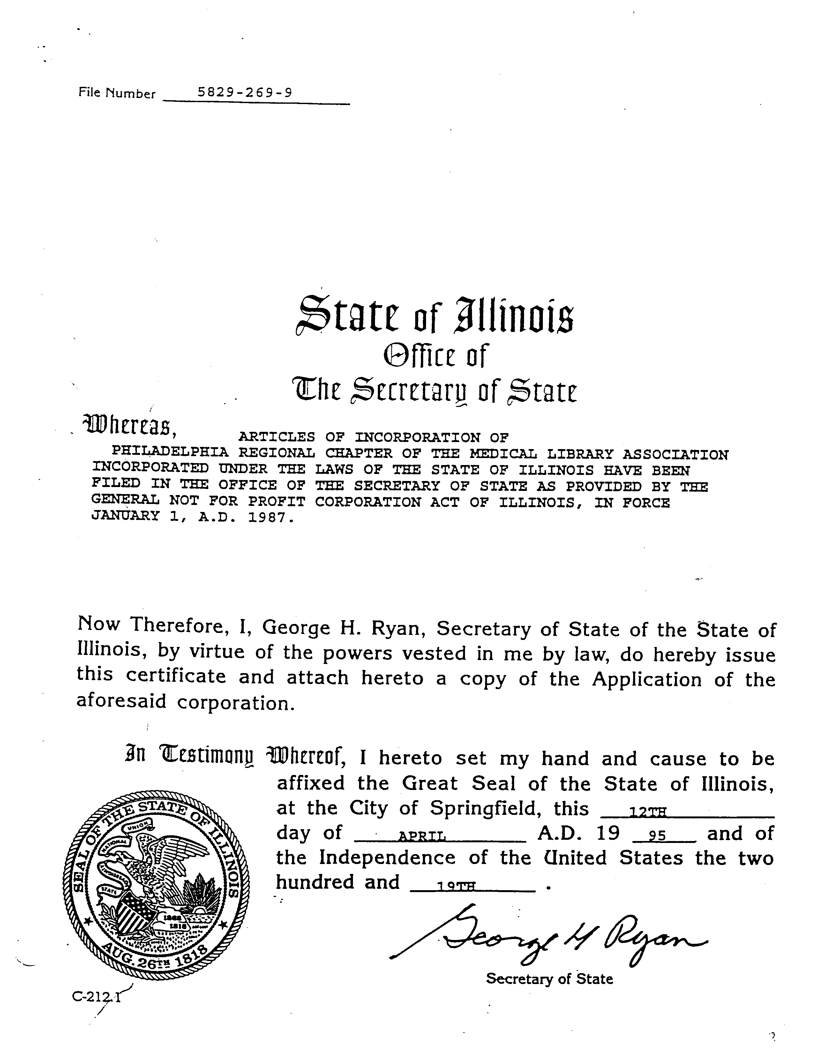
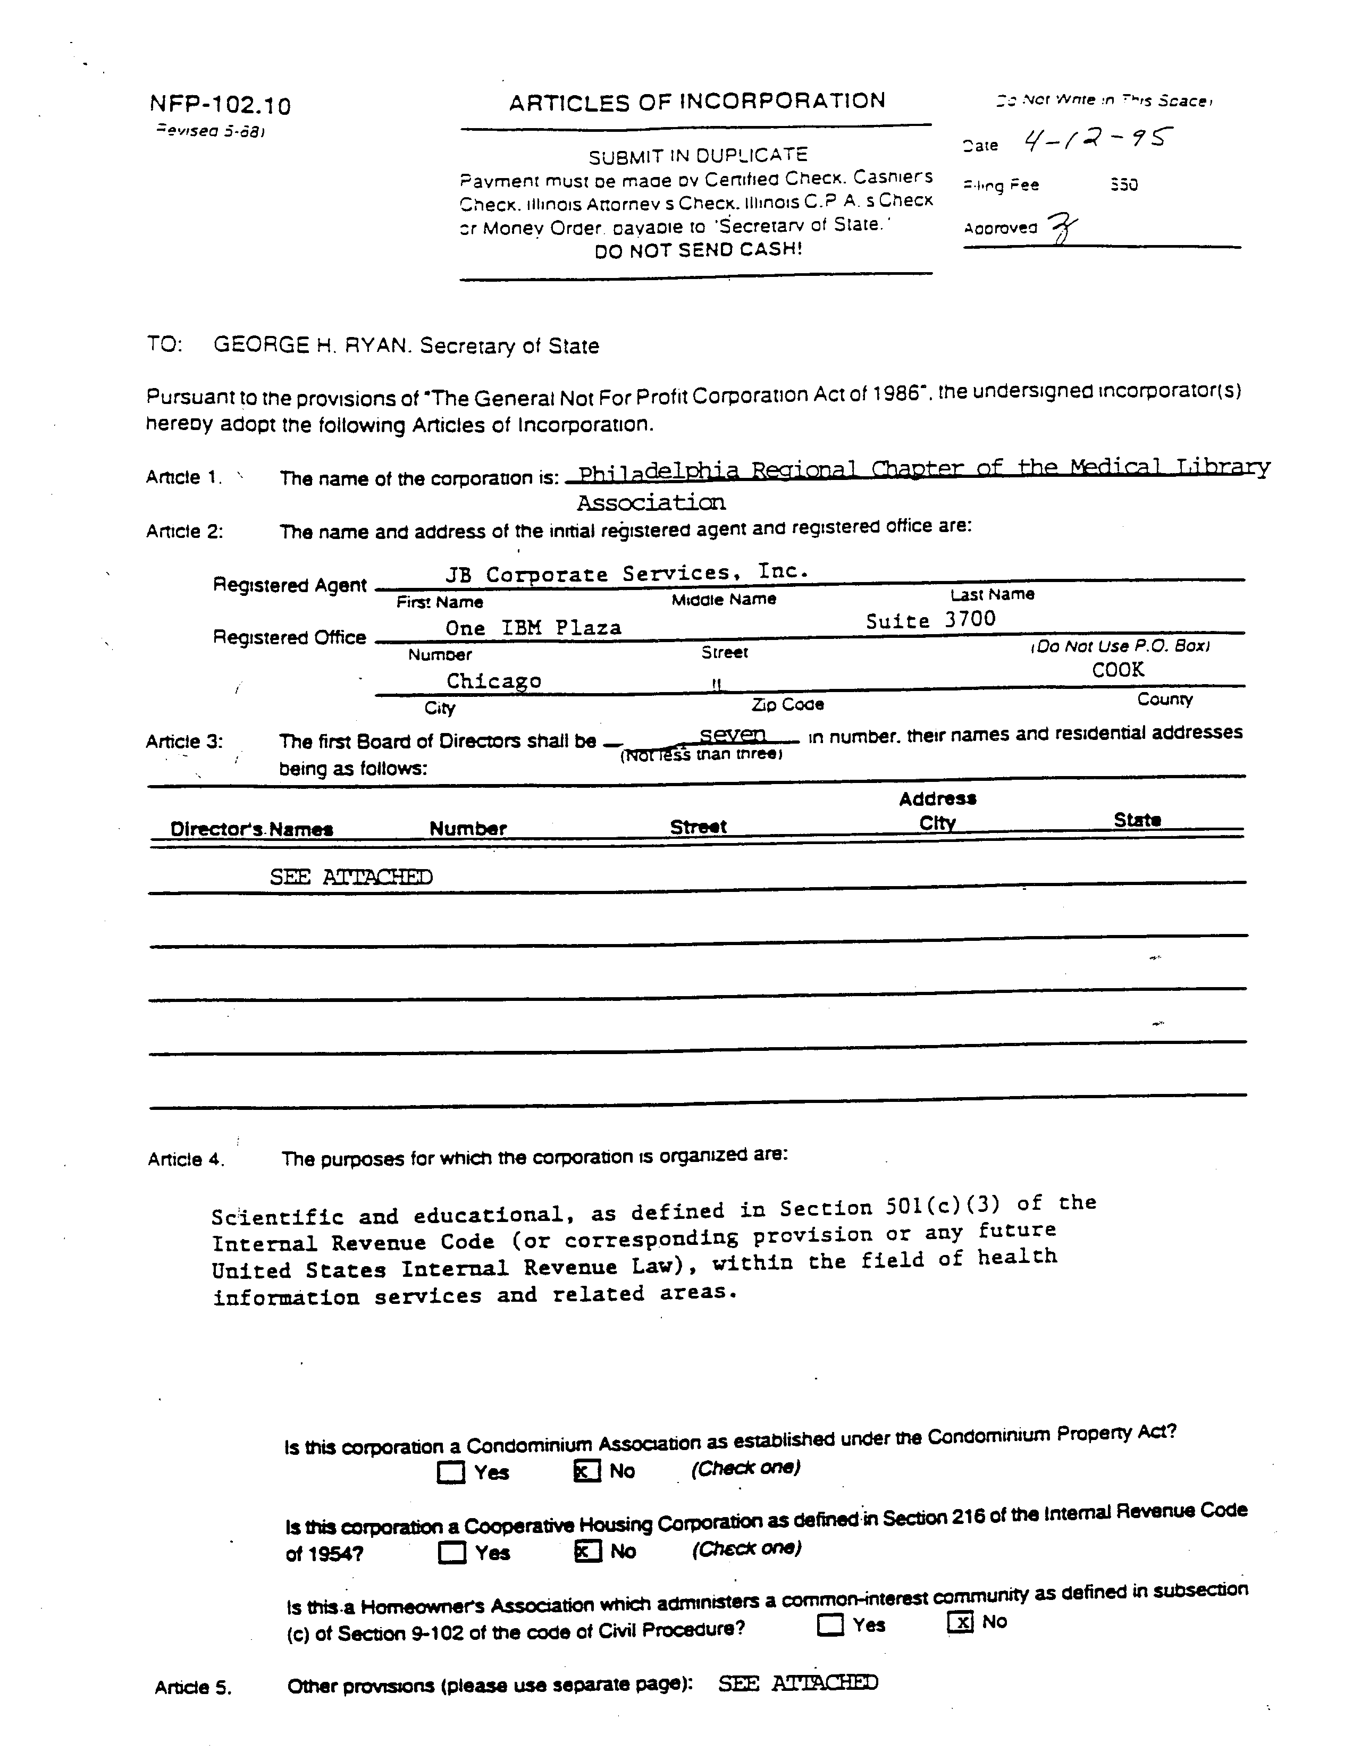
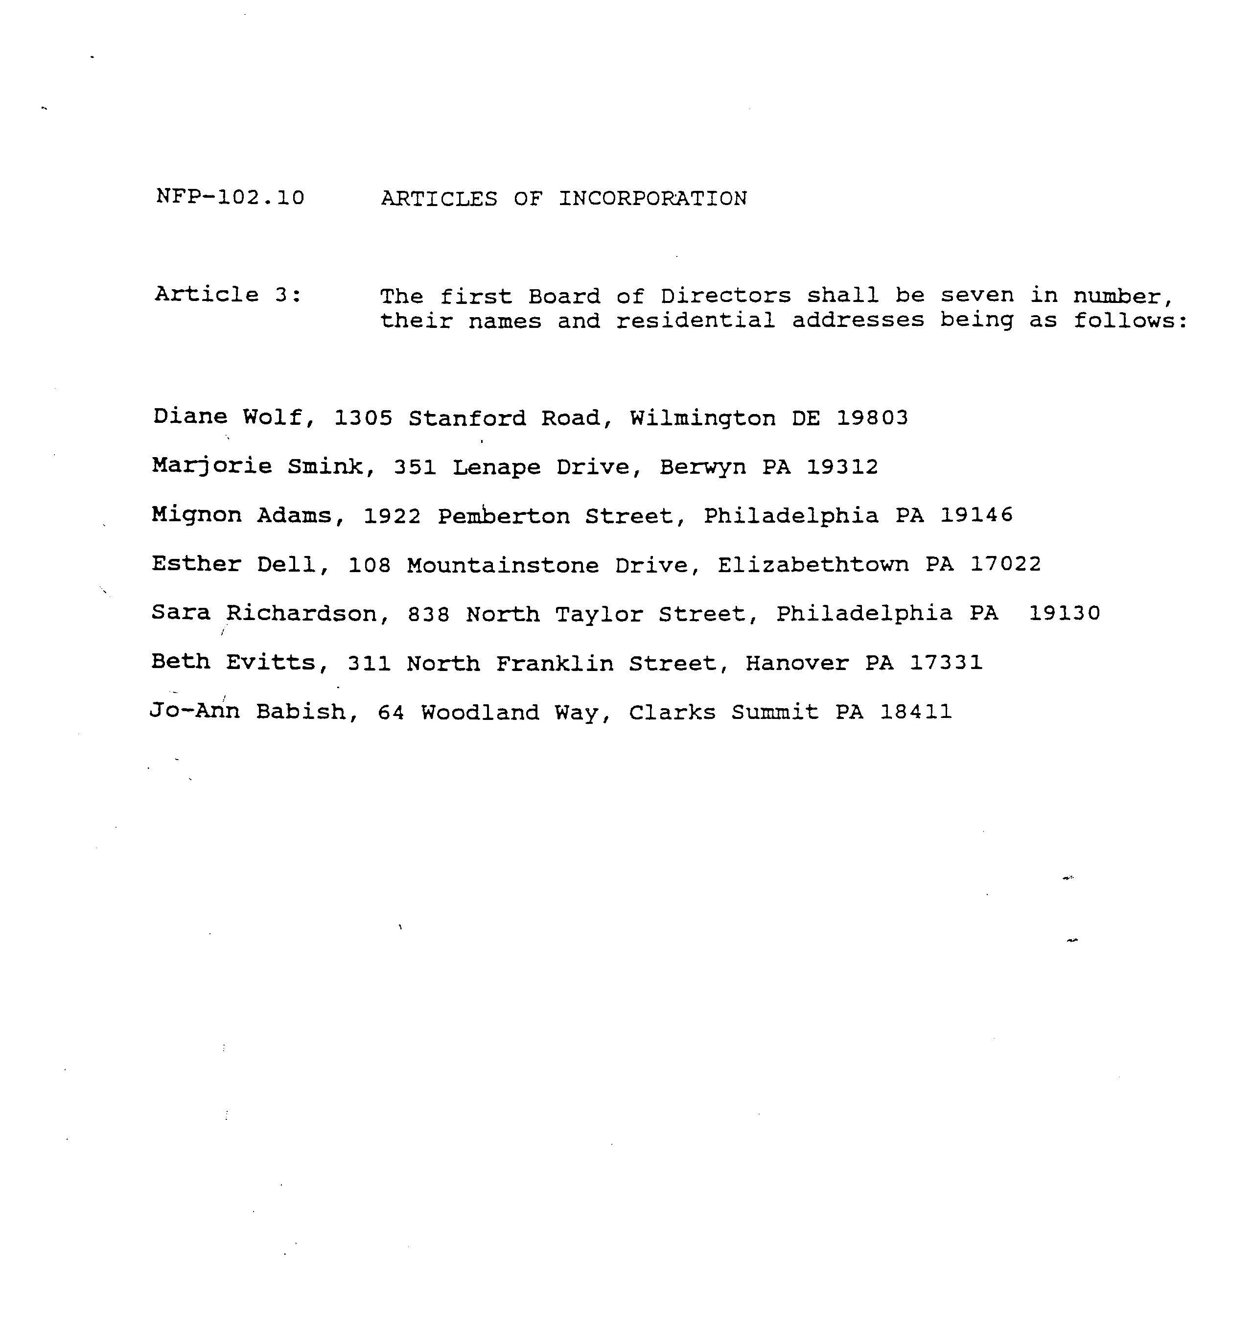

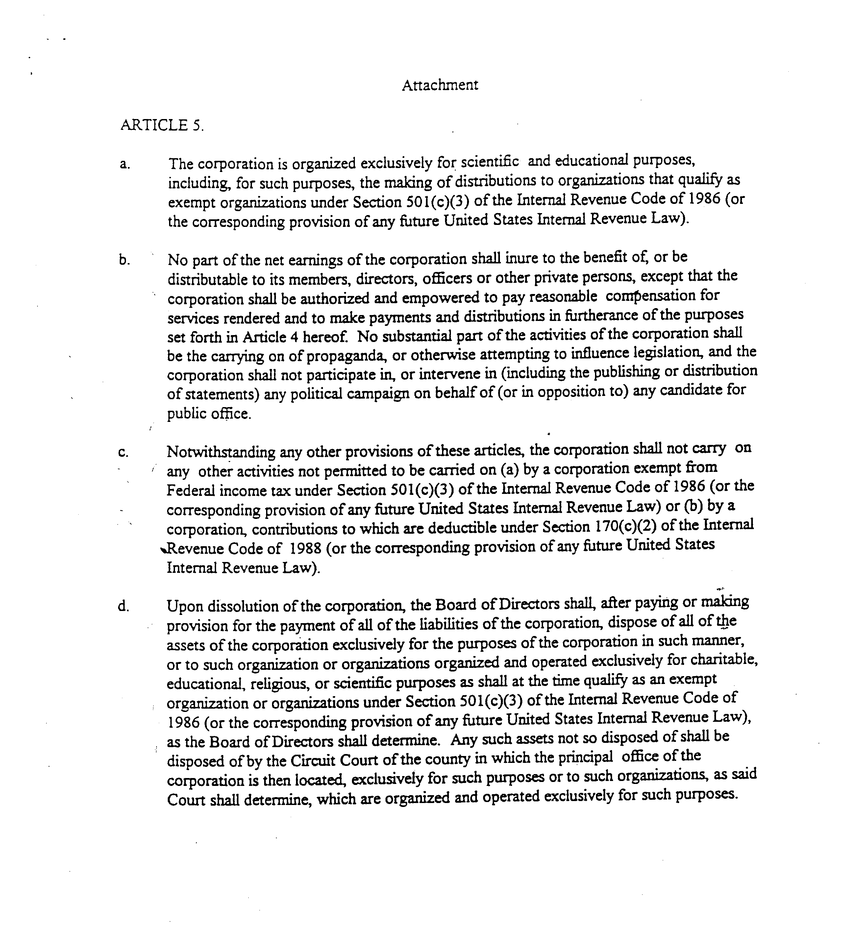

Medical Library Association
Philadelphia Regional Chapter

Officers, 1951-present
1951-52: | Chairman: | Margaret Palmer
 | Vice-Chairman: | Elliott Morse*
 | Secretary/Treasurer: | Lucy Finkel
1952-53: | Chairman: | Elliott Morse*
 | Vice-Chairman: | Elizabeth Johnson
 | Secretary/Treasurer: | Minerva Dunning*
1953-54 | Chairman: | Elizabeth Johnson
 | Vice-Chairman: | Betty Feeney
 | Secretary/Treasurer: | Ruth Yarger Diamond
1954-55: | Chairman: | Betty Feeney
 | Vice-Chairman: | Lucy F. Cooke*
 | Secretary/Treasurer: | Hazel Collier
1955-56: | Chairman: | Lucy F. Cooke*
 | Vice-Chairman: | Muriel Hodge
 | Secretary/Treasurer: | James L. Olsen
1956-57: | Chairman: | Muriel Hodge
 | Vice-Chairman: | Charlotte Coffman*
 | Secretary/Treasurer: | Adeline Redheffer
1957-58: | Chairman: | Charlotte Coffman*
 | Vice-Chairman: | Liselotte Bendix
 | Secretary/Treasurer: | Katherine E. Veigel
1958-59: | Chairman: | Liselotte Bendix
 | Vice- Chairman: | Robert T. Lentz
 | Secretary/Treasurer: | Pauline G. Johnston
1959-60: | Chairman: | Robert T.Lentz
 | Vice-Chairman: | Ida J. Draeger*
 | Secretary/Treasurer: | Ruby Horwood
1960-61 : | Chairman: | Ida J. Draeger*
 | Vice- Chairman: | Ruby Horwood
 | Secretary/Treasurer: | Ann Ludovici*
1961-62: | Chairman: | Ruby Horwood
 | Vice-Chairman: | Samuel A Davis
 | Secretary/Treasurer: | Suzanne Cross
1962-63: | Chairman: | Samuel A Davis
 | Vice-Chairman: | Jacqueline Bastille
 | Secretary/Treasurer: | Elizabeth Thorp
1963-64: | Chairman: | Jacqueline Bastille
 | Vice-Chairman: | Lois J. Lehman
 | Secretary/Treasurer: | Janet Oswald
1964-65: | Chairman: | Lois J. Lehman
 | Vice-Chairman: | K. Bernice Odorn
 | Secretary/Treasurer: | Nancy Whitten
1965-66: | Chairman: | K. Bernice Odorn
 | Vice-Chairman: | Pauline Johnston
 | Secretary: | Ann Woodward
 | Treasurer: | Nancy ‘Whitten
1966-67: | Chairman: | Pauline Johnston
 | Vice-Chairman: | Arlene North
 | Secretary: | Ann Woodward
 | Treasurer: | Ann Ludovici*
1967-68: | Chairman: | Arlene North
 | Vice-Chairman: | Esther Israel
 | Secretary: | Virginia E. Lampson
 | Treasurer: | Ann Ludovici*
1968-69: | Chairman: | Helen Lake
 | Vice-Chairman: | Lisabeth Holloway
 | Secretary: | Virginia E. Lampson
 | Treasurer: | Lillian Bryant
1969-70: | Chairman: | Lisabeth Holloway
 | Vice- Chairman: | Caroline Morris
 | Secretary: | Marie Norton
 | Treasurer: | Lillian Bryant *
1970-71: | Chairman: | Caroline Morris
 | Vice-Chairman: | Barbara Williams
 | Secretary: | Marie Norton
 | Treasurer: | Lillian Bryant
1971-72: | Chairman: | Barbara Williams
 | Vice-Chairman: | Marie Norton
 | Secretary: | Maureen Smith
 | Treasurer: | Lillian Buxbaum
1972-73: | Chairman: | Marie Norton
 | Vice-Chairman: | Jerome Rauch
 | Secretary: | Maureen Smith
 | Treasurer: | Lillian Buxbaum/Henry Armistead
1973-74: | Chairman: | Jerome Rauch
 | Vice-President: | Jackie Rustigian
 | Secretary: | Marie Tucker
 | Treasurer: | Henry Armistead
1974-75: | President: | Ruby Horwood
 | Vice-President: | John Timour
 | Secretary: | Marie Tucker
 | Treasurer: | Henry Annistead
1975-76: | President: | John Timour
 | Vice-President: | Carol H. Fenichel
 | Secretary: | Bruce Harvey
 | Treasurer: | Nancy Calabretta
1976-77: | President: | Carol H. Fenichel
 | Vice- President: | Helen St. Clair
 | Secretary: | Nancy Calabretta
 | Treasurer: | Bruce Harvey
1977-78: | President: | Helen St. Clair
 | Vice-President: | Helen Lake
 | Secretary: | Bruce Harvey/Alice Mackov
 | Treasurer: | Valerie A Pena
1978-79: | President: | Caroline Morris
 | Vice- President: | JoAnn King
 | Secretary: | Valerie A Pena
 | Treasurer: | Judith Delbaum
1979-80: | President: | JoAnn King
 | Vice-President: | Beatrice Davis
 | Secretary: | Judith Delbaum
 | Treasurer: | Karen Adelman/Rosalinda Ross
1980-81: | President: | Beatrice Davis
 | Vice-President: | Diane M. Farney*
 | Secretary: | Rosalinda Ross
 | Treasurer: | Michael Rissinger
1981-82: | President: | Diane M. Farney*
 | Vice-President: | Elizabeth R Warner
 | Secretary: | Alice Mackov
 | Treasurer: | Michael Rissinger
1982-83: | President: | Elizabeth R. Warner
 | Vice-President: | James E. Bobick
 | Secretary: | Alice Mackov
 | Treasurer: | Sherry L. Montgomery
1983-84: | President: | James E. Bobick
 | Vice-President: | Helen J. Hohman
 | Secretary: | Etheldra Templeton
 | Treasurer: | Sherry L. Montgomery
1984-85: | President: | Helen J. Hohman
 | Vice-President: | Sara Richardson
 | Secretary: | Etheldra Templeton
 | Treasurer: | Robert Lee*
1985-86: | President: | Sara Richardson
 | Vice-President: | Linda C. Stanley
 | Secretary: | Margaret G. Fallis/Judith Baker
 | Treasurer: | Robert Lee*
1986-87: | President: | Linda C. Stanley
 | Vice-President: | Sherry L Montgomery
 | Secretary: | Dianne E. Rose
 | Treasurer: | Margaret Devlin
1987-88: | President: | Sherry L. Montgomery
 | Vice- President: | Kathy Ahrens
 | Secretary: | Dianne E. Rose
 | Treasurer: | Margaret Devlin
1988-89: | President: | Kathy Ahrens
 | Vice-President: | Ann S. Nista
 | Secretary: | Dianne E. Rose
 | Treasurer: | Nancy B. Rainey
1989-90: | President: | Ann S. Nista
 | Vice- President: | Margaret Devlin
 | Secretary: | Diana Zinnato
 | Treasurer: | Nancy B. Rainey
1990-91: | President: | Margaret Devlin
 | Vice-President: | Andrea Kenyon
 | Secretary: | Diana Zinnato
 | Treasurer: | Marion C. Chayes
1991-92: | President: | Andrea Kenyon
 | Vice-President: | Barbara Casini
 | Secretary: | Jo-Ann Babish
 | Treasurer: | Marion C. Chayes
1992-93: | President: | Barbara Casini
 | Vice-President: | Mignon Adams
 | Secretary: | Jo-Ann Babish
 | Treasurer: | Judy Donovan
1993-94: | President: | Mignon Adams
 | Vice-President: | Diane G. Wolf
 | Secretary: | Esther Dell
 | Treasurer: | Judy Donovan
1994-95: | Chairperson: | Diane G. Wolf
 | Chairperson-Elect | Marjorie M. Smink
 | Secretary: | Esther Dell
 | Treasurer: | Sara Richardson
1995-96 | Chairperson: | Marjorie M. Smink
 | Chairperson-Elect: | Marion C. Chayes
 | Secretary: | Janet C. Clinton
 | Treasurer: | Sara Richardson
1996-97 | Chairperson: | Marion C. Chayes
 | Chairperson- Elect: | Patricia Wilson
 | Secretary: | Janet C. Clinton
 | Treasurer: | Miranda D. Scott
1997-98 | Chairperson: | Patricia Wilson
 | Chairperson-Elect: | Valerie Pena
 | Secretary: | Ann Laliotes
 | Treasurer: | Miranda D. Scott
1998-99 | Chairperson: | Valerie Pena
 | Chairperson- Elect: | Patricia Insetta-Rath
 | Secretary: | Ann Laliotes
 | Treasurer: | Barbara Shearer
1999-2000 | Chairperson: | Patricia Insetta Rath
 | Chairperson-Elect: | Anne Seymour
 | Secretary: | Mary McCann
 | Treasurer: | Barbara Shearer
2000-2001 | Chairperson: | Anne Seymour
 | Chairperson-Elect: | Patricia Heller
 | Secretary: | Mary McCann
 | Treasurer: | Linda Katz
2001-2002 | Chairperson: | Patricia Heller
 | Chairperson-Elect: | Eric Delozier
 | Secretary: | Barbara Shearer/Bradley A. Long
 | Treasurer: | Linda Katz
2002-2003 | Chairperson: | Eric Delozier
 | Chairperson-Elect: | Nina Long
 | Secretary: | Bradley A. Long
 | Treasurer: | Linda Katz
2003-2004 | Chairperson | Bradley Long
 | Chairperson-Elect | Lenore Hardy
 | Secretary | Melanie Cedrone
 | Treasure: | Stephanie Ferretti

Award Recipients
Chapter Achievement Award (1987-)

Helen St. Clair (1987)
John Timour (1988)
Sara Richardson (1989)
Linda C. Stanley (1990)
Gail P. Gill (1991)
June H. Fulton (1992)
Nancy Calabretta (1994)
Elizabeth R. Warner (1994)
Andrea Kenyon (1995)
Barbara Palmer Casini (1996)
Diane Wolf (1997)
JoAnn Babish (1998)
Diane Farney (1999)*
Marjorie Smink (2000)
Marion Chayes (2001)
Barbara Shearer (2002)
Cheryl Capitani (2002)
Anne Seymour (2002)
Linda Katz (2003)
Karen Albert (2004)

Grant Program for Professional Develpment (1988-)

Cheryl Capitani (1989)
Nina Long (1989)
Mark Allen-Taylor (1991)
Sharon Lezotte (1997)
Cheryl Capitani (1998)
Nina Galpern (2002)
Jannette Pierce (2003)
Rachel Resnick (2004)

Honorary Life Membership (1950s-)
Elliott Morse (1985)*
Robert T. Lentz (1985)
Jean Antes (1986)
John Timour (1988)
Karen Albert (2001)
Sara Richardson (1998)
Marjorie Smink (2004)

Certificate of Appreciate

Diane Farny (1988)*
June Fulton (1988)
Judith M. Baker (1989)
M. Sandra Wood (1990)
Karen M. Albert (1992)
Barbara J. Williams (1992)
Marion Schaner (1993)
Roderick McNeil (1993)
Margaret Devlin (1994)
Barbara Palmer Casini (1995)
Barbara Bernoff Cavanaugh (1995)
Linda M.G. Katz (1996)
Dianne Rose (1997)
Frank Campbell (1997)
Local Arrangements Committee (1998)
Janet Clinton (1999)
M. Sandra Wood (1999)
Eric P. Delozier (2000)
Elizabeth R. Warner (2000)
Judith Baker (2001)
Joan McKenzie (2001)
Carlos Rodriguez (2002)
Nancy Calabretta (2002)
Christine C. Chastain-Warheit (2002)
Marion C. Chayes (2002)
Sharon Easterby-Gannett (2002)
Bradley A. Long (2002)
Diane G. Wolf (2002)
Kevin R. Block (2003)
Karen M. Albert (2003
Joan McKenzie (2003)
Anne Seymour (2004)

Robert Preston Lee Memorial Award

Carol Fenichel (1992)
Health Sciences Libraries Consortium (1994)
Joyce Post (1995)
Liz Mikita (1996)
Margaret Devlin (1997)

Beatrice Davis Education Award (1987-)

Debbie Stewart (1990)
Debra DiMario (1990)
Ellen Davis (1992)
Heidi Sue Adams (1995)
Cynthia Nicotera (1995)
Melissa Butka (1997)
Leslie Pope (1998)
Wendy Solm 1999)
Christine Koehler (2000)
Karen Lee Olson (2002)
Rebecca Rishar (2004)

Randy Brenner Consumer Health Award (2004-)

Barbara Henry (2004)

IMPORTANT DATES AND DEADLINES

July | Chairperson sends Directory information form to MLA, Inc. Headquarters.  Joint meeting of incoming & outgoing members of the Chapter Board of Directors is held.  Chairperson submits Chapter objectives to the MILA, Inc. Headquarters.*  Prospective Chapter committee members are reviewed and approved by the Board of Directors.
November | Mid-Winter Report is sent to MLA, Inc. Headquarters.* Membership brochure and application forms are mailed.
February | Chairperson calls officers and committee chairs whose terms are coming to an end and asks how else they would like to serve the Chapter.  Election slate is finalized (may be done in March if Annual Meeting to be held in May).
March | Annual Report is sent to the MLA, Inc. Headquarters.* Chapter election ballots are mailed thirty days prior to Annual Meeting.
April/May | Chapter Annual Meeting is held.
May | Chapter Committee application appears in Spring issue of The Chronicle.  Chairperson-Elect begins to identify Chapter members who are interested in filling Chapter Committee Chair vacancies occurring at the conclusion of the MLA, Inc. Annual Meeting.  MLA, Inc. Annual Meeting is held.  New Chapter officers and committee chairs assume their responsibilities.
June | Chapter committee chairs select committee members. Chapter objectives are formulated by Chairperson.
* | Deadline for material to be sent to the MLA, Inc. Headquarters may change from time to time.

THE MEDICAL LIBRARY ASSOCIATION, INC. STRUCTURE

MLA Structure
The Medical Library Association is a professional organization of individuals and institutions in the field of health sciences librarianship. The purposes of the Associations include: fostering the professional growth of its members; setting standards of professional practice; promoting quality service; and providing leadership in solving problems in health information delivery.

The activities of the Association fall into broad program areas that derive from its mission and are continuously reviewed by the board in its planning role. All of the Association’s many components – general membership, sections and chapters, committees – standing and ad hoc –Board liaisons, Board of Directors, Executive Director, and headquarters program staff – contribute in some way to the total program activity.

This information concerning the MLA, Inc. structure and the relationship of the Chapters to MLA, Inc. is excerpted from the 2004/05 Chapter Chair’s Manual <http://www.chaptercouncil.mlanet.org/manuals/ChapterChairManual2004.pdf>.

Chapters and Their Relationship to the MLA, Inc.
Fourteen geographic groups, defined as chapters, are currently affiliated with MLA (See MLA Bylaws Article XI, “Chapters and Sections of the Associations”):

Hawaii-Pacific
Mid-Atlantic
Midcontinental
Midwest
New York/New Jersey
North Atlantic Health Sciences Libraries
Northern California and Nevada Medical Library Group
Pacific Northwest
Philadelphia Regional
Pittsburgh
South Central
Southern
Medical Library Group of Southern California and Arizona
Upstate New York and Ontario

The legal relationship among chapters and MLA is defined by the Association’s bylaws, history and culture. While it is the practice of chapters and MLA to work together and be closely affiliated; from a legal perspective chapters are separate entities. In accordance with good business practice, all chapters are incorporated effective April 1995. Incorporation shields chapter members from personal liability for chapter obligations and MLA from liabilities, should the chapter become involved in legal action.

Chapter membership is open to both members of MLA and to other interested health science librarians and information specialists.

Chapters may file individually for tax-exempt status. Many chapters have filed for federal or state tax exemption.

Chapters may obtain general liability and professional liability (Director and Officer) insurance through MLA.

Chapter Council

Chapter Council is one of two councils serving in an advisory capacity to the Board of Directors of the Association. Chapter Council promotes interchange between chapters, and, together with its counterpart, Section Council, promotes interchange between sections and chapters. Chapter Council receives recommendations from individual chapters and considers them for approval or disapproval. Approved recommendations are forwarded to the Board of Directors; those not approved are referred back to the originating chapter. Chapter Council provides an opportunity for chapters to participate more directly in the governance of the Association through representation of their interests at the Board level. Council also enables chapters to better define their role and function within the Association through participation in a coordinated, unified representative body. Chapter Council is composed of one representative and one alternate from each chapter who shall be a Regular Member or Fellow of the Association, elected in accordance with the bylaws of that chapter. Representatives and alternates to the Chapter Council shall be elected for a three year term. Chapter Council elects its own officers and has its own committees to carry out its work.

Activities

Chapters constitute a vital part of the activity in each program area of the Association, and set regional goals and objectives to accomplish a wide variety of functions. Chapters also receive benefits from being affiliated with MLA.

Chapter activities encompass the broad range of Association purposes. A chapter’s bylaws define the broad outline of the chapter’s activities. The bylaws of existing chapters and revisions of these bylaws must be examined by the Association’s Bylaws Committee to determine whether they are in conformity with Association bylaws. Follow the “Procedures for Submission of Bylaws Revision by Chapters and Sections.” The MLA Bylaws Committee has developed a set of model bylaws to serve as a guide for chapters when developing bylaws or submitting bylaws changes. The only portions that are mandated are those which are taken from the MLA bylaws proper, as indicated with article and section numbers.

Chapter Chair

The chapter chair is the presiding officer of the chapter and is responsible for the following areas:

The general organization of chapter work including the formulation of objectives.

Communication of chapter activities and actions to the Chapter Council Representative, Chapter Council Chair, and other chapters as appropriate.

Establishment of a timetable for the chapter.

Preparation of midwinter and annual reports.

Relationship to Headquarters Program Staff

The professional development department provides materials for regionally sponsored MLA continuing education courses. This department, along with the MLA Continuing Education Committee and Subcommittees, also provides information and consultation in the design, development and provision of continuing education course opportunities, and grants MLA CE credit for approved educational programs.

The business office can generate custom MLA membership lists for chapters on request.

The headquarters staff responds to information requests concerning Association policies, procedures, and planning. The chapter chair should feel free to contact the MLA Executive Director at any time with questions or concerns related to any MLA policy, activity or program.

Relationship to MLA Committees

Chapter committees should maintain close liaison with Association committees and conform to Association standards and policies where national matters are concerned.

The Governmental Relations Committee supports a network whose major nodes are chapter legislation committee chairs. The chairs of chapter governmental relations committees serve as non-voting members of this MLA committee.

The MLA Membership Committee, including one member from each chapter, promotes membership in the Association. The MLA Membership Core Committee includes a member from Chapter Council as liaison between Chapter Council and the MLA Membership Committee.

The MLA Continuing Education Committee includes a member from Chapter Council as liaison to chapters on all aspects of the development and provision of continuing education opportunities. A Chapter Council committee supports the liaison in the expanded communications with chapters through the chapter CE committee chairs.

The MLA Credentialing Committee includes a member from Chapter Council as liaison to Chapter Council and chapters on all aspects of the Academy of Health Information Professionals (AHIP) and credentialing.

Dues

Chapters may establish dues to support their activities provided they do not exceed Association membership dues for a regular member.

Objectives

Chapter Chairs are asked to formulate objectives for the coming year’s activities. In formulating these objectives, the chair should consider chapter objectives which support the goals and objectives of MLA’s Strategic Plan, as well as the annual priorities of the Association.

Requests and guidelines for objectives are sent by the Executive Director’s office and are due:
*****(1) for those chapters with spring meetings, by July 1 or
*****(2) for those chapters with fall annual meetings, by one month after the annual meeting.

Reports

Chapters communicate with the Chapter Council and the MLA Board through midyear and annual progress reports. The reports should track to the chapter’s objectives. The midyear report is due in early December, for the winter board meeting. The date varies upon the date of the board meeting. The annual report is due in early March.

Originals of both reports should be sent to the Executive Director’s office for distribution to the Board in the case of the midwinter report, and as camera-ready copy in the case of the annual report for incorporation into the Annual Report. Copies of the report should also be sent to the Chapter Council Chair and Representative, and submitted with the chapter’s Declaration of Compliance, if and when compliance is required again.

Guidelines for preparation of reports will be distributed by the Executive Director’s office at least 30 days prior to the deadline. All reports should follow the prescribed format.

Motions

Requests for action by the Board should be submitted by the Chapter Council Representative in the form of a motion to the Chapter Council. Council receives recommendations from individual chapters; considers for approval or disapproval; and forwards approved recommendations to the board. Recommendations not approved are referred back to the originating chapter.

Compliance Declaration

Chapter Compliance is no longer a formal process. The process was removed
from the Special Rules of Order because the manner in which it was written made
it difficult to enforce. All Chapters had 50% or more of their members as MLA
members when the last compliance was conducted in 2000. MLA Headquarters
conducted this last compliance in 2000 by chapters sending their membership lists
to MLA Headquarters. MLA will continue to monitor chapter memberships to
determine if compliance is a process which needs to be reinstated.

The following paragraphs which address compliance are left in the manual for historical purposes and also as guidelines in the event compliance is required in the future.

The purpose of the Declaration of Chapter Compliance is to monitor chapters’ continued eligibility for recognition as units of the Association. Chapters must maintain a member ship of MLA voting members equal to one-half of the Association’s voting members within the chapter’s boundaries. (See MLA Bylaws Special Rules of Order, #5, “Continued Recognition of Chapters and Sections.”) In addition, officers of chapters must be regular members or fellows of the Association and chairs of chapter committees must be regular members, representatives of institutional members, or fellows of the Association. (See MLA Bylaws Article XI, Section 5, “Officers and Committee Chair.”)

A chapter which fails to meet compliance standards for three consecutive years may be subject to Board action concerning its chapter status.

Chapters are required to complete the Declaration in even-numbered years, i.e., 1990, 1992, and so on. A chapter which is out of compliance in a survey year will also be required to complete the Declaration for the preceding year and for the following year.

The Chapter Council Compliance and Formation Committee will arrange for MLA Headquarters to provide annual lists of MLA voting members by chapter. These lists will be distributed to chapters via their Council Representatives. In survey years, a chapter will use its list to complete item #4 of the Declaration. In non-survey years, a chapter should retain its list until the following year’s Declaration shows it to be in compliance.

Lists, forms, and instructions will be sent to Council Representatives at least 45 days prior to the survey deadline (typically April 1). The Representative will work with appropriate chapter committees and officers to complete the Declaration. Results of the survey will be shared with all chapters.

Petition to Establish New Chapter

Petitions to establish a new chapter and/or alter the geographic area of an existing chapter must be submitted to the Chapter Council. The Chapter Council will consider each petition and forward to the board with recommendations for action.

MLA Board and Officer Travel to Chapter Meetings

In an effort to maintain communication between the chapters and MLA, the MLA Board of Directors allocates funds for travel reimbursement, up to a specified amount, to be available to each chapter that wishes to invite the President, President-Elect, Immediate Past President, members of the Board of Directors, or the Executive Director to its chapter meetings. Invitations (with a copy to the Chapter Council Chair) should be made directly with the individual Board member by the Chapter Chair or Chapter Council Representative as early as possible in each calendar year or several months prior to the chapter meeting involved, which ever is more appropriate. (For guidelines and specified amounts, see Appendix 6.8 –MLA Guidelines for Board and Officer Travel to Chapter Meetings.)

Potential Nominees to MLA Nominating Committee

Each chapter may submit to the Chapter Council the name of one regular member or fellow of the Association, chosen in accordance with chapter bylaws, as a potential candidate for membership on the MLA Nominating Committee. From the potential nominees submitted by each chapter, the Chapter Council at its final assembly at the MLA Annual Meeting selects six candidates (MLA Bylaws Article V, Section 2B). These are included, along with six candidates selected by the Section Council and six candidates selected by the Board of Directors, on the MLA election ballot. From the eighteen potential candidates, nine are elected, by the MLA membership, to serve on the MLA Nominating Committee. The Nominating Committee, one of the Association’s most important committees, nominates the candidates for President-Elect and the Board of Directors.

In selecting your chapter’s nominee to the MLA Nominating Committee, you may wish to consider candidates who have established national reputations. These are the candidates who are most likely to be elected by the MLA membership to serve on the Nominating Committee.

Names and completed biographical forms of potential candidates should be sent to the Council Representative no later than 30 days before the Annual Meeting with a copy to the Chapter Council Chair. The Chapter Council Representative is responsible for submitting the name and documentation to the Chapter Council Elections Committee.

Chapter Directory Information

MLA headquarters sends to the Chapter Chair a chapter information form in June for the purpose of updating the Directory. All information should be typed and the completed form returned to MLA headquarters by the stated deadline with an informational copy to the Chapter Council Chair (Illustration 7.5).

Correspondence and Documentation

Documents and reports, as well as substantive correspondence which relates to Association policy are retained at headquarters and may be sent to the Archives for permanent retention. It is important that Chapter Chairs submit copies of substantive correspondence and documentation to the Executive Director’s office for retention or archival purposes. Copies should also be sent to the Chapter Council Chair and the MLA President and President-Elect. Documents and correspondence which should be sent will include but not necessarily be limited to:

a. Correspondence which relates to Association policy.
b. Minutes of Business Meetings.
c. Programs of Annual Meetings.
d. Chapter Procedures Manuals. (These need be sent only to the Executive Director’s office and the Chapter Council Chair.)

e. Chapter newsletters.

News

Chapters wishing to send information for publication in the MLA News should plan items in conjunction with the Council Representative. The Chapter Council Representative will discuss the item with the editor of the Chapter Column; this should be done as soon as possible. The Representative will send the final copy to the editor of the Chapter Column by the 12th of the month. It will be published in the issue dated a month and a half later.

Chapter Membership Fact Sheet

A Chapter Membership Fact Sheet is included with the annual MLA dues invoice. It is designed to promote membership in MLA’s chapters. The fact sheet is updated in July of each year. All revisions should be given to your Chapter Council Representative.

Official Statements

It is important that chapters do not speak for the Association in an official policy-making capacity unless clearly authorized to do so by the Board of Directors. Chapters may make recommendations to Chapter Council regarding Association policies or actions.

Meeting Arrangements

Individual or joint chapter meetings may be held at any time during the year and in any place convenient for chapter members. Several chapters have held joint meetings with other organizations as well.

MLA, Inc. Organizational Chart
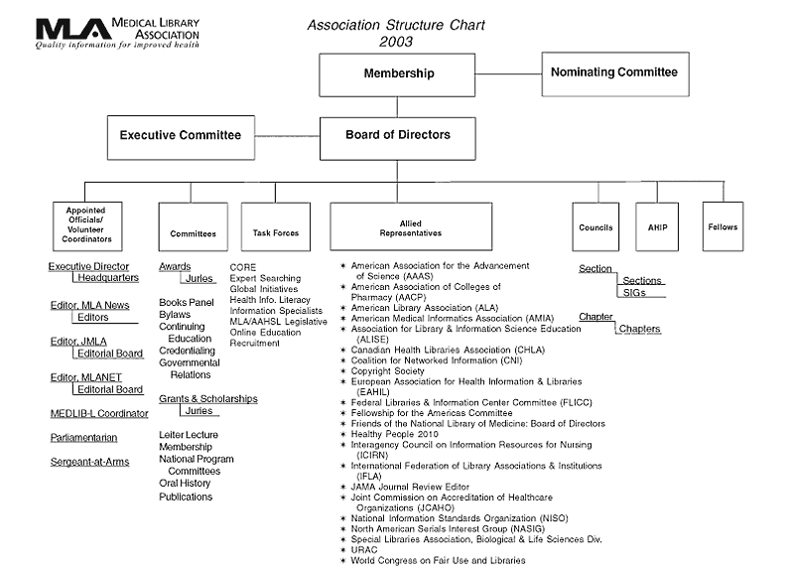

MLA-PHIL BYLAWS
Bylaws of the Philadephia Regional Chapter, Inc.
A Chapter of the Medical Library Association, Inc.
ARTICLE I. NAME AND BOUNDARIES
§1. Name
The name of this organization shall be the Philadelphia Regional Chapter, Inc., a Chapter of the Medical Library Association, Inc. hereafter in these bylaws called the Chapter.
§2. Boundaries
The boundaries of the Chapter shall be the State of Delaware and that portion of the State of Pennsylvania bounded by the Delaware River to the east, the New York State border on the north, the State of Maryland to the south and to the west, the eastern border of the counties of Bedford, Blair, Centre, Clinton, and Potter.
ARTICLE II. PURPOSE
The purpose of this organization shall be to promote health sciences libraries by fostering the educational and professional growth of health sciences librarians and information specialists in the Philadelphia region.
ARTICLE III. MEMBERSHIP
§1. Members
Membership shall be open to all persons who are actively engaged or interested in the work carried on in libraries or information centers serving medicine and allied scientific fields. Both members and nonmembers of the Medical Library Association, Inc. may belong to this Chapter.
§2. Rights & Privileges
Members in good standing shall be eligible to vote, to hold office and to serve on committees as stipulated in these Bylaws, except that only Voting Members of the Medical Library Association shall be qualified to move or to vote on recommendations to the Chapter Council regarding MLA policies or actions, or to vote on the selection of the Chapter's Representative and Alternate Representative to the Chapter Council. Honorary Chapter membership may be conferred at the discretion of the Chapter Board of Directors.
§3. Dues
Annual dues shall be assessed in an amount recommended by the Board of Directors and approved by a majority of the membership present and eligible to vote at the Annual Meeting of the Chapter. Chapter dues may not exceed MLA membership dues for Regular Members.
The membership and the fiscal year shall be the calendar year. Dues shall be assessed on an annual basis. If annual dues are not paid by February 15, membership in the Chapter shall lapse and the member shall no longer receive any of the rights and privileges of membership.
Members of the Chapter who are elected Fellows of the MLA, Inc., or those on whom the Chapter has conferred Honorary membership shall be exempt from paying Chapter dues.
ARTICLE IV. OFFICERS
§1. Officers
Elective officers of the organization shall be a Chairperson, a Chairperson-Elect, a Secretary, a Treasurer, a Representative to the Chapter Council, and an Alternate Representative to the Chapter Council. The Immediate Past-Chairperson also serves as an officer.
Officers shall be Voting members of the Medical Library Association, Inc. and members of the Philadelphia Regional Chapter, MLA.
§2. Terms of Office
The term of office of the Chairperson shall be one year as Chairperson-Elect and one year as Chairperson, and one year as Immediate Past-Chairperson. No one may serve more than one successive term as Chairperson-Elect, Chairperson, Immediate Past-Chairperson.
The term of office of the Secretary shall be two years. An individual may not serve more than one successive term as Secretary.
The term of office of the Treasurer shall be two years. An individual may not serve more than one successive term as Treasurer.
The term of office of the Representative to the Chapter Council shall be three years, except that if the Representative's term be made shorter by action of the Council or the Bylaws of the Medical Library Association, the term will coincide with that action.
The term of office of the Alternate Representative to the Chapter Council shall be the same as that of the Representative.
Elected officers shall take office at the close of the MLA Annual Meeting following their election and serve, unless they resign, die, become incapacitated, or are removed, until the close of the MLA Annual Meeting at the end of their terms of office or until their successors are elected and assume their duties.
§3. Duties
The duties of the Chairperson shall be to preside over all meetings and to represent the Chapter at all times and on all occasions not in conflict with any other officer's defined duties and responsibilities, to serve as chief executive officer of the Chapter, to have general supervision and control of its affairs, to recommend to the Board such measures as are considered desirable to further the objectives and broaden the effectiveness of the Chapter, to submit an Annual Report to MLA Headquarters by the date requested and to perform all other duties prescribed by these Bylaws and by the parliamentary authority adopted by the Chapter.
The duties of the Chairperson-Elect shall be to serve as Chairperson whenever the Chairperson is not able to do so, to assist the Chairperson in the performance of her/his duties, to serve as Chair of the Program Committee and to perform all other duties prescribed by these Bylaws and by the parliamentary authority adopted by the Chapter.
The duties of the Immediate Past-Chairperson shall be to serve as Chair of the Nominating Committee, and to perform all other duties prescribed by these Bylaws and by the parliamentary authority adopted by the Chapter.
The duties of the Secretary shall be to be responsible for incoming and outgoing correspondence, to prepare minutes of all meetings of the Chapter, the Executive Committee and the Board of Directors, and to perform all other duties prescribed by these Bylaws and by the parliamentary authority adopted by the Chapter.
The duties of the Treasurer shall be to receive and account for all monies due the Chapter, to report on Chapter finances at all Executive Board and Chapter meetings, to report to the members on the financial status of the Chapter at the Annual meeting and to perform all other duties prescribed by these Bylaws and by the parliamentary authority adopted by the Chapter.
The duties of the Representative to the Chapter Council shall be to represent the Chapter on the MLA Chapter Council by attending the meetings of the Council, to transmit to the Council recommendations that have been approved by the Chapter, to communicate Council business to the officers and membership of the Chapter and to perform other duties as the Chapter Chairperson or MLA Chapter Council Chairperson may assign.
The duties of the Alternate Representative to the Chapter Council shall be to attend the meetings of the Chapter Council, to serve as Representative whenever the Representative is unable to do so, to assume the office of Representative and serve out the unexpired term should the Representative become unable to complete the term of office, and to perform other duties as the Chapter Chairperson may assign.
§4. Vacancies
A vacancy arising in the office of Chairperson shall be filled by the Chairperson-Elect, who shall cease to be Chairperson-Elect, shall serve out the unexpired term of the Chairperson, and shall continue as Chairperson for the full succeeding term to which elected. A new Chairperson-Elect shall be elected by the Chapter to fill out the unexpired term of the Chairperson-Elect.
A vacancy arising in the office of Representative to the Chapter Council shall be filled by the Alternate Representative, who shall cease to be Alternate Representative, and shall serve out the unexpired term of the Representative. A new Alternate Representative shall be elected by the Chapter.
A vacancy arising in any other elected office shall be filled by the Executive Committee in consultation with the Nominating Committee. The person filling the vacancy shall serve for the duration of the unexpired term and may be considered for reelection.
A vacancy arising in any appointed office or committee chair of the Board of Directors shall be filled by a majority vote of the remaining members.
ARTICLE V. BOARD OF DIRECTORS AND EXECUTIVE COMMITTEE
§1. Board of Directors
The Board of Directors shall consist of the Chairperson, the Chairperson-Elect, the Immediate Past- Chairperson, the Secretary, the Treasurer, the Representative and Alternate Representative to the Chapter Council, the chair of each standing committee, and the Parliamentarian.
§2. Duties
The Board of Directors shall have general supervision of the Chapter's affairs between its meetings, including the power and authority to manage the Chapter's property, to regulate and govern its affairs, to fix time and place of meetings, and to select a potential candidate for membership for the MLA Nominating Committee, whose name shall be submitted to the Chapter Council before its final assembly at the MLA Annual Meeting. The potential candidate for the MLA Nominating Committee shall be a Voting Member of the Medical Library Association. No one shall serve on the MLA Nominating Committee as a voting member for more than one term during a period of five years. The Board of Directors shall perform other duties as are specified in these Bylaws and by the parliamentary authority adopted by this Chapter.
§3. Executive Committee
The Executive Committee of the Board of Directors shall consist of the elected officers of this Chapter. The Executive Committee shall take action delegated to it by the Board between regularly scheduled Board meetings, except that the Executive Committee may not modify any action taken by the Board. The Executive Committee shall serve on the Board's behalf in unforeseen circumstances. All transactions of this Committee shall be reported and reviewed at the next regularly scheduled Board of Directors meeting. Meetings shall be held upon call of the Chairperson or upon request of any three members of the Executive Committee. Four members of the Executive Committee shall constitute a quorum.
ARTICLE VI. MEETINGS
§1. Schedule of Meetings
At least two meetings of the Chapter shall be held each year, one in the fall and one in the spring. The spring meeting shall be the Annual Meeting, at which the business of the Chapter shall be conducted. Additional meetings may be held at the discretion of the Board of Directors. None of the meetings shall conflict in time with a meeting of the Medical Library Association, Inc.
§2. Notification
Written notice of meetings shall be sent to each member at least thirty (30) days before the meeting.
§3. Quorum
A quorum for the transaction of business at Chapter meetings shall be 35 voting members of the Chapter.
ARTICLE VII. STANDING AND SPECIAL COMMITTEES
§1. Committee Chairs
Chairs of committees shall be voting members of the MLA, Inc. and members of the Philadelphia Regional Chapter, MLA.
§2. Standing Committees
Standing committees of this Chapter shall consist of the Membership Committee, Program Committee, Nominating Committee, Bylaws Committee, Education and Credentialing Committee, Government Relations Committee, Archives Committee and the Communications Committee. Other standing committees may be established by the Executive Committee of the Board subject to subsequent amendment of the Bylaws.
§3. Special Committees
The Chapter Chairperson may appoint such other special committees as are necessary with the advice and consent of the Board of Directors.
§4. Appointments
The Chairperson shall appoint the chair of each committee subject to approval by the Executive Committee, with the exception of the Chair of the Program Committee who is the Chairperson-Elect and the Chair of the Nominating Committee who is the Immediate Past-Chairperson. The Committee Chair shall appoint and approve committee members subject to review by the Executive Committee. A Parliamentarian may be appointed by the Chairperson to serve a one year term concurrent with that of the Chairperson. This person may be reappointed to serve additional terms.
§5. Duties
Each Committee Chair shall submit to the Board of Directors annually, a list of committee objectives, a report of its activities and any recommendations to be considered. The Parliamentarian shall serve as an ex-officio member of the Bylaws Committee and shall serve as the authority on proper usage of parliamentary procedure in the conduct of Chapter, Executive Committee, and Board of Directors meetings.
ARTICLE VIII. NOMINATIONS AND ELECTIONS
§1. Nominating Committee
A Nominating Committee consisting of three members shall be formed no later than 75 days prior to the Annual Meeting. The Immediate Past-Chairperson shall serve as the ex-officio, non-voting chair of the Nominating Committee and shall appoint the other two members subject to Board of Directors' approval. No member of the Nominating Committee may serve more than one term during a three year period. The Immediate Past-Chairperson is the only member of the Board of Directors who shall serve on the Nominating Committee.
§2. Offices to be Filled
The Nominating Committee shall present annually at least one nominee for each office to be filled. A Chairperson-Elect shall be elected each year. The Secretary and the Treasurer shall be elected in alternate years. The Chapter Council Representative and Alternate Representative shall be elected every third year, unless their term of office shall be made shorter by action of the Chapter Council or Bylaws of the MLA, Inc., in which case their election shall coincide with that action.
§3. General Ballots
Ballots shall be mailed to the membership by the Nominating Committee at least thirty (30) days prior to the Chapter's Annual Meeting, shall be returned by mail to the chair of the Nominating Committee, and shall be received no later than ten (10) days prior to the Annual Meeting. The Nominating Committee shall meet and count the ballots. Candidates shall be declared elected by a simple majority vote of the ballots returned. Where there are more than two candidates, a plurality shall elect. In case of a tie, selection from among the candidates shall be by lot. The results of the election shall be announced at the Annual Meeting.
§4. Ballots for Chapter Council Representative
Election of the Chapter Council Representative and Alternate Representative shall be accomplished by mail ballot sent to all members of the Philadelphia Regional Chapter, MLA who are also voting members of MLA, Inc. The ballots shall be mailed thirty (30) days prior to the Annual Meeting and shall be returned by mail to the Chair of the Nominating Committee and shall be received no later than ten (10) days prior to the Annual Meeting. Candidates shall be declared elected by a simple majority vote of the ballots returned. In case of a tie, selection from among the candidates shall be by lot. The results of the election shall be announced at the Annual Meeting.
ARTICLE IX. PUBLICATIONS
§1. Control
Control of all publications of the Chapter shall be vested in the Board of Directors.
§2. Responsibility
The Chapter shall not be responsible for the statements or opinions advanced in its publications or at meetings of the Chapter or for statements by any of its members except those authorized by the Board of Directors or those reflecting duly established policies of the Chapter or MLA, Inc.
ARTICLE X. BYLAWS
§1 Consistency in Bylaws
Chapter Bylaws shall not be inconsistent with MLA Bylaws. Should an inconsistency occur, MLA Bylaws shall take precedence until the inconsistency is remedied.
§2. Amendments of Bylaws
A. The Bylaws may be amended at any meeting of the Chapter by a two-thirds (2/3) vote of those members present, provided that the amendment(s) have been submitted in writing to the membership at least thirty (30) days prior to the meeting at which the vote shall be taken.
B. These Bylaws and any future amendments thereto shall become effective on January 1 of the year following their adoption by the Chapter membership and the MLA, Inc.
XI. PARLIAMENTARY AUTHORITY
The rules contained in the current edition of Robert's Rules of Order Newly Revised shall govern this Chapter in all cases to which they are applicable and in which they are not inconsistent with these Bylaws and any special rules of order the Chapter may adopt.
Bylaws in the nature of rules of order may be suspended at any meeting of the organization by a vote of two-thirds of those members present.
ARTICLE XII. TAX STATUS
§1. Activities
Notwithstanding any other provision of these articles, the Chapter shall not participate in any other activities not permitted (a) by an association exempt from Federal income tax under Section 501(c)(3) of the Internal Revenue Code of 1954 b) by an association, contributions to which are deductible under Section 170(c)(3) of the Internal Revenue Code of 1954.
§2. Dissolution of Chapter
In the event of the dissolution of the Chapter, the Board of Directors shall, after paying or making provision for payment of all of the liabilities of the Chapter, dispose of all of the assets of the Chapter exclusively for the purposes of the Chapter in such manner, or to such organization or organizations organized and operated exclusively for charitable, educational, religious, or scientific purposes as shall at the time qualify as an exempt organization under 501(c)(3) of the Internal Revenue Code of 1954, or provisions of the U.S. Internal Revenue Law as the Board of Directors shall determine. All records pertaining to the Chapter will be turned over to the Medical Library Association, Inc.
§3. Incorporation
The Philadelphia Regional Chapter, Inc. of the Medical Library Association, Inc. shall be incorporated as a not-for-profit corporation.
Revised and approved 03/24/98
Revised and approved 05/22/96
Revised and approved 12/94
Revised and approved 09/93

LONG-RANGE PLAN

Strategic Plan
This edition of the Philadelphia Regional Chapter/MLA’s strategic plan covers the Chapter years 2000 through 2002. This document updates the Chapter’s “Long-Range Plan” which covered the years 1993-94 through 1997-98 and reflects and echoes the priorities of “The Strategic Plan of the Medical Library Association 1997-2002.” Its intent is to document and address membership needs that the Chapter recognizes as priorities, based on information from members and discussion at the August 1997 Chapter Retreat, to give direction to the Board as it designs and assigns Chapter work, yearly objectives, materials and activities.

—Adopted by the Board, February 15, 2000

Throughout the years 2000-2002, the Philadelphia Regional Chapter/MLA will focus its efforts to achieve the following goals:

Advocacy—The Philadelphia Regional Chapter/MLA advocates for the health sciences library and information professionals who are its members by carrying out any of the following:

Communicating the needs and requests of Chapter members to the Medical Library Association, especially regarding the promotion of greater recognition for our profession as a whole. For example: collaboration with the Joint Commission on the Accreditation of Healthcare Organizations and the National Library of Medicine. Responsibility: Chapter Board

Recognizing or seeking recognition for members who make significant contributions to the profession and publicizing these contributions to the broader information community, the regional health care community, and the public. Developing new mechanisms for recognizing and honoring member achievement. Responsibility: Awards Committee, Communications Committee

Developing and maintaining liaisons with other regional health care associations, library associations, health agencies, library agencies, information services/information systems associations, and relevant corporations. Responsibility: Chapter Board, Program Committee, Education and Credentialing Committee

Promoting the visibility of Chapter health sciences librarians and their information expertise to the health care community via public relations activities, which may include exhibits, press releases, public service announcements, representation at a variety of health association meetings, publication in health association newsletters and journals, and other appropriate means. Responsibility: Communications Committee, Chapter Board

Professional Development—The Philadelphia Regional Chapter/MLA provides a variety of learning opportunities for members to enhance skills and knowledge, especially regarding technology, teaching, statistics, finance, leadership, research, evidence-based health care, evidence-based librarianship, and evidence-based management by carrying out any of the following:

Supporting members in acquiring credentials which are valid and which carry recognition. Responsibility: Education and Credentialing Committee, Program Committee, Chapter AHIP Liaison

Providing leadership skills development forums. Responsibility: Education and Credentialing Committee, Program Committee

Providing opportunities and resources for learning how to be information skills teachers and trainers. Responsibility: Education and Credentialing Committee, Program Committee

Establishing leadership, research, and technology as the themes for the Chapter’s continuing education courses and chapter programs. Responsibility: Education and Credentialing Committee, Program Committee

Exploring distance learning and other alternative delivery methods for professional development. Responsibility: Education and Credentialing Committee, Program Committee

Information Technology—The Philadelphia Regional Chapter/MLA offers support to its members as users of technology and forward-thinking planners for appropriate technologies for the information needs of the health care community by implementing any of the following:

Offering technology-related sessions at the introductory, intermediate, and advanced levels. Responsibility: Program Committee, Education and Credentialing Committee

Helping members stay aware of trends in technology, the future of technology. Responsibility: Program Committee, Education and Credentialing Committee, Communications Committee, Program Committee

Research—The Philadelphia Regional Chapter/MLA recognizes the practice of research as essential for assuring the critical role of health sciences library and information professionals by carrying out any of the following:

Focusing on evidence-based health care. Responsibility: Program Committee, Education and Credentialing Committee

Providing opportunities for learning through courses and programs on research and publication skills. Responsibility: Program Committee, Education and Credentialing Committee
Providing opportunities for highlighting methods and skills in forums such as Research Days through which members would share ideas and disseminate key research-based information about library/information science practices, particularly as they relate to outcomes. Responsibility: Program Committee, Education and Credentialing Committee

Considering a Chapter Research Project. Responsibility: Ad Hoc Research Committee

Leadership— The Philadelphia Regional Chapter/MLA recognizes and develops health sciences library and information professionals as leaders within their institutions, within the Association, and in the broader health care community by implementing any of the following:

Providing opportunities for learning about and implementing statistics and benchmarking. Responsibility: Education and Credentialing Committee, Program Committee, Chapter Council Representative and Alternate

Providing opportunities to learn skills for teaching and training and other communication skills for the technology-intensive managed care and health systems environments. Responsibility: Education and Credentialing Committee, Program Committee

Providing opportunities for general leadership skills that could be used in any institutional environment. Responsibility: Education and Credentialing Committee, Program Committee

Organization—The Philadelphia Regional Chapter maintains a continuous strategic planning process to provide necessary direction for the Chapter and ensure the Chapter’s continuing viability by:

Encouraging Chapter membership and participation by all health sciences librarians and information professionals in the Philadelphia Region

Assuring appropriate funding streams and financial support for the activities and work proposed by this document. Responsibility: Chapter Board

Reviewing progress on this document at least annually and reporting results to membership. Responsibility: Chapter Board

Holding a third Chapter Retreat in 2002. Responsibility: Chapter Board.

BOARD OF DIRECTORS RESPONSIBILITIES

Board of Directors
2004-2005

Chairperson, 2004-2005 | Lenore Hardy  Director of Libraries  Drexel University Health Sciences Libraries  245 N. 15th St., MS 449  Philadelphia, PA 19102  215-762-7022 (Phone)  215-762-4028 (Fax)  hardy@drexel.edu
Chairperson-elect and Program Committee Chair, 2004-2005 | Daniel Kipnis  Education Services Librarian  Scott Memorial Library  Thomas Jefferson University  1020 Walnut Street  Philadelphia, PA 19107  215-503-2825  215-923-3203 (fax)  dan.kipnis@jefferson.edu
Nominating Committee Chair, 2004-2005 | Bradley Long  Senior Information Services Librarian  Scott Memorial Library  Thomas Jefferson University  1020 Walnut Street  Philadelphia, PA 19107  215-503-7676  215-923-3203 (Fax)  bradley.long@jefferson.edu
Secretary, 2003-2005 | Melanie Cedrone  Graduate Studies Liaison Librarian  Biomedical Library  University of Pennssylvania  3610 Hamilton Walk  Philadelphia, PA 19104  215-898-1862 (Phone)  mcedrone@mail.med.upenn.edu
Treasurer, 2004-2006 | Stephanie Ferretti  Associate Director Library and Educational Information Systems.  Philadelphia College of Osteopathic Medicine  O.J. Snyder Memorial Library  4170 City Avenue, Philadelphia, PA 19131  phone: 215-871-6475  fax: 215-871-6478  stephaniefe@pcom.edu
Chapter Council Representative, 2002-2005 | Susan Couch  Information Specialist  Library  National Board of Medical Examiners  3750 Market Street  Philadelphia, PA 19104  215-590-9663 (phone)  215-243-3730 (fax)  scouch@nbme.org (e-mail)
Chapter Council Alternate, 2002-2005 | Marion C. Chayes  Director  Wilmer Memorial Library  Abington Memorial Hospital  1200 Old York Road  Abington, PA 19001  215-481-2096 (Phone)  215-481-7508 (Fax)  chayes@amh.org (E-mail)
AHIP Liaison, 2004-2006 | Esther Y. Dell  Interlibrary Loan Librarian  George T. Harrell Library  Hershey Medical Center  P.O.Box 850, H127  Hershey, PA 17033  717-531-8633 (phone)  717-531-8635 (fax)  eyd1@psu.edu (e-mail)
Archives Committee Chair, 2002-2004 | Joan R. McKenzie  Coordinator for Technical Services  Library  College of Physicians of Philadelphia  19 South 22nd St.  Philadelphia, PA 19103  215-563-3737 x256 (phone)  215-569-0356 (fax)  mckenzie@collphyphil.org (e-mail)
Benchmarking Chapter Educator, 2003-2005 | Mary McCann  Manager, Library Services  Pennsylvania Hospital  800 Spruce St.  Philadelphia, PA 19107  215-829-3998 (Phone)  215-829-7155 (Fax)  mccannm@pahosp.com
Bylaws Committee Chair and Parliamentarian, 2004-2006 | Vacant
Communications Chair, 2003-2005 | Linda M.G. Katz  Associate Director Drexel University Health Sciences Libraries/Library Coordinator  Hahnemann Library  Drexel University of the Health Sciences  245 North 15th Street, MS 449  Philadelphia, PA 19102  215-762-7632 (phone)  215-849-8180 (fax)  linda.katz@drexel.edu (e-mail)
Development Coordinator, 2004-2006 | Gina Kaiser  Coordinator of Technical Services  Joseph W. England Library  University of the Sciences in Philadelphia  600 S. 43rd Street  Philadelphia, PA 19104  215-596-8963 (phone)  215-596-8760 (fax)  g.kaiser@usip.edu (e-mail)
Education and Credentialing Committee Chair, 2004-2006 | Tom Cummiskey  Manager, Library Services  Doylestown Hospital  595 West State Street Doylestown, PA 18901  215-345-2310 (phone)  215-345-2541 (fax)  tcummiskey@dh.org
Government Relations Committee Chair, 2004-2006 | Gary Christopher  Directory, Health Sciences Library  Frankford Hospitals  Red Lion and Knight  Philadelphia, PA 19114-1436  215-612-4135 (Phone)  gchristopher@fhcs.org (E-mail)
Membership Committee Chair, 2003-2005 | Gary Childs  Education Librarian  Hahnemann Library  Drexel University of the Health Sciences  245 North 15th Street, M.S. 449  Philadelphia, PA 19102  215-762-3696  215-762-8180 (fax)  gc24@drexel.edu

Board of Directors Responsibilities
Function: | The Board of Directors (hereafter known as the Board) shall have power to manage the Chapter’s property, and govern and regulate its affairs.
Selection: | The members of the Board are Chairperson, Chairperson-Elect, Immediate Past-Chairperson, Secretary, Treasurer, Chapter Council Representative. Chapter Council Alternate, the Chair of each standing committee, Parliamentarian (when named), and Development Coordinator. (Board Minutes 7/97)
Term: | The Chairperson, Chairperson-Elect and Immediate Past-Chairperson and Parliamentarian serve one year. The Secretary, Treasurer and Committee Chairs serve two years. The Chapter Council Representative and Alternate serve three years.
Appointment: | The Chapter Chairperson appoints all Committee Chairs. The Board reviews and approves the Committee members who have been selected by each Committee Chair.
Duties: | 1. Meets at least four times a year in order to manage and regulate Chapter affairs. Meetings are open to all members of the Chapter. Action items should be submitted to Chapter Chairperson prior to each meeting so that they can be placed on the agenda. (Board Minutes 9/93; 3/95). If host organization for Board Meeting cannot provide lunches, Board Members will pay for their own lunch. (Board Minutes 7/92)  2. Reviews Committee Chairs’ proposed members.  3. Approves a potential candidate for membership on the MLA, Inc. Nominating Committee (see Chapter Council Representative duties #10).  4. Fills vacancies on the Board, if needed.  5. Serves as liaison to MLA, Inc.  6. Serves all members of the Chapter regardless of their geographical location.

Executive Committee
Function: | The Executive Committee transacts business of an emergency nature when the Board is not in session and carries out other duties assigned by the Board.
Selection: | The members of the Committee are the elected members of the Board: the Chairperson, Chairperson-Elect, Immediate Past-Chairperson, Secretary, Treasurer, Chapter Council Representative and Chapter Council Alternate. (Board Minutes 11/87)
Duties: | 1. Transacts business at the call of the Chairperson or any three members of the Executive Committee.  2. Transacts business when the Board is not in session.  3. Approves all Committee Chairs appointed by the Chairperson.

Interim Motions
Discussion by E-mail/Voting by Fax

Policy: | If business arises that must be resolved before the next Board meeting, a motion may be posted and the topic may be discussed via electronic mail. Votes are sent by signed telefacsimile to the Chapter Secretary and are ratified at the next Board meeting. (Board Minutes 10/96; patterned after MLA National Board Protocol: Motion Over E-Mail)
Procedure: | 1. After sufficient discussion, a formal motion is made to all members of the Board by electronic mail or telefacsimile.  2. Votes are returned by signed telefacsimile to the Secretary with a copy to the Chairperson. The vote is then announced.  3. The votes are ratified at the next Board meeting. The Secretary records the votes by name and includes them in the minutes. This constitutes the official record of the Board’s action.

Formation of Standing Committees
Policy: | 1. It is the responsibility of the Chapter Chairperson to appoint the Committee Chair of each standing committee with the exception of the Program Committee whose Chair is the Chairperson-Elect and the Nominating Committee whose Chair is the Immediate Past-Chairperson. These appointments are subject to the approval of the Executive Committee. (Chapter Bylaws)  2. The Committee Chair shall appoint and approve committee members subject to review by the Board of Directors. (Chapter Bylaws)  3. The Committee Chair reserves the right to remove a committee member for failure to participate as requested. (Board Minutes 4/04)  4. Each Committee, excluding the Nominating Committee, has a maximum of 10 members including the Committee Chair. (Board Minutes 9/94) The charge of each committee is stated in the Policy Procedure Manual under the heading of each standing committee.
Procedure: | 1. A committee application form will be published in the Spring issue of The Chronicle  2. The forms will be returned to the current Chairperson-Elect of the Chapter.  3. The Executive Committee will approve the appointment of each standing Committee Chair prior to the July meeting of the Board.  4. All approved Committee Chairs serve two year terms. Therefore, not all standing Committee Chairs need to be appointed each year. The Chapter Chairperson makes the initial contact with each potential Committee Chair. Prior to his or her acceptance, each potential Committee Chair should be informed of the responsibilities of the Committee, and of the Chair including attendance at meetings of the Board. He or she should also be told that his/her appointment is subject to Executive Committee approval.  5. The Committee Chairs will be given access to completed committee application forms for aid in selecting their committee members. Committee Chairs will strive to appoint members from different geographical areas.  6. Committee Chairs will inform perspective members of the duties involved in being a committee member of the possibility of travel to attend meetings; and that appointment is subject to Executive Committee review.  7. The Committee Chairs should bring information on their prospective committee members to the July meeting of’ the Board for review by the Executive Committee. Committee Chairs may also request that the Chairperson conduct this review via electronic mail or fax.  8. The Board will review proposed Committee members ensuring that no one serves on more than two committees simultaneously in any given year, unless as ex officio. (Board Minutes 9/94)

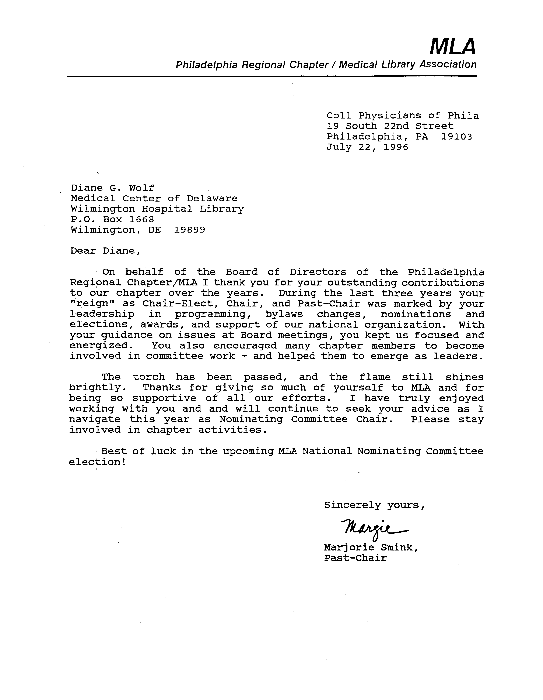

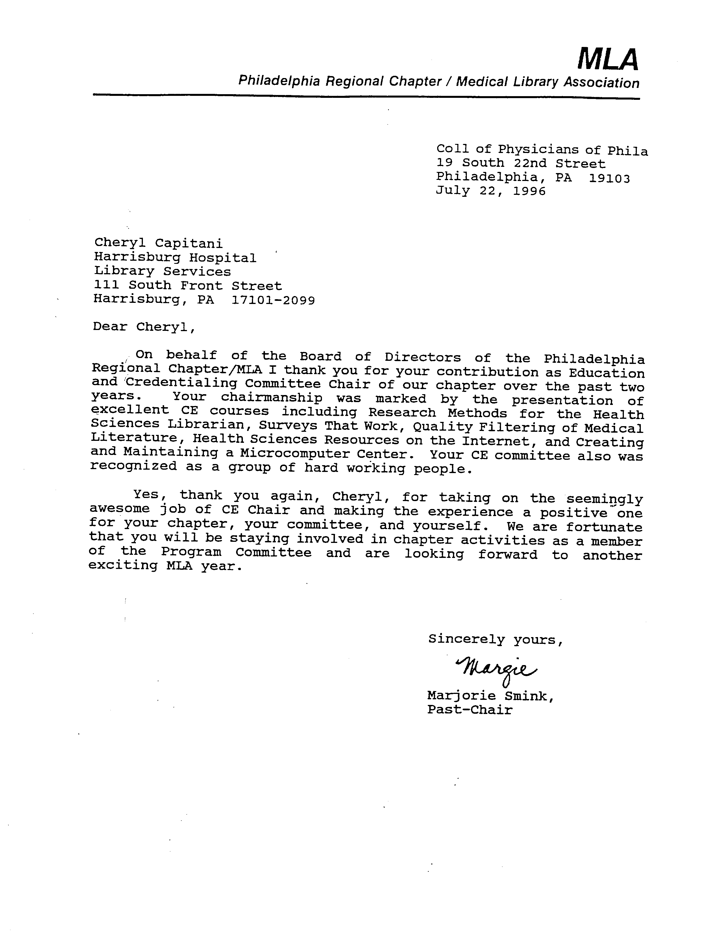

Memorial Gifts
Policy: | The Board decides when to make a memorial gift. Memorial gifts may be monetary donations or gifts in kind and are determined by the Board. Monetary donations are left to the discretion of the Chair. A history of giving should be included to help in the decision-making process. (Board Minutes 9/94)
Procedure: | 1. When a proposal for a memorial gift is made to the Board and approved, the Board shall appoint an Ad Hoc Committee to decide on an appropriate gift. (Board Minutes 11/84)  2. The Ad Hoc Committee shall determine an appropriate memorial gift and submit its recommendation to the Board for approval.  3. Once the Board approves the recommendation, the Ad Hoc Committee will obtain the necessary funds from the Treasurer and select the gift.  4. A letter explaining the gift will be sent by the Chairperson to the family and/or significant other.

Correspondence
Policy: | All Official Chapter correspondence should be conducted using Chapter letterhead consisting of cream paper and green inked logo. (Board Minutes 11/87)

OFFICERS

Chairperson
Function: | The Chairperson shall be chief executive officer of the Chapter and, subject to the Board, shall have supervision and control of its affairs. S/he shall preside at all meetings of the Chapter, the Board and the Executive Committee. S/he shall appoint all special committees and shall be ex-officio member of all committees except the Nominating Committee. The Chairperson shall prepare and submit the Annual Report of Chapter activities to MLA, Inc. by the date designated each year.
Requirements: | The Chairperson shall be a Voting Member of MLA, Inc., and the Philadelphia Regional Chapter/MLA and shall have served one year as Chairperson-Elect/Program Committee Chair.
Selection: | The Chairperson is elected by the Chapter membership.
Term: | One year.
Duties: | 1. Appoints Committee Chairs, who are subject to approval by the Executive Committee.  2. Presides over meetings of the Board including a joint meeting of the incoming and outgoing Board in July and presides over Executive Committee communications.  3. Schedules meetings of the Board at least four times per year, notifies members, prepares the agenda, and presides over the meetings.  4. Develops objectives for the year and submits them for approval at the July Board meeting. (Board Minutes 7/89)  5. Serves as ex officio member of all standing committees except the Nominating Committee.  6. Presides over all general meetings and conducts the Annual Meeting.  7. Seeks high visibility in the Chapter.  8. Reads and follows guidelines stated in Chapter’s Policy and Procedure Manual  9. Prepares and submits column “From the Chair” for each issue of The Chronicle.  10. Prepares and submits Mid-Winter Report and Annual Report to the MLA, Inc. as requested.  11. Participates in MLA, Inc. activities and responds promptly to requests for reports and other materials.  12. Appoints the Parliamentarian or assigns the position of Parliamentarian to the Bylaws Committee Chair.  13. Appoints, in consultation with the Communications Committee Chair, the Chapter Listserv Owner. (Board Minutes 9/94)  14. Appoints Special Committees as needed.  15. Appoints a substitute to take minutes at a Chapter, Board or Executive Committee meeting in the absence of the Secretary.  16. Ensures that the incoming Board is aware of the Chapter’s spending guidelines for all Committees.  17. Prepares forewords and/or introductions for any Chapter publication that is printed for distribution to the membership.  18. Writes thank-you letters to departing Committee Chairs.  19. Monitors discretionary fund, amount to be determined by the Board to provide a Chapter social gathering at MLA, Inc. Annual Meeting. (Board Minutes 1/89; 9/94)  20. Signs written contracts and agreements upon approval by the Board.  21. Selects certified public accountant to review/audit the checking and money market account records and the Quicken reports at the end of each Treasurer’s term.  22. Copies official correspondence and reports to the Archives.  23. Notifies Chairs and officers whose terms are due to expire and asks them how else they would like to serve. (Board Minutes 5/96)

Chairperson-Elect
Function: | The Chairperson-Elect’s function is to serve as Program Committee Chair, to assist the Chairperson in the performance of all duties, and in the event of the withdrawal or absence of the Chairperson, to assume all duties and obligations of the Chairperson.
Requirements: | The Chairperson-Elect shall be a Voting Member of MLA, Inc. and the Philadelphia Regional Chapter/MLA. S/he should be familiar with recent concerns and activities of the Chapter (usually through a recent term as a Committee member, or Committee Chairperson of the Chapter).
Selection: | The Chairperson-Elect is elected by the Chapter membership.
Term: | One year.
Duties: | 1. Serves as a voting member of the Board and the Executive Committee.  2. Serves as the Program Committee Chair.  3. Seeks high visibility in the Chapter.  4. Assists the Chairperson with his/her duties.  5. Presides, in the absence of the Chairperson, over Board meetings and general meetings.  6. Assumes, in case of the withdrawal, all Chairperson duties.  7. Copies official correspondence and reports to the Archives.  8. Selects members of the Program Committee and presents them to the Board for review.

Immediate Past-Chairperson
Function: | The function of the Immediate Past-Chairperson is to serve for one year on the Board and as Chair of the Nominating Committee. S/he shall assist the Board in decision making consistent with the Association Bylaws and shall provide the Chapter with recent past program information.
Requirements: | The Immediate Past-Chairperson should be a Voting Member of MLA, Inc. and the Philadelphia Regional Chapter/MLA.
Selection: | The Immediate Past-Chairperson has been elected by the membership.
Term: | One year.
Duties: | 1. Attends Board and Executive Committee meetings as a voting member.  2. Assists the Board in any extra activities which arise throughout the year.  3. Chairs the Nominating Committee which includes the preparation of a slate of candidates, and the Ad Hoc Awards Committee which solicits and selects individuals to receive Chapter awards.  4. Revises the Chapter’s Policy and Procedure Manual.  5. Copies official correspondence to the Archives.

Updating the Policy and Procedure Manual
Policy: | The Policy Procedure Manual (The Manual) will be updated yearly by the Immediate Past-Chairperson, during his/her term of office.
Procedure: | 1. Any changes in the Bylaws are incorporated into The Manual This will involve not only changes in the Bylaws themselves, but their implications for changes, deletions, and/or additions to job descriptions and/or policies and procedures.  2. The minutes for the year, and the Annual Reports of Board Members and Committees, will be consulted for actions that require changes in job descriptions and/or policies and procedures. Dates of major Board decisions related to policies and procedures should be referenced.  3. The Immediate Past-Chairperson will consult with the Board members for input before completing the final revision.  4. The revised manual should be available to be distributed at the July Board Meeting when both outgoing and incoming members will be present.

Secretary
Function: | The Secretary’s function is to maintain an accurate record of all meetings of the Chapter, the Board and the Executive Committee.
Requirements: | The Secretary must be a Voting Member of MLA, Inc. and the Philadelphia Regional Chapter/MLA and have facilities for typing, reproducing and distributing the minutes.
Selection: | The Secretary is elected by the membership.
Term: | Two years.
Duties: | 1. Serves as a voting member of the Board and the Executive Committee.  2. Attends all meetings of the Chapter, the Board and the Executive Committee.  3. Takes minutes of all Chapter, Board and Executive Committee meetings. In the absence of the Secretary, the Chairperson will appoint a substitute.  4. Makes available a file of Board minutes (Has available one year, plus current year of minutes at every Board meeting).  5. Writes and distributes minutes of all Chapter, Board and Executive Committee meetings in a timely fashion. (Board Minutes 7/87). The minutes should contain the following information: date, place, motions and votes thereon; a statement of topics discussed and summary of discussion; reports of officers and Committee Chairs, either in the body of the minutes or as attachments; and a list of attendees (whether members or visitors), and absentee Board members. (Board Minutes 7/9 1)  6. Writes and see that minutes of the previous year’s Annual Meeting are distributed to the entire current membership p to the next Annual Meeting. Coordinating with the Nominating Char, minutes are included with election ballots mailed the following year. Additional postings, such as publication in The Chronicle are left to the discretion of the Secretary and the Communications Chair. (Board Minutes 9/94)  7. Secretary generates certificates for outgoing Board members. (Board Minutes 7/98)  8. Sends two sets of approved Board and Annual Meeting minutes and Reports to the Archives Committee Chair: one set for the Chapter Archives and one set for MLA, Inc. Headquarters Archives.

Treasurer
Function: | The Treasurer serves as the custodian of the Chapter’s funds, maintains these funds in a bank, and disperses them at the direction of the Chapter’s officers.
Requirements: | The Treasurer shall be a Voting Member of MLA, Inc. and the Philadelphia Regional Chapter/MLA.
Selection: | The Treasurer is elected by the Chapter membership.
Term: | Two years.
Duties: | 1. Receives Chapter dues remittance checks and other income due the Chapter.  2. Prepares annual budget with the assistance of Chapter officers.  3. Assists with periodic review (audit) of the Chapter’s financial records.  4. Maintains the Chapter’s bank account and controls the check register, Records all transactions with Quicken software.  5. Maintains a system to document approved disbursements.  6. Prepares periodic financial reports with Quicken.  7. Monitors expenditures to maintain a financial balance which allows the Chapter to be progressive without overspending.  8. Retains and maintains financial records in accordance with retention schedules.  9. Obtains the Chapter Chairperson’s signature and places it on file with the Chapter’s bank.  10. Serves as a voting member of the Board of Directors and the Executive Committee.  11. Copies official correspondence and reports to the Chapter Archives.

Bank Accounts
Policies: | 1. A checking account is maintained in the name of the Philadelphia Regional Chapter/Medical Library Association.  2. Signatures for Treasurer and the Chapter Chairperson are kept on file at the Chapter’s bank.  3. The checking account is reviewed or audited every two years, at the expiration of the Treasurer’s term.
Procedures: | 1. Except in unusual circumstances, a minimum balance of $300.00 is maintained in the Chapter’s checking account to avoid account maintenance fees. Sufficient additional funds are included to cover checks written.  2. Bank statements are received monthly for the checking account. Transactions and balances on the statement are checked against the Quicken file and any discrepancies are resolved.  3. Blank checks are re-ordered as needed.  4. The Chairperson selects an accountant to review/audit the Treasurer’s records every two years, including checking account information, the Quicken file, and Treasurer’s reports. (Board Minutes 5/96)

Bill Payment
Policies: | Bills incurred by the Chapter for expenses approved by the Chairperson and/or the Board are paid by the Treasurer.
Procedures: | 1. All bills are forwarded to the Treasurer. The Chairperson’s and/or the Board’s approval of expenditures should be obtained prior to the commitment for any expenditures. Any bills not approved are referred to the Chapter Chairperson.  2. Approved bills are paid by check within thirty days of receipt. Canceled checks (seven years) and original invoices (three years) are retained in order to document all expenditures.

Internal Control Procedures for Financial Activities
Sound financial management is essential for the effective operation of the Chapter. One important aspect of good financial management is a Chapter’s internal control procedures to handle its financial activities. Chapters with good internal control systems gain several benefits including:

- Availability of complete financial information for decision-making.

- Management of finances within budget and in accordance with Chapter policies and guidelines.

Implementation of the following internal control procedures is advised by MLA, Inc.
Headquarters:

- Record transactions using a chart of accounts.

- Approve expenditures and financial commitments according to clear lines of authority.

- Maintain and follow written expense reimbursement policies.

- Prepare annual budgets, compare them to financial reports, and investigate unusual variances.

- Distribute regular and routine financial reports.

- Involve Chapter officers in financial matters.

- Periodically, appoint a person to conduct an independent review (audit) of financial records. (This should occur at least every two years, at the end of the Treasurer’s term of office.)

PERIODIC REVIEWS

The Chapter Chairperson shall choose an accountant to review the past two years’ bank statements, budgets, and financial reports to determine if:

- Cash and checks are deposited promptly into the Chapter’s bank account(s).

- Timely bank reconciliations are conducted.

- Paid expense reports and invoices have the proper authorizations and account numbers, and none are unpaid or paid twice.

- All disbursements and pre-numbered checks are recorded.

- Totals for the checking account and financial statement agree.

- Recorded balances in financial statements are compared with budgeted amounts periodically and unusual relationships are investigated and explained to Chapter officers.

RECORD RETENTION

Certain records are required for financial purposes, some for historical significance and others to maintain daily activities. Minimum retention periods for financial records are as follows:

- Bank statements and cancelled checks — 7 years.

- Bank signature cards and account records — 3 years after they are out of date.

- Contracts — 3 years after the end of the contract.

- Incorporation certificates — indefinite period of time.

- Mailing permits — indefinite period of time.

- Other financial reports, bills, expense reports and correspondence — 3 years.

- Tax exemption letter — indefinite period of time.

Financial Reports
Policies: | 1. A written financial report is distributed at each Board Meeting.  2. A financial report is made to the membership at the Annual Meeting by the Treasurer.
Procedures: | 1. The financial reports are distributed at each Board Meeting. The Financial Statement details the checking account credits, debits and balances since the last Board meeting. The Income Versus Expenses Statement provides a summary of income and expenses by category for the calendar year. An Income Versus Expenses Final Report is completed at the close of each calendar year.  2. A summary of the Chapter’s assets and liabilities is presented at the Annual Meeting.  3. Copies of all written reports are added to the Treasurer’s permanent record and submitted to the Chapter Archives annually.

Treasurer’s Report: 1/8/02

The Chapter’s bank account as of January 8 has a balance of $10, 504.34. Expenditures since the fiscal year began on July 1 totaled $2,634.87. Income was $2,869.70. Thus, we spent $254.83 more than we took in this year. However, there are still some bills to be paid for the Winter CE class, Proving Your Worth. It is anticipated that we will make up for the expenses of Proving Your Worth with proceeds from the PDA Teleconference in February.

For a specific breakdown of how the Chapter’s money was spent since the last report that ran through September 21, see the Transaction Report (attached). I’ve also attached the Cash Flow Report, which runs from July 1, 2001 to the present time.

Linda M.G. Katz,
Treasurer

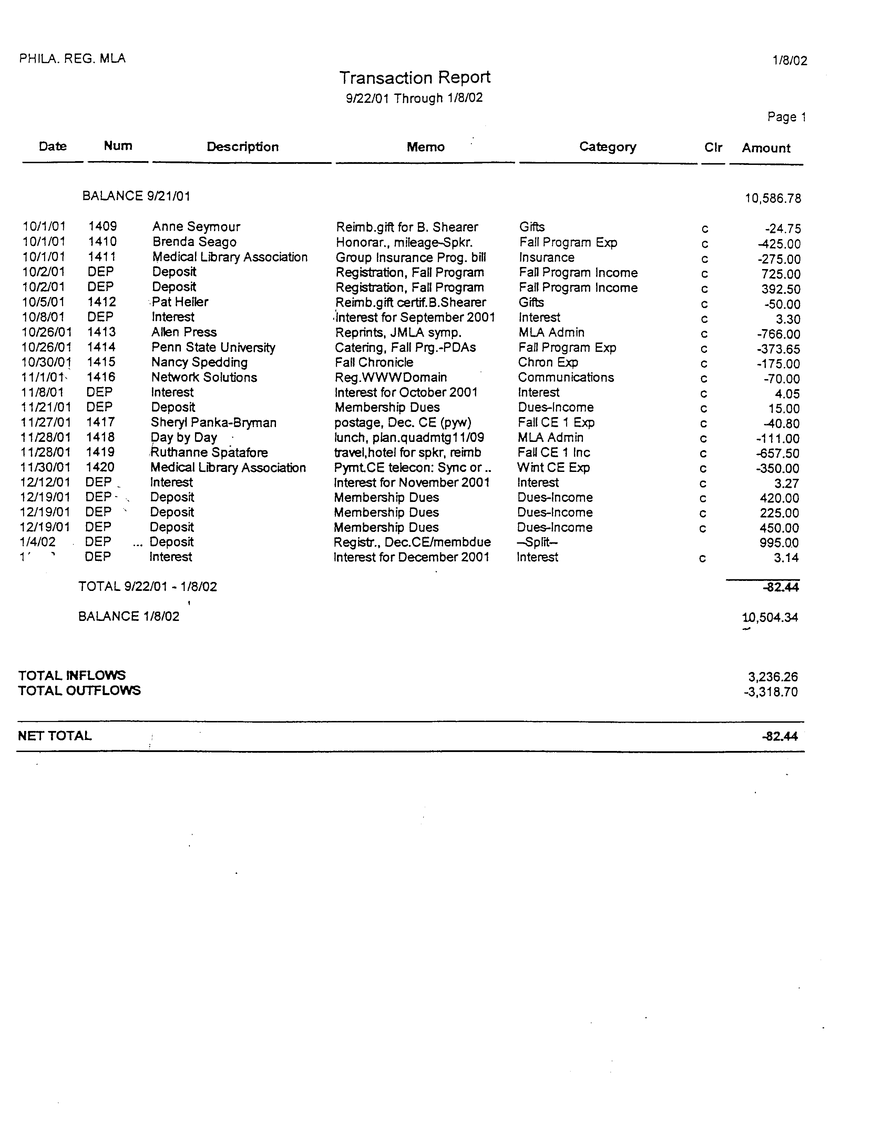

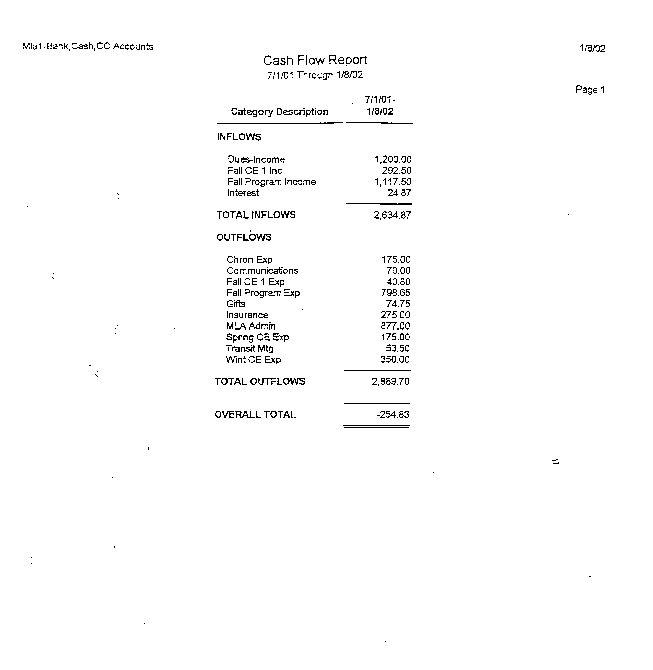

Tax Exempt Status
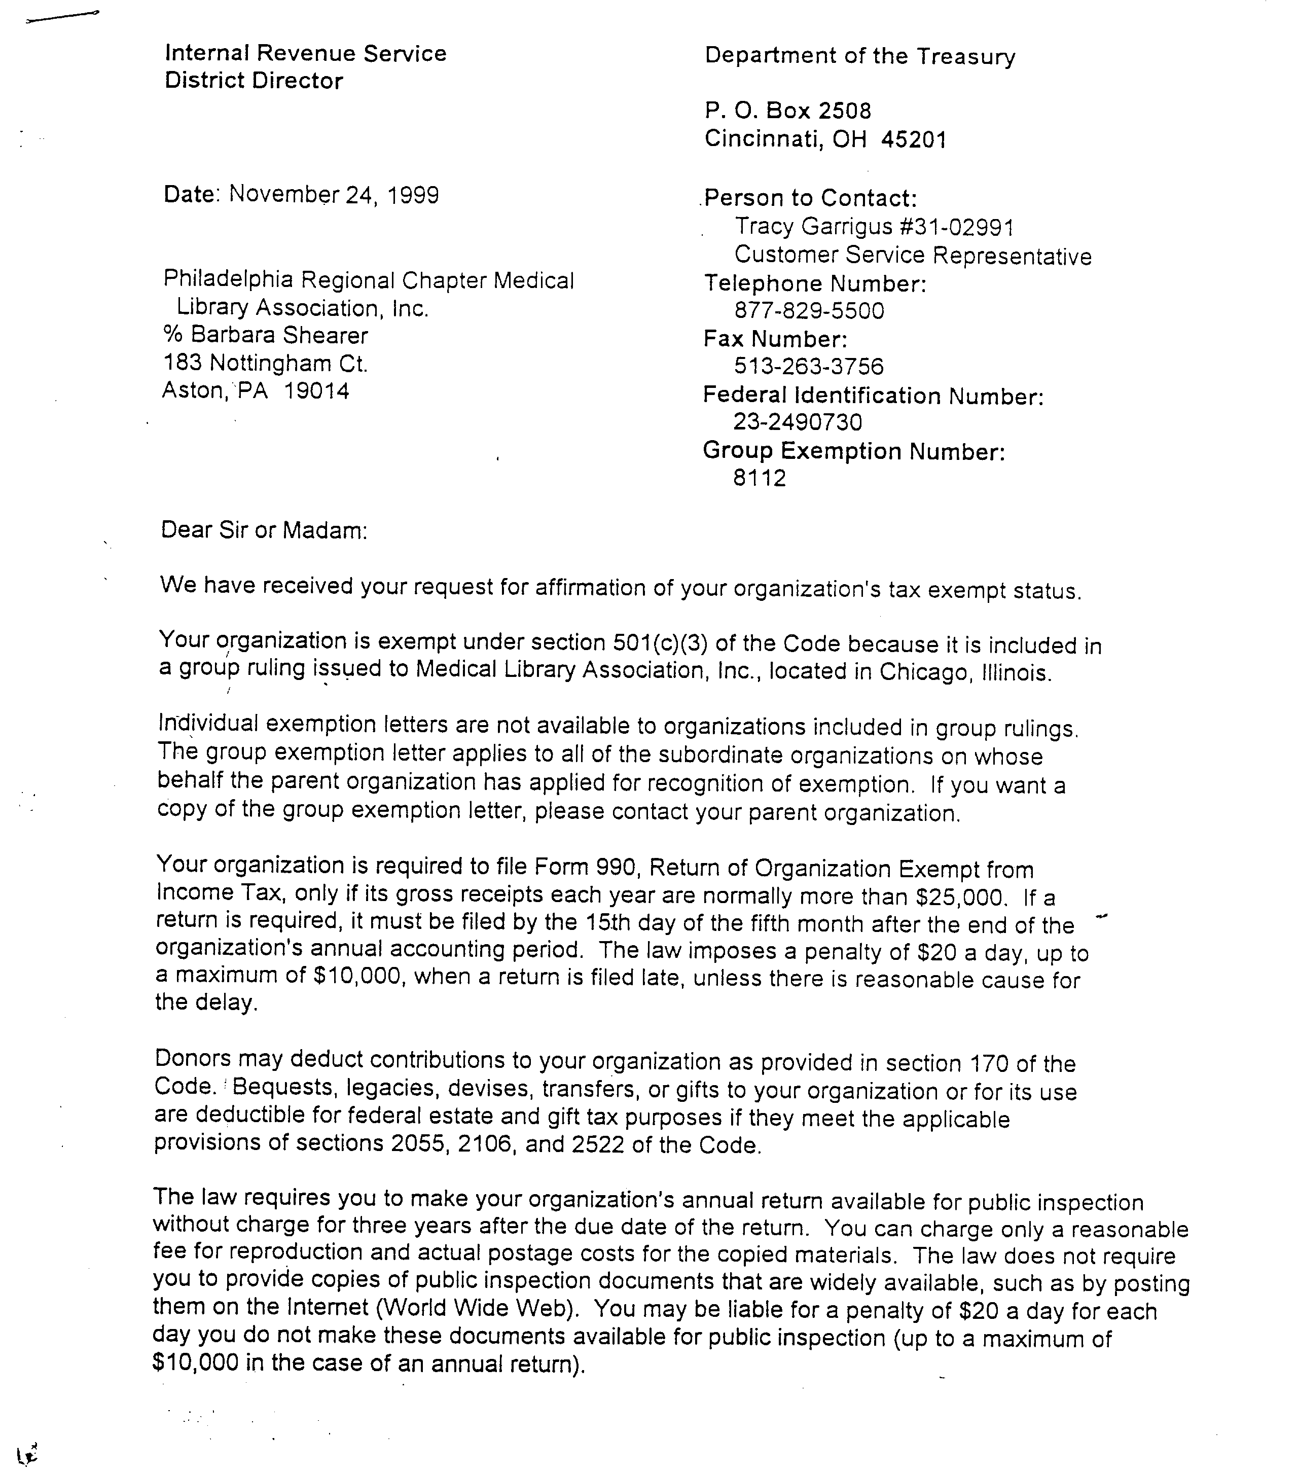

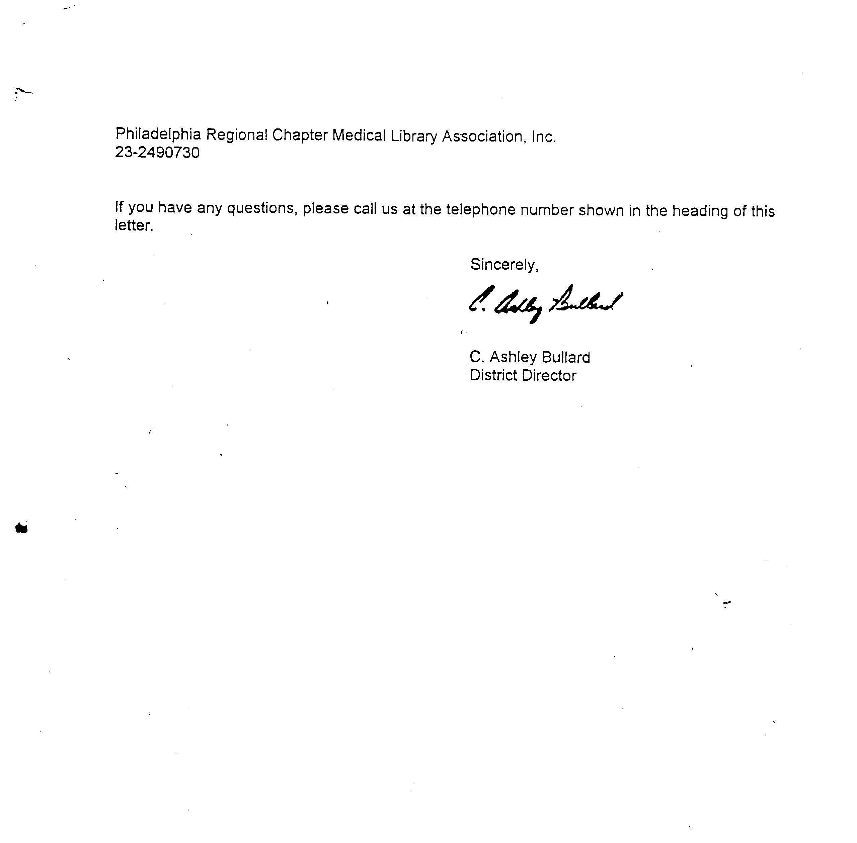

Certificate of Insurance
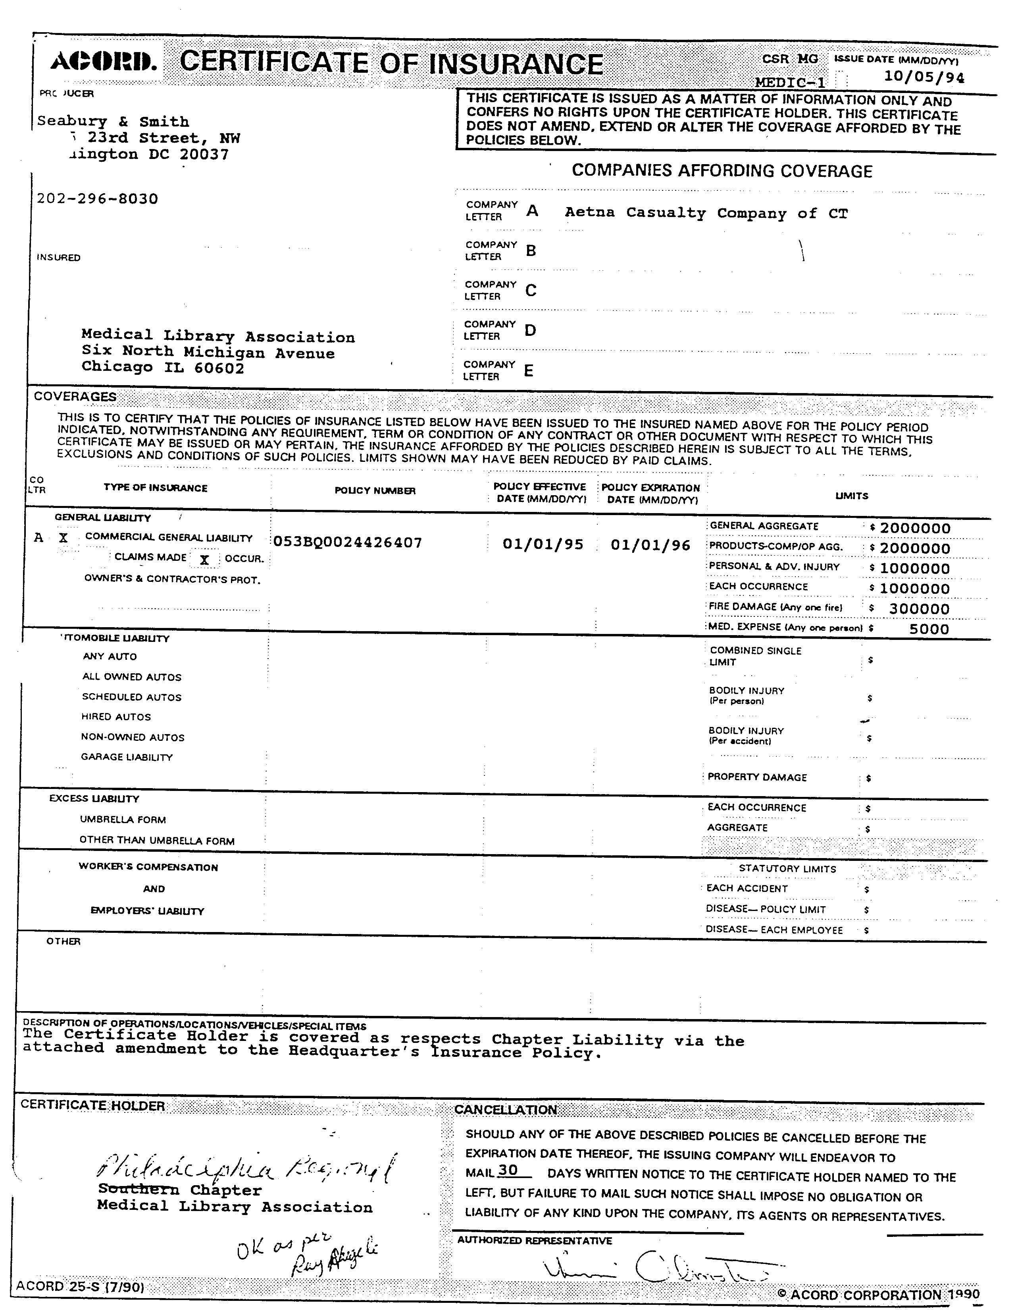
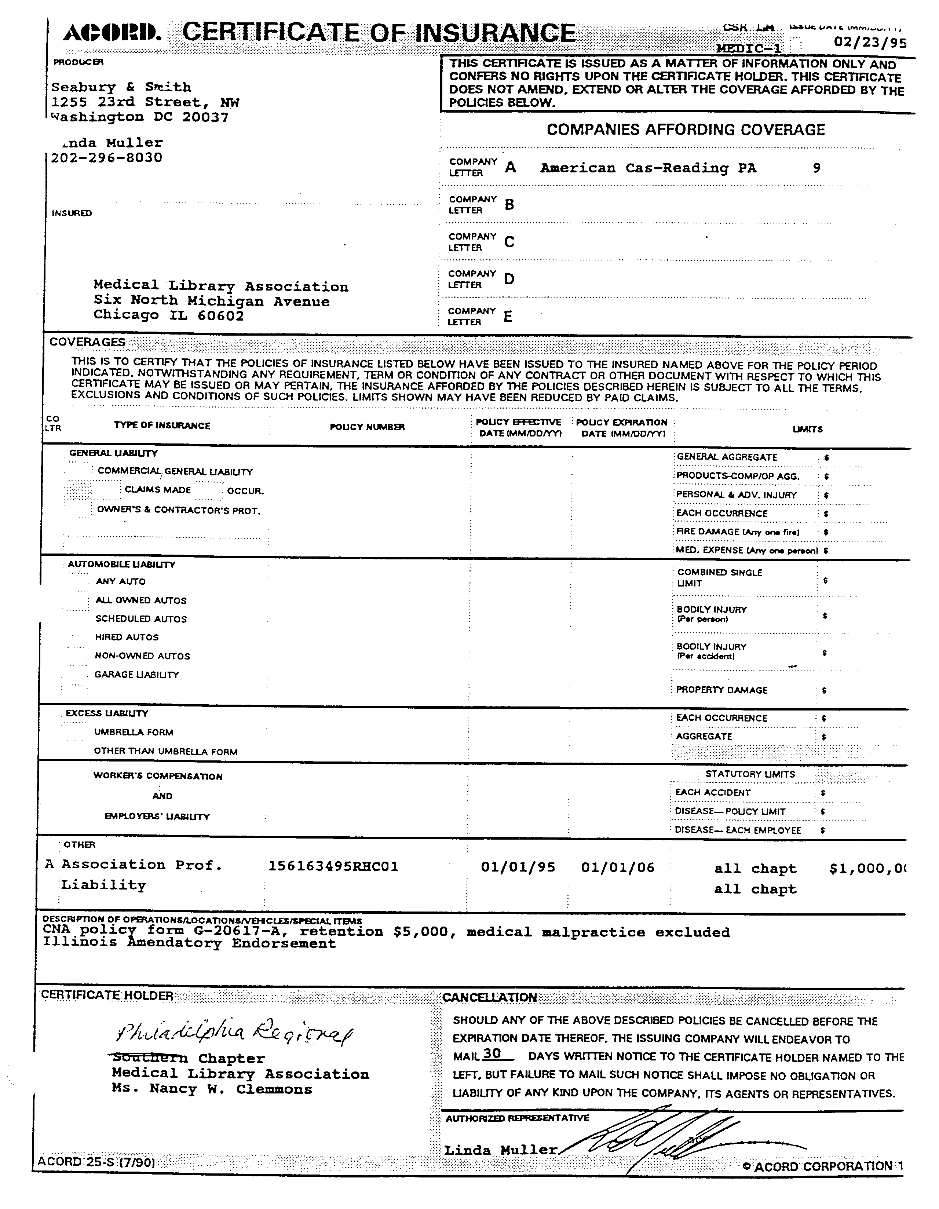

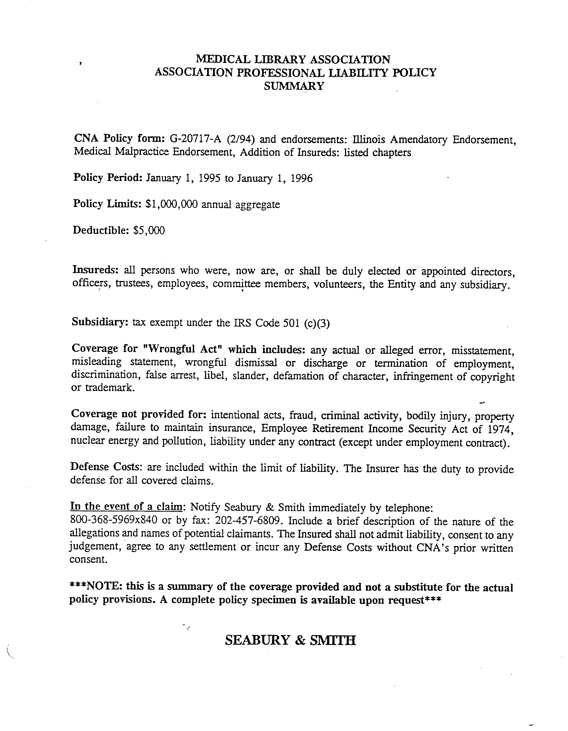

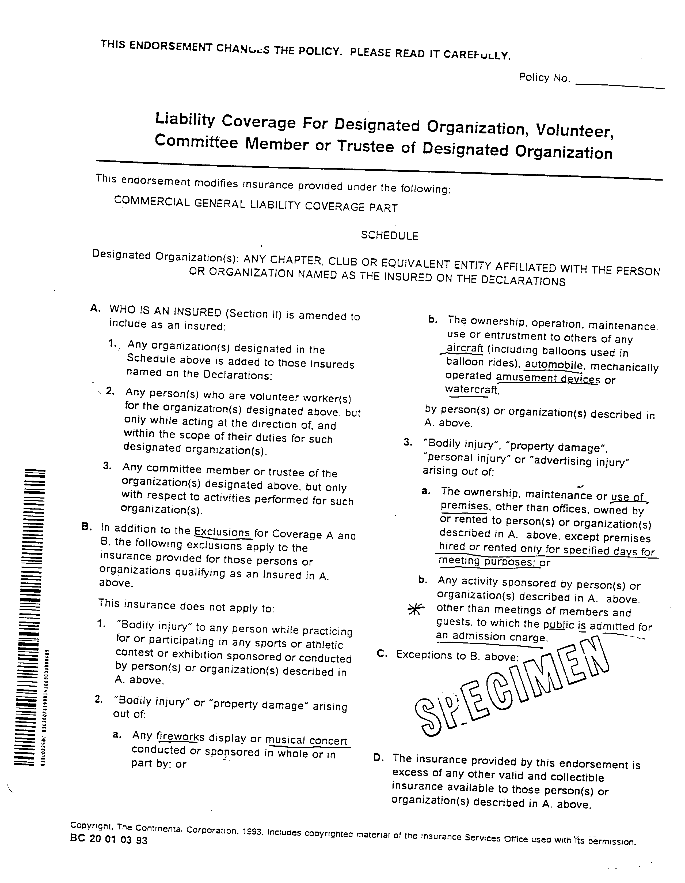

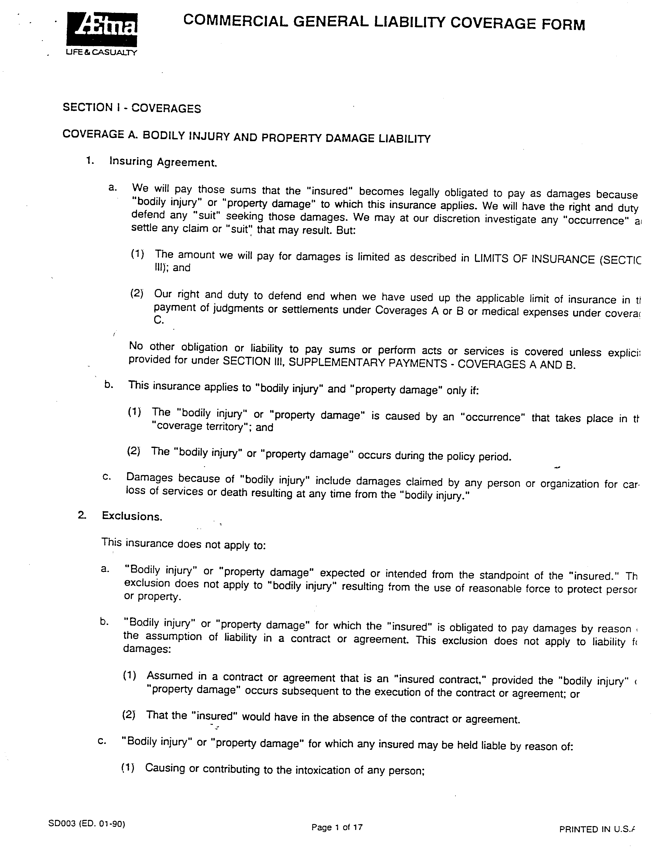

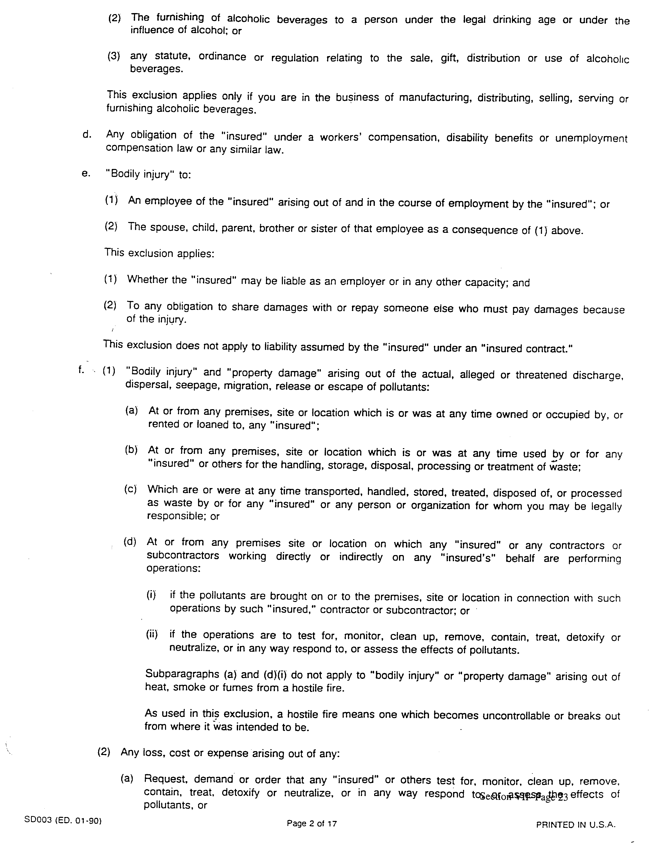

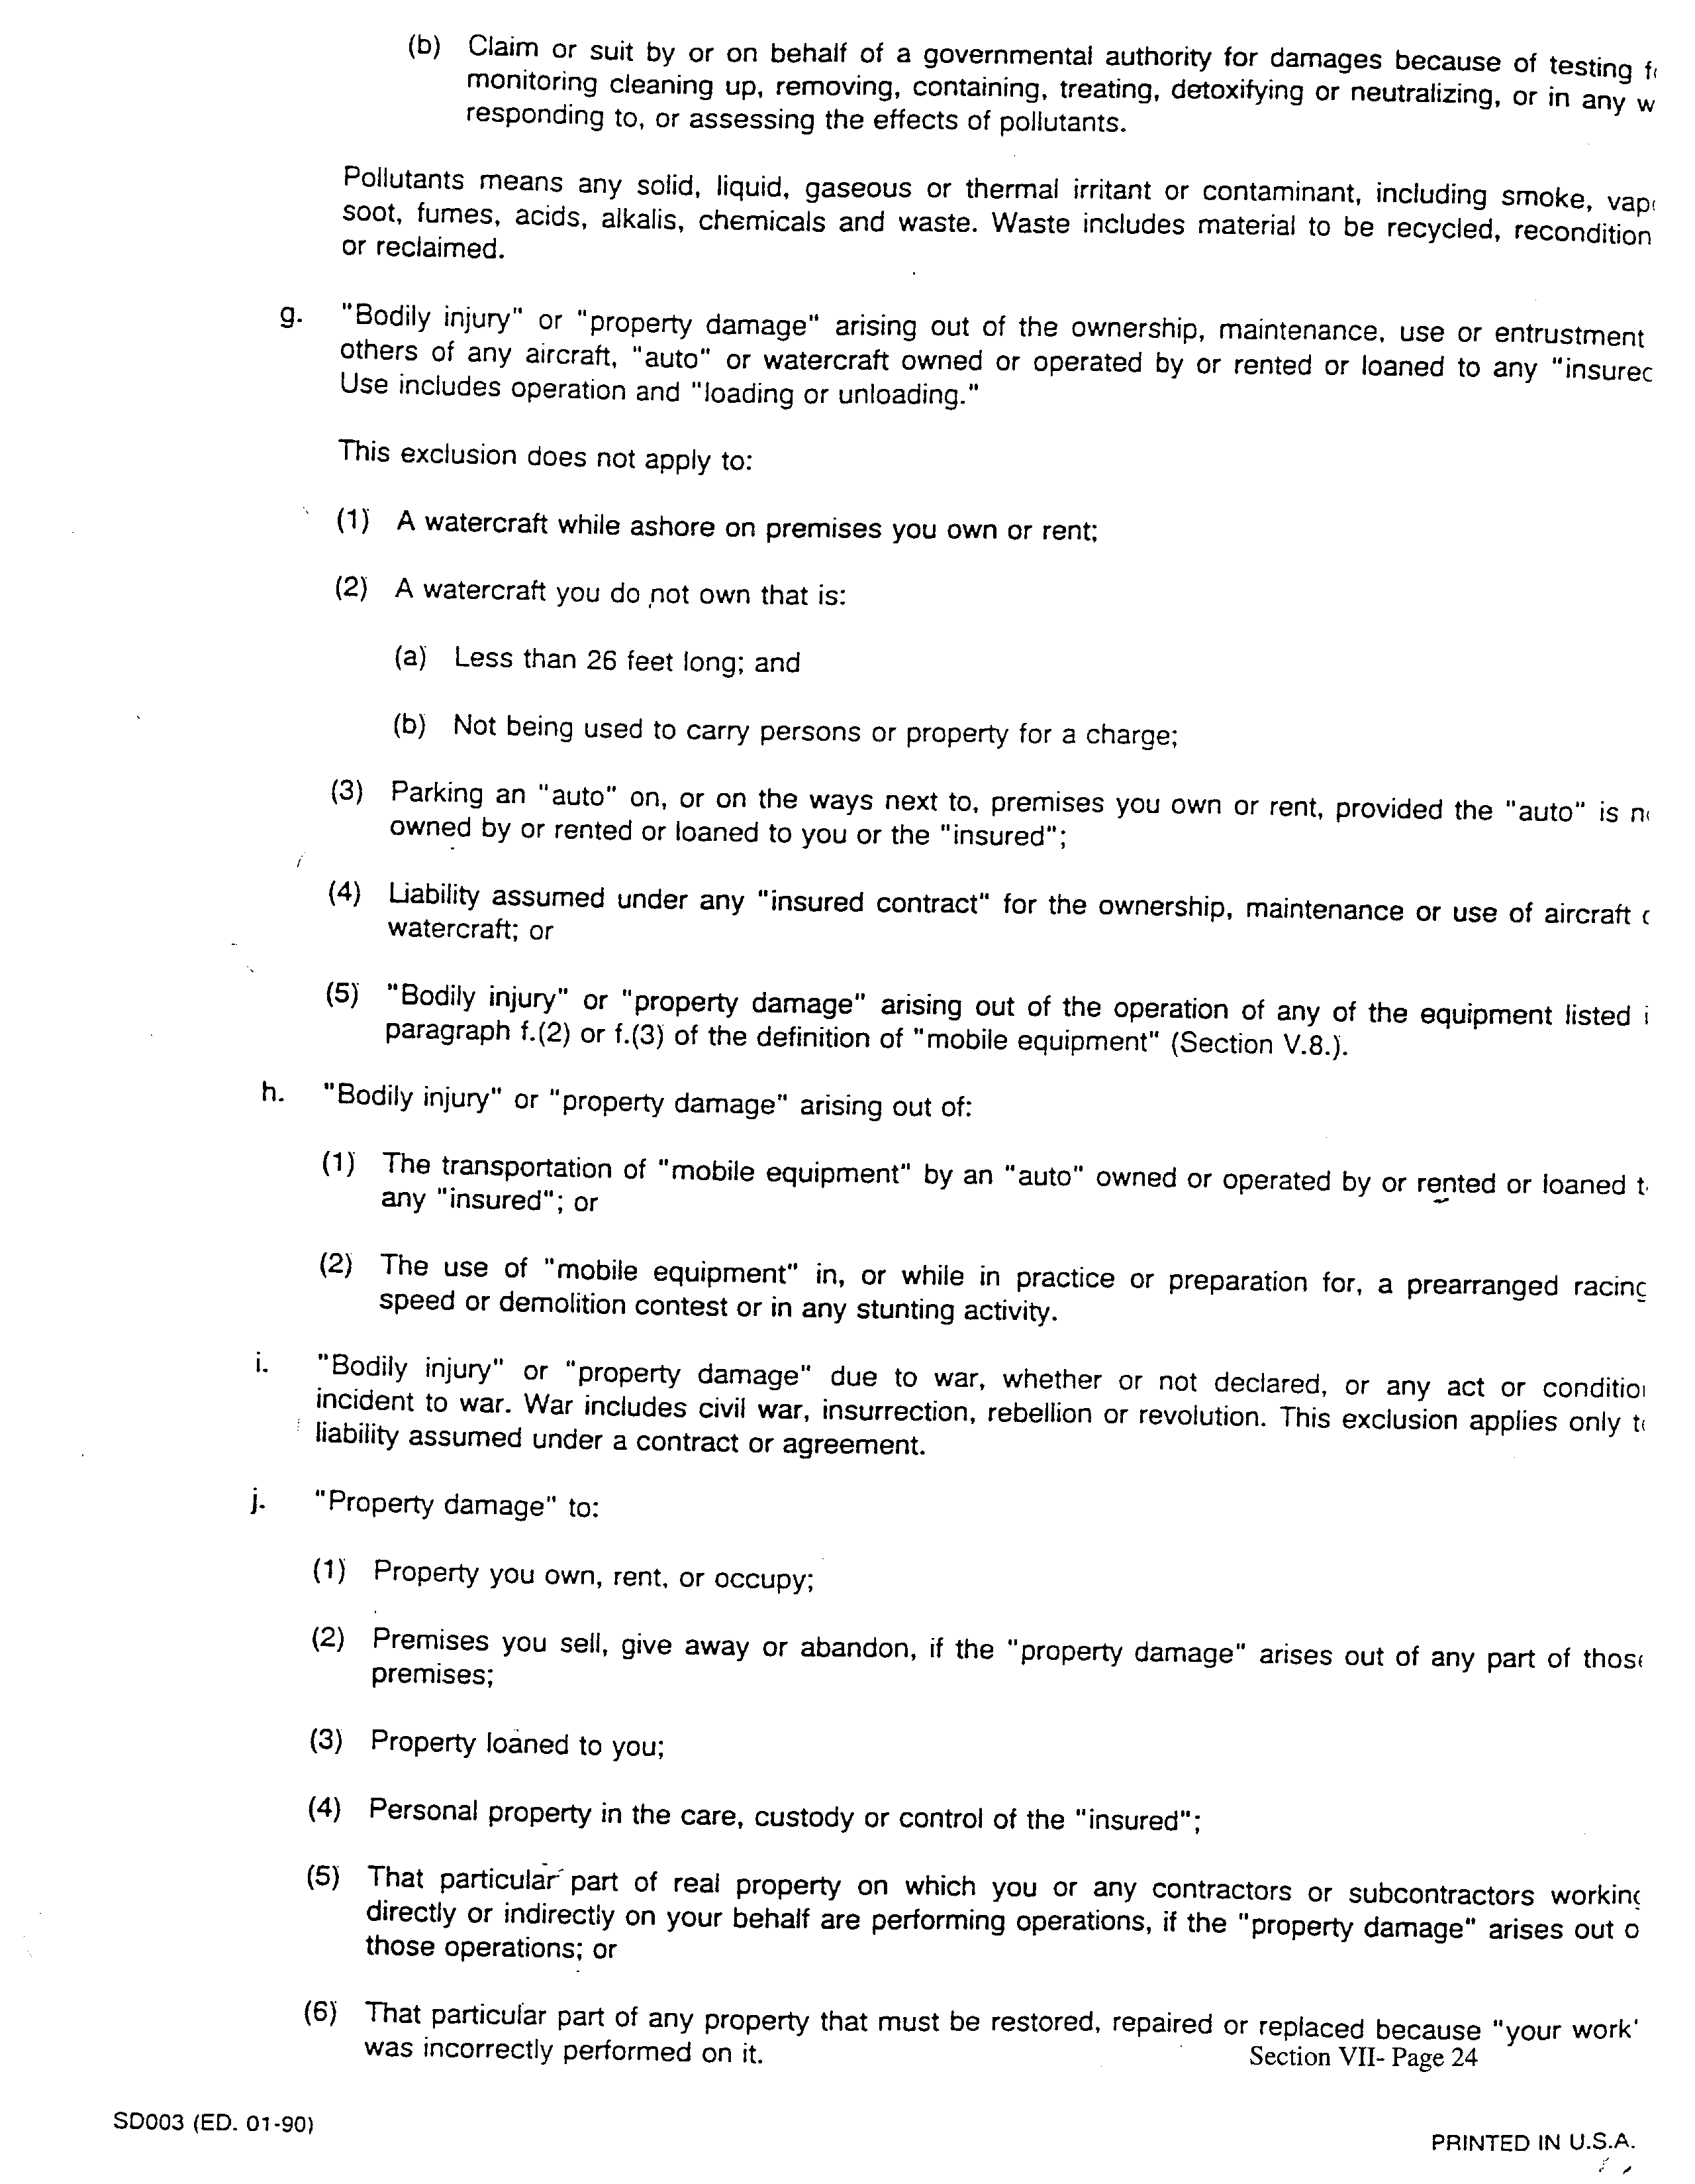

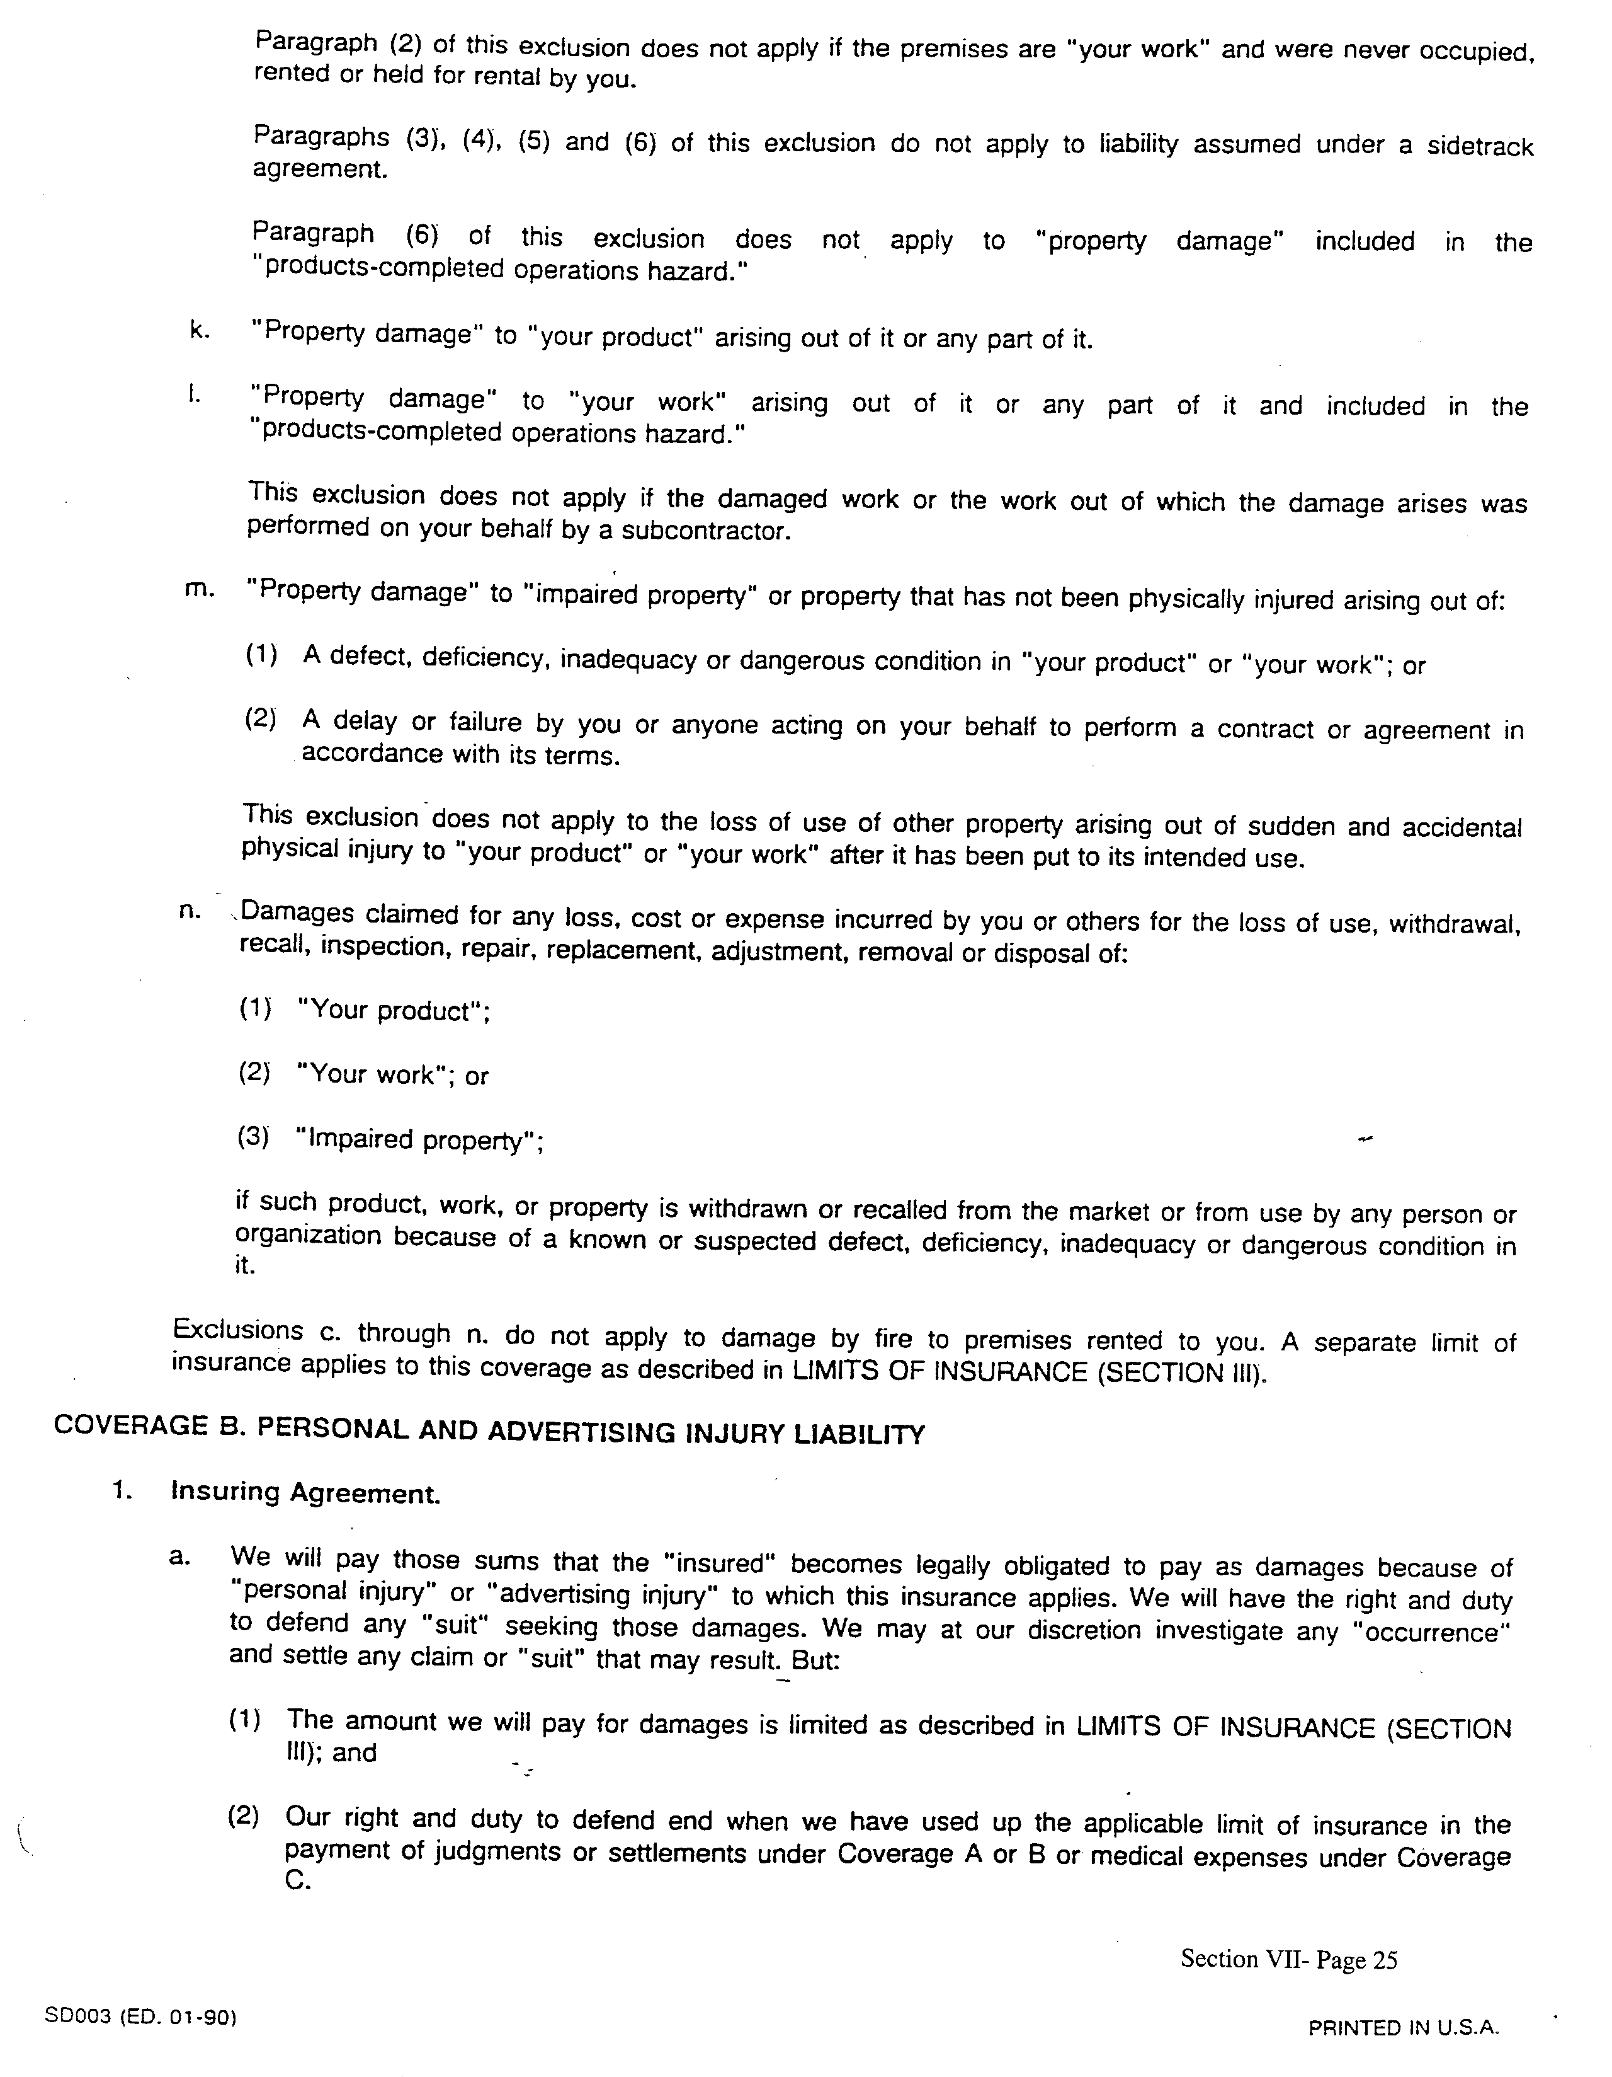

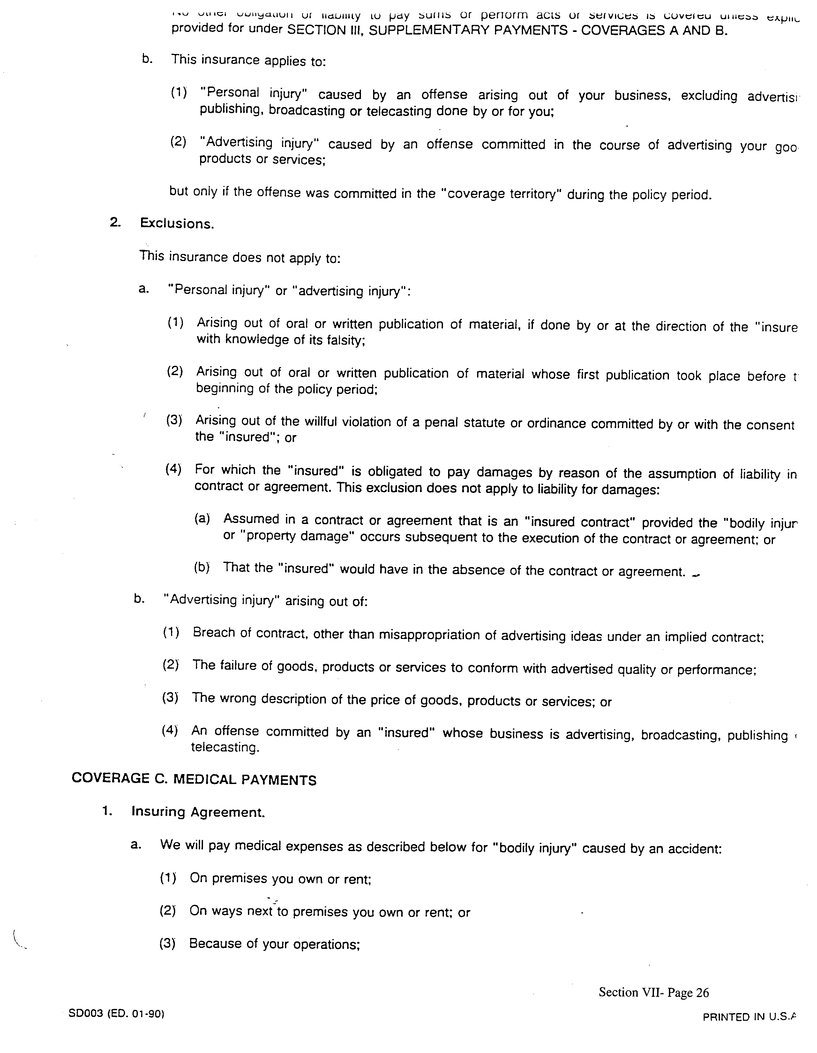

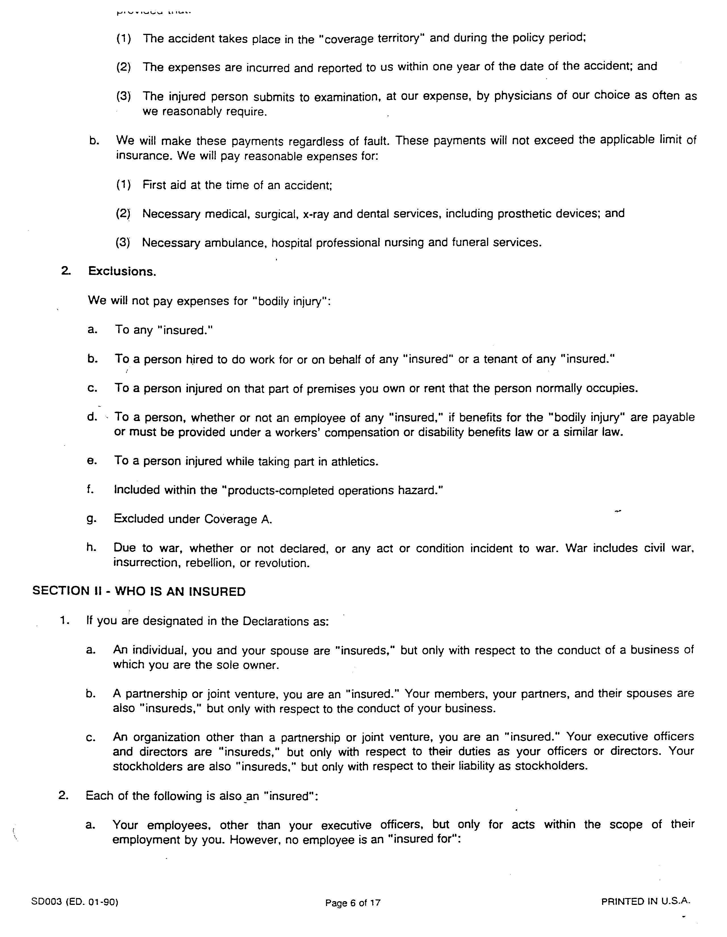

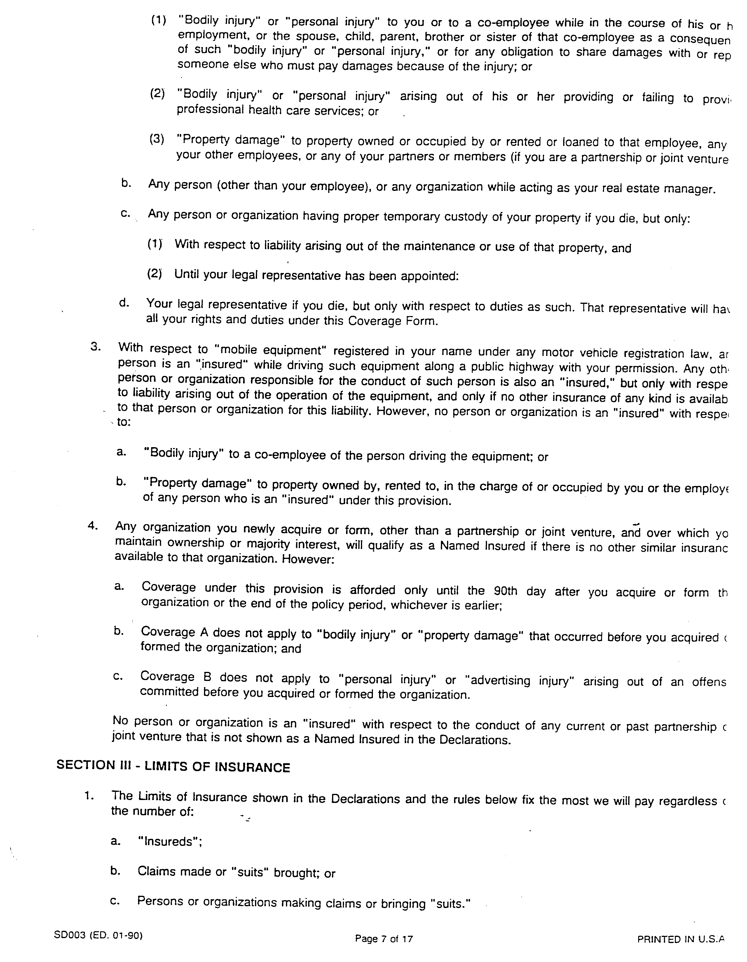

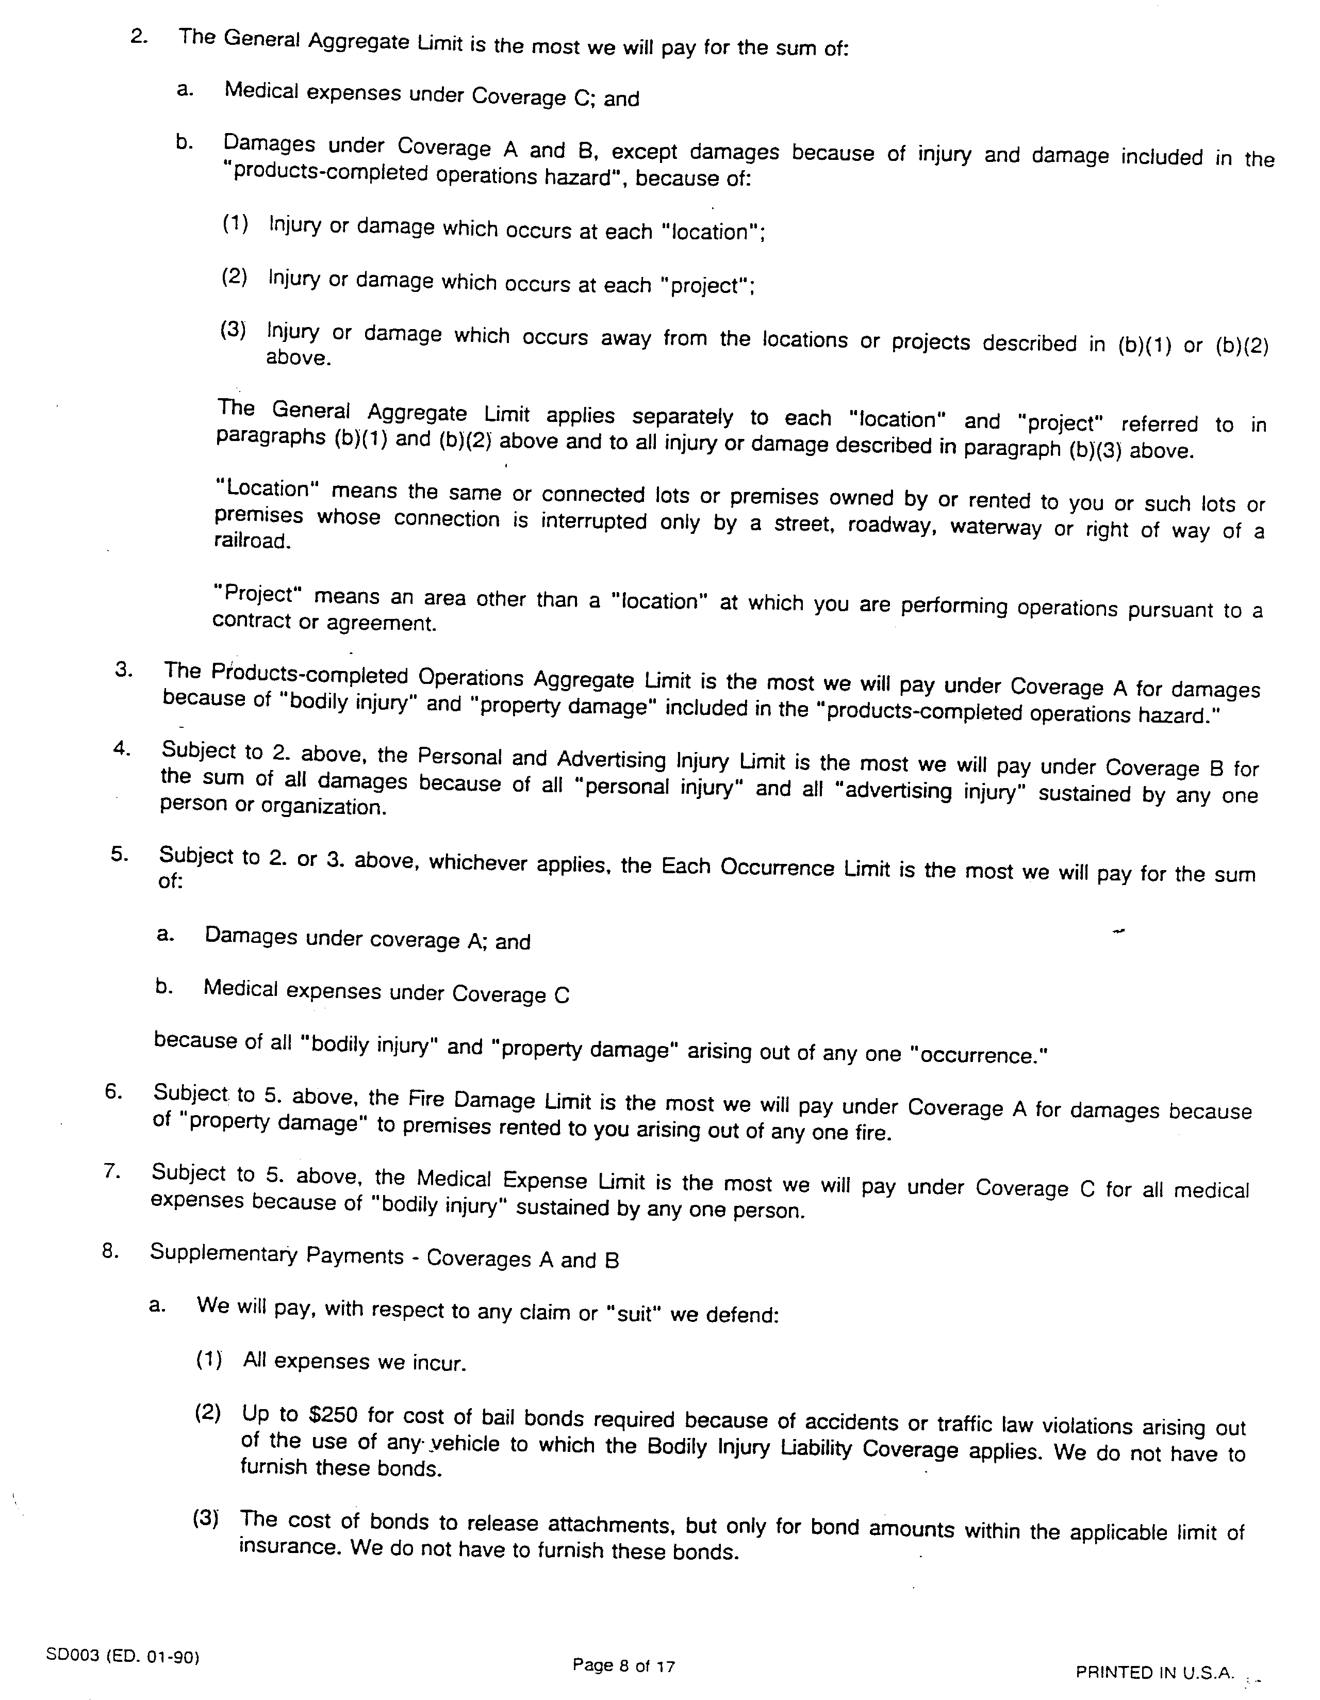

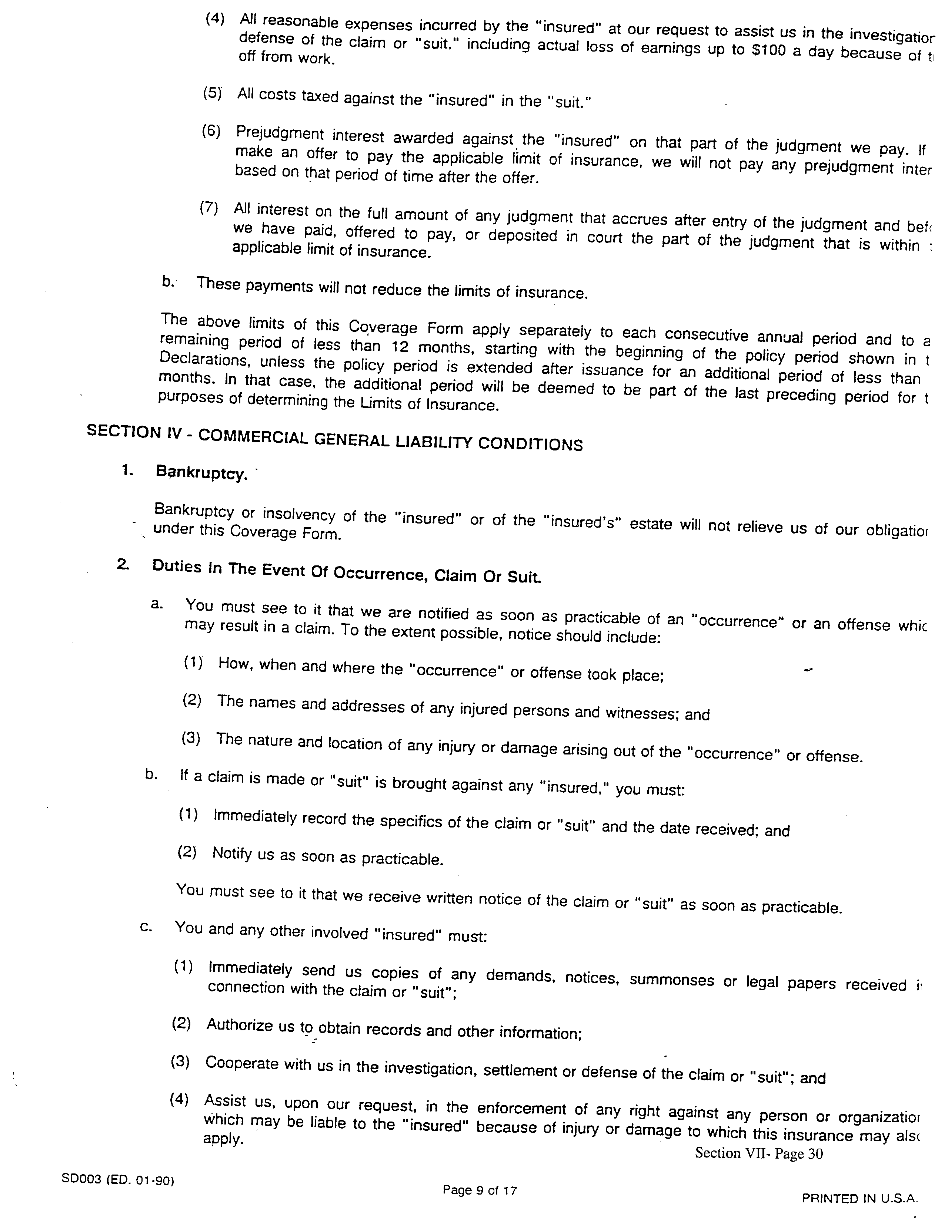

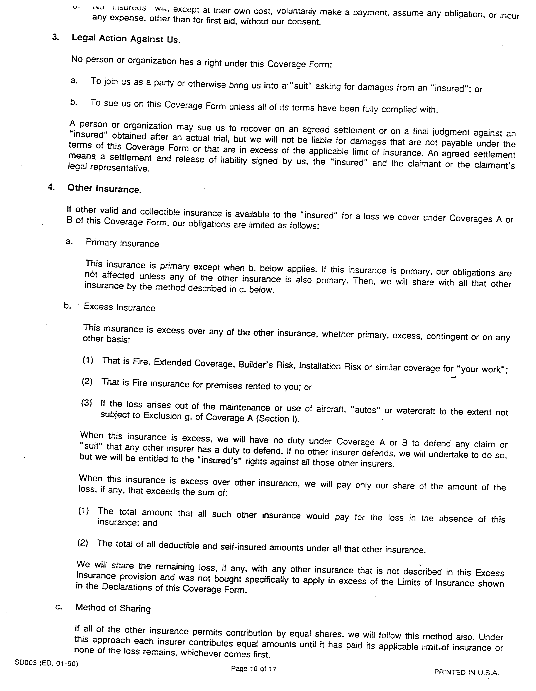

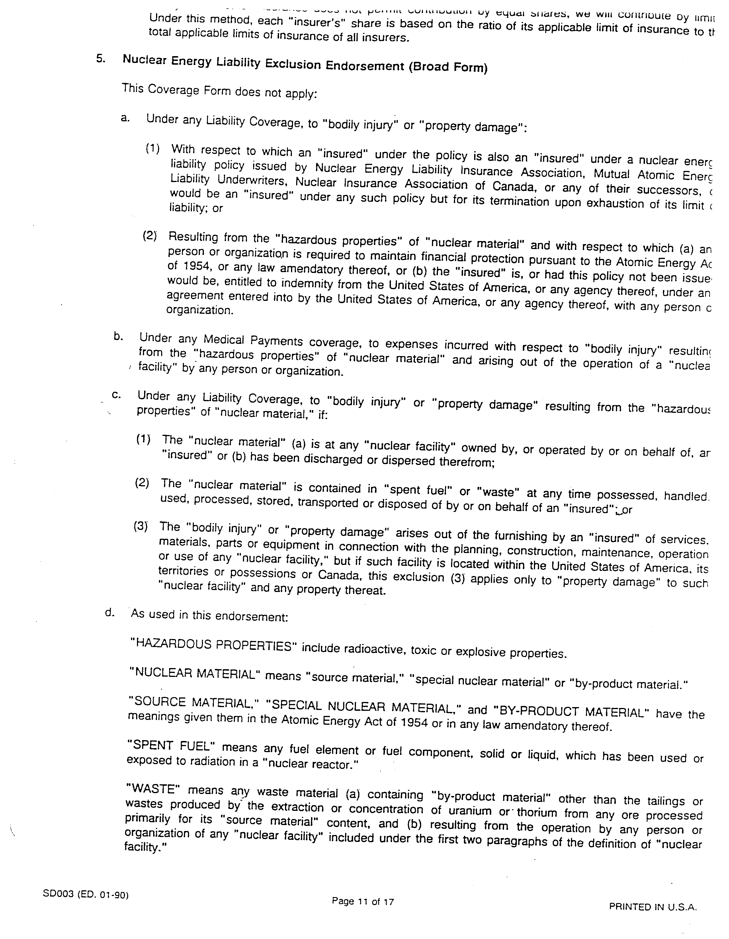

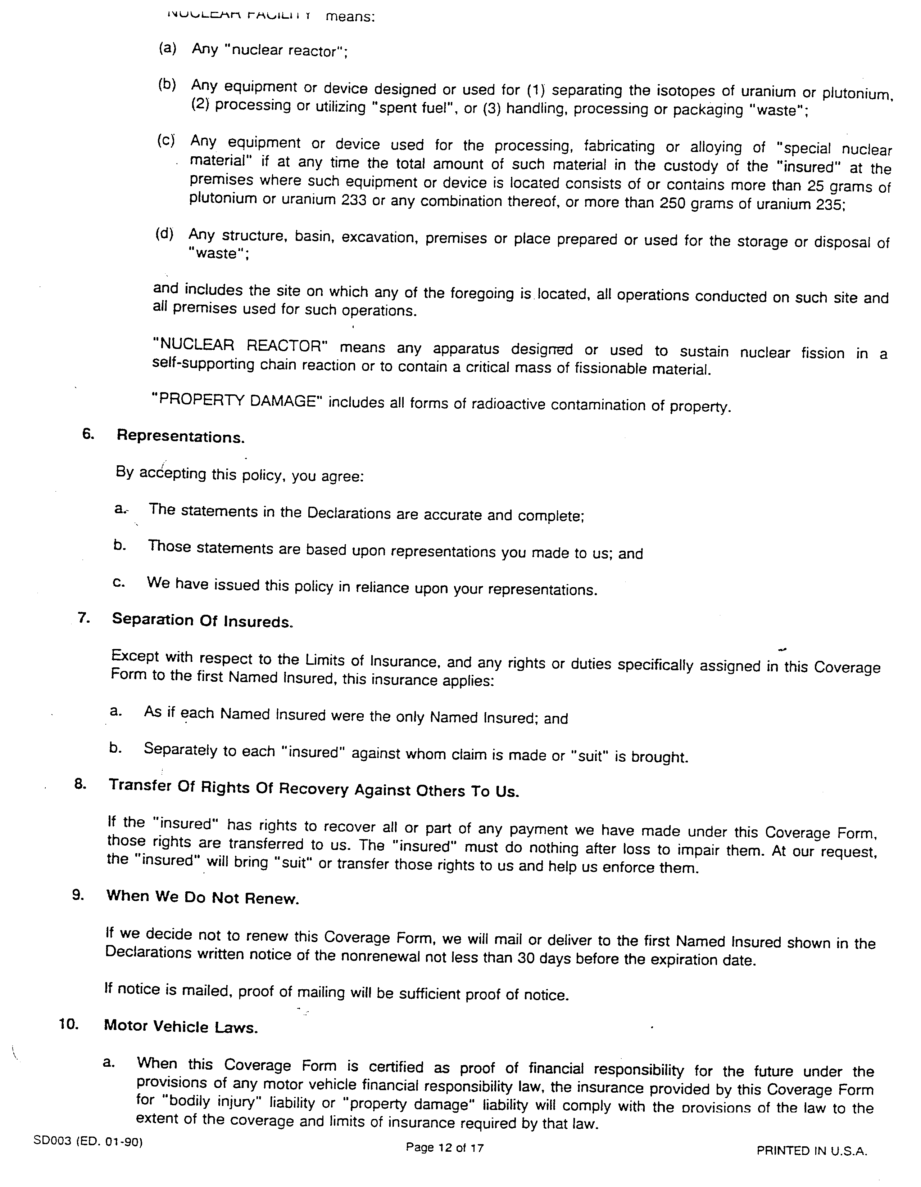

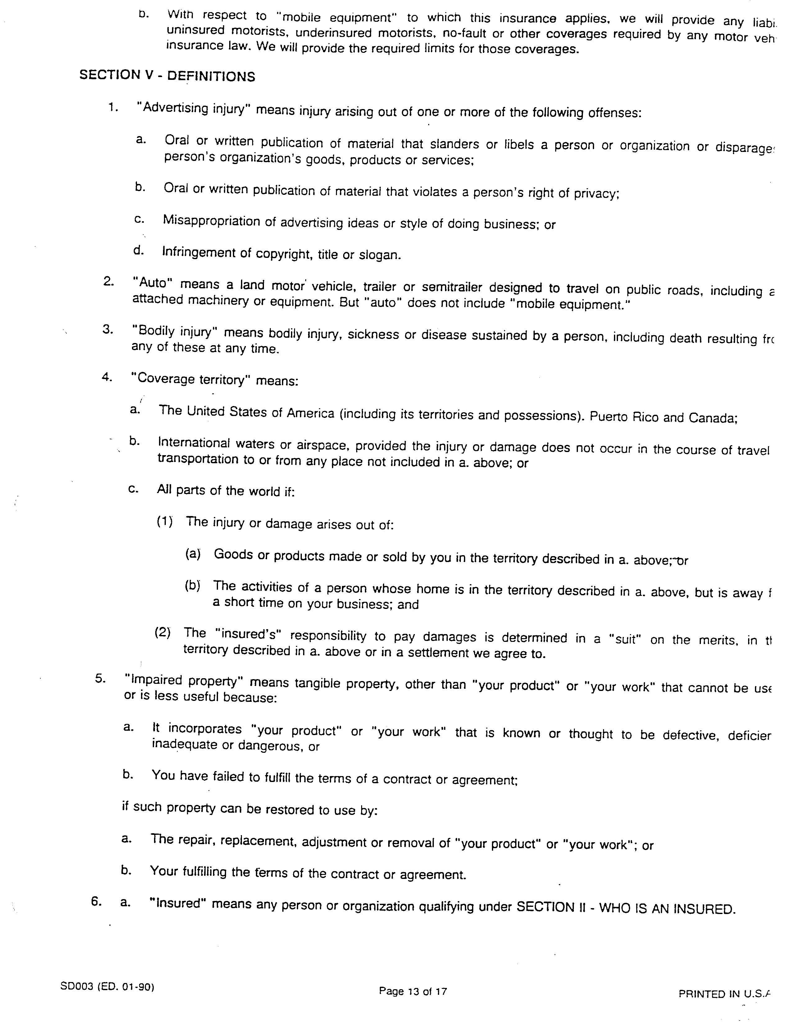

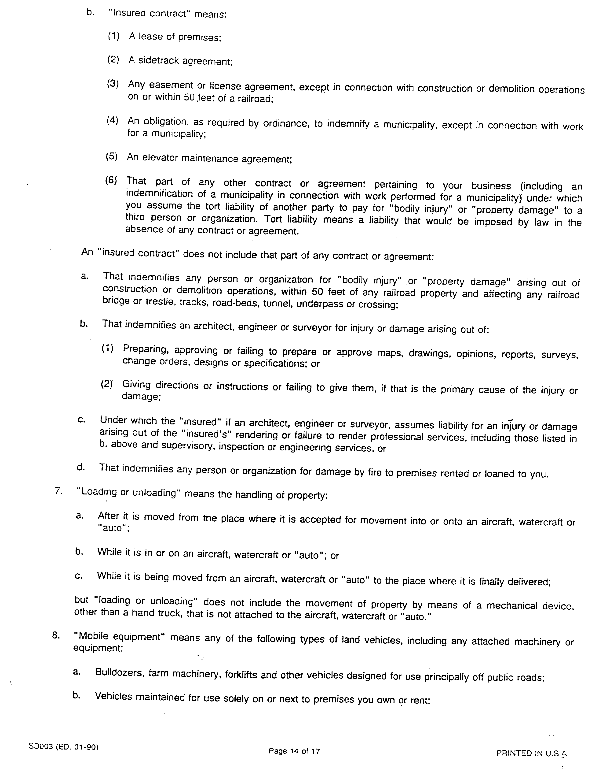

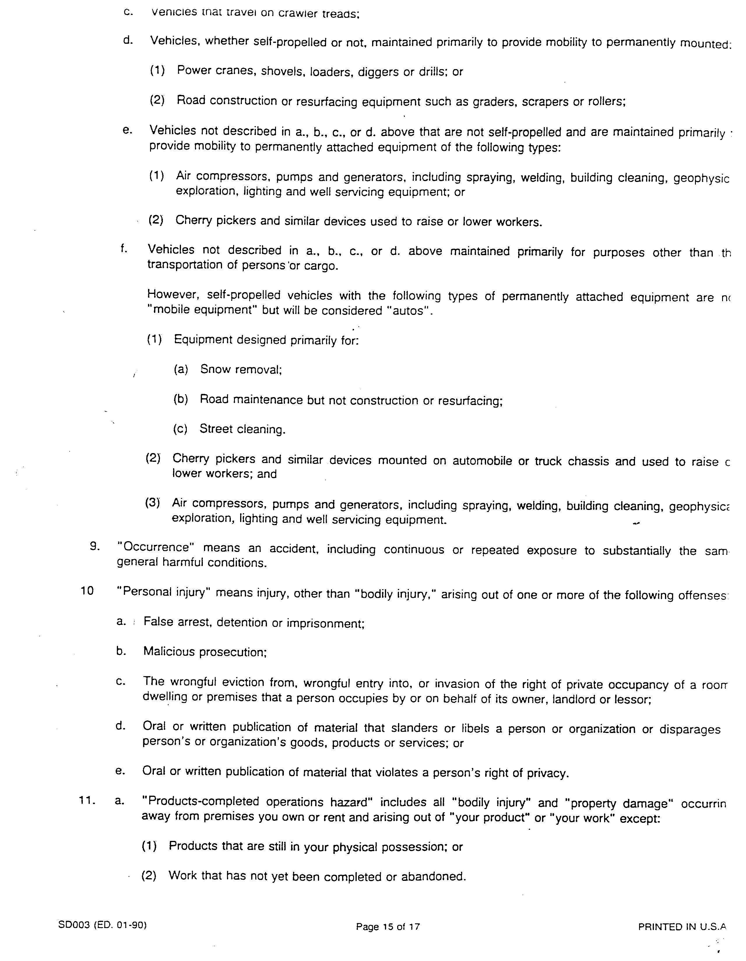

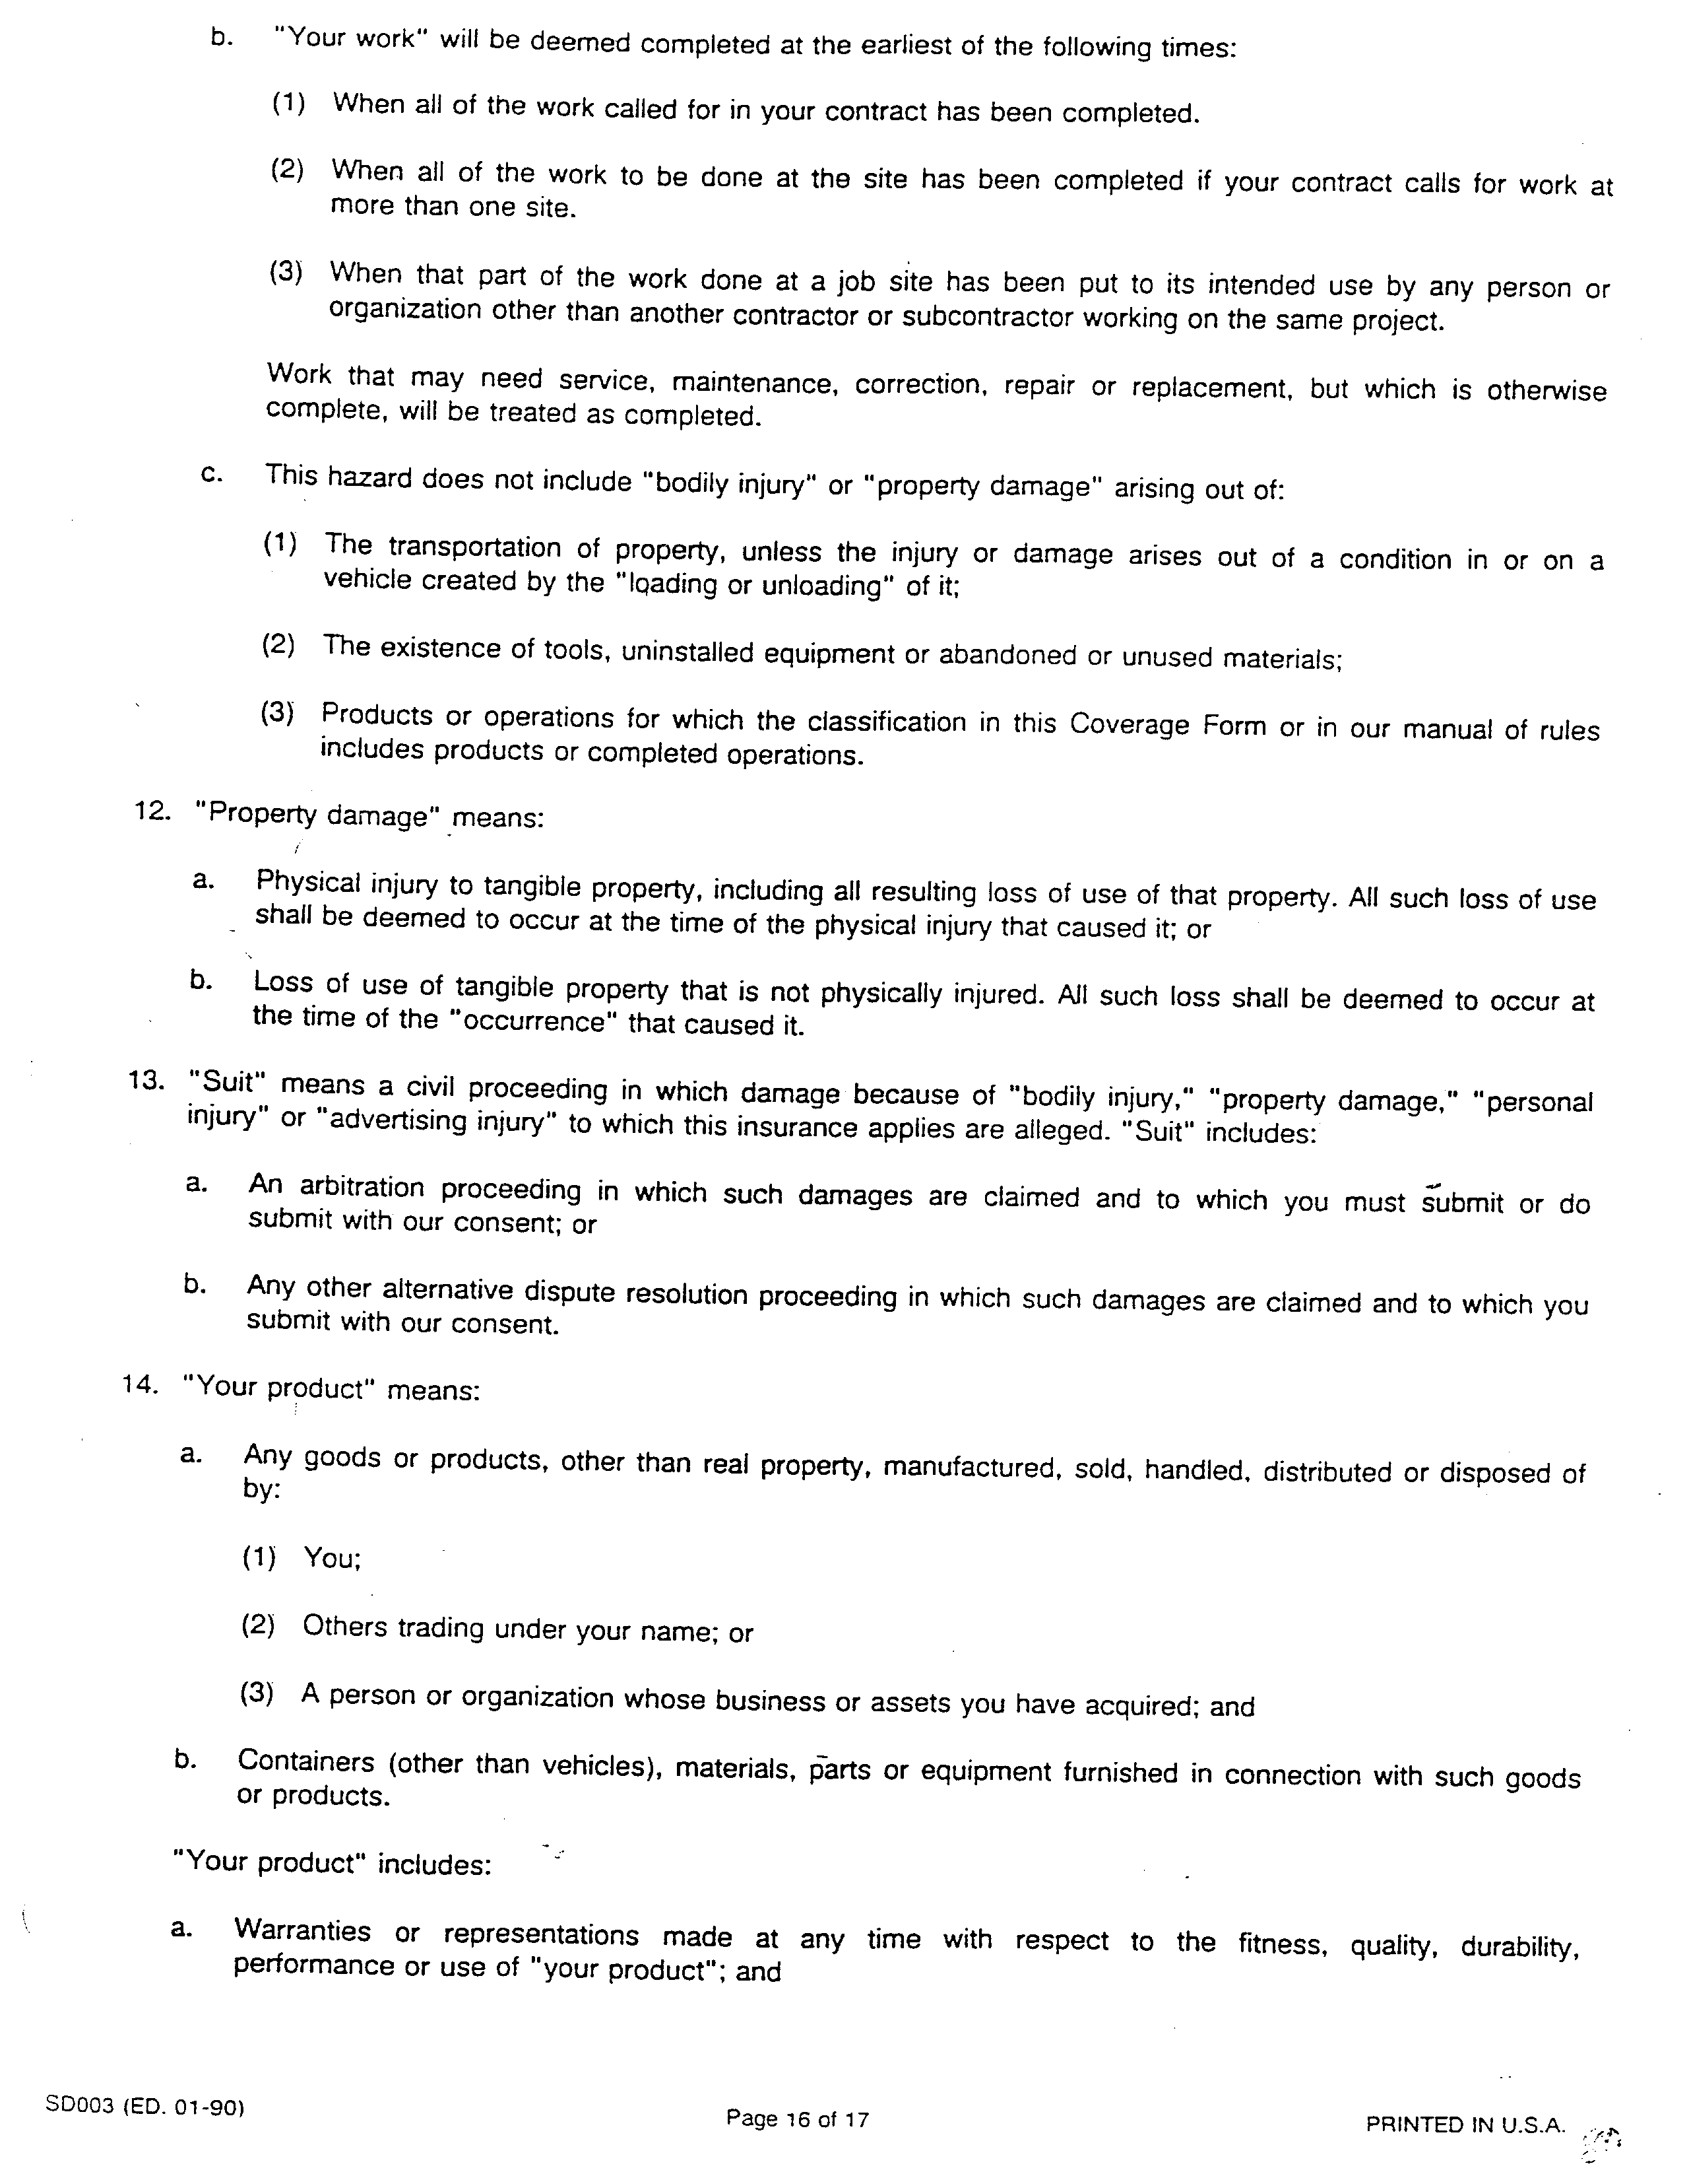

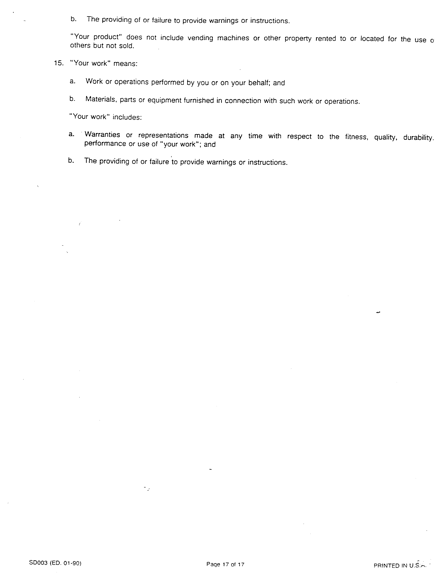

CHAPTER COUNCIL

Chapter Council Representative
Function: | The Chapter Council Representative represents the Philadelphia Regional Chapter at the MLA, Inc. Chapter Council and performs such other duties as the Chairperson may assign between meetings of the Council. The Chapter Representative is a voting member of the Board.
Requirements: | The Representative must be a Voting Member of MLA, Inc. and the Philadelphia Regional Chapter/MLA. S/he should be familiar with recent concerns and activities of the Chapter and of MLA, Inc. (usually through a recent term as an Officer or Committee Chairman). Must attend Chapter Council meetings of MLA, Inc. Annual Meeting.
Expenses: | The Chapter will pay the travel expenses of the Chapter Council Representative to the MLA, Inc. Annual Meeting. (Board Minutes 7/9 1)
Selection: | The Representative is elected by mail ballot sent to all Voting Members of MLA, Inc. who are Philadelphia Regional Chapter members.
Term: | Three years.
Duties: | - Attends Chapter Board, Executive Committee and MLA, Inc. Annual Meetings.  - Attends all Chapter Council meetings.  - Serves on at least one Chapter Council Committee.  - Implements Chapter Council decisions.  - Gathers information and on relevant Chapter issues to communicate to the Chapter Council.  - Informs Chapter membership of issues discussed by Chapter Council and solicits comments and suggestions.  - Prepares and submits copy for The Chronicle on Chapter Council issues.  - At each Board meeting, presents oral and written reports on Chapter Council concerns, activities, or other issues of importance to the Chapter.  - Works with the Chapter Nominating Committee to assure the election of a new Chapter Council Representative and Alternate.  - Assures the selection of a MLA, Inc. Nominating Committee nominee. Submits name and completed biographical form to the MLA, Inc. Chapter Council Elections Committee thirty days prior to the MLA, Inc. Annual Meeting.  - Keeps the Alternate and other Chapter officers apprised of Chapter Council issues.  - Seeks high visibility in the Chapter.  - Submits Mid—Winter and Annual Reports on activities as Chapter Representative to MLA, Inc. Council Chair by designated deadlines.  - Copies official correspondence and reports to the Archives.

Chapter Council Alternate
Functions: | The Chapter Council Alternate represents the Philadelphia Regional Chapter at the MLA, Inc. Chapter Council in the absence of the Chapter Council Representative, and performs such other duties as the Chairperson may assign between meetings of the Council.
Requirement: | The Alternate must be a Voting Member of MLA, Inc. and the Philadelphia. Regional Chapter/MLA. S/be should be familiar with recent concerns and activities of the Chapter and of MLA, Inc.
Expenses: | The Chapter will pay the travel expenses of the Chapter Council Alternate to the MLA, Inc. Annual Meeting. (Board Minutes 7/91)
Selection: | The Alternate is elected by mail ballot sent to all Voting Members of MLA, Inc. who are Philadelphia Regional Chapter/MLA members.
Term: | Three years.
Duties: | - Attends Board and Executive Committee meetings as a voting member.  - Serves as a non-voting member of the Chapter Council, except when the Philadelphia Regional Chapter Council Representative is not present at a Council meeting, the Alternate shall temporarily assume the office of Representative, including the right to vote. Participates in informal votes as requested by the Chapter Council Chair to get a “sense of the group” on issues presented to Chapter Council.  - Replaces the Chapter Council Representative should he/she be elected Chapter Council Chair or become unable to complete the term of office. A new Alternate from the Philadelphia Regional Chapter shall be elected by the Chapter when this occurs, and shall serve the remaining term of the Alternate who is being replaced.  - Serves on at least one Chapter Council Committee and/or subcommittees. (Board Minutes 9/95)  - Works with the Chapter Council Representative to gather information for the Chapter Table at MLA, Inc. Annual Meeting. (Board Minutes 1/90)  - Copies official correspondence and reports to the Archives.

PARLIAMENTARIAN

Functions: | The Parliamentarian serves as the authority on proper usage of parliamentary procedure in the conduct of Chapter, Board and Executive Committee meetings.
Requirements: | The Parliamentarian must be a Voting Member of MLA, Inc. and the Philadelphia Regional Chapter/MLA. The Parliamentarian must have knowledge of the Chapter Bylaws, the Policy and Procedure Manual and correct parliamentary procedure.
Selection: | The Parliamentarian is appointed by the Chairperson.
Term: | One year.
Duties: | - Interprets the rules and practices which govern the proceedings of Chapter, Board and Executive Committee meetings.  - Serves as an ex-officio voting member of the Bylaws Committee.  - Attends Board meetings as a non-voting participant, unless also serving as Bylaws Committee Chair.

COMMITTEES

Nominating Committee

Established: | Prior to 1963
Revised: | June 2004
Composition: | - Three members.  - Chair is the Chapter’s Immediate Past Chairperson and serves a one year term; must be Voting Member of MLA, Inc. and the Philadelphia Regional  - Chapter/MLA.  - Members are appointed annually for a one year term by the Immediate Past Chairperson; must be approved by the Board; (Board Minutes 11/87) must be voting members of the Chapter. Members should be familiar with Chapter membership.  - Committee shall be formed no later than 75 days prior to the Annual Meeting.
Charge: | - Submits an article to The Chronicle prior to selection process asking for nominations and encouraging members to nominate themselves.  - Reviews the qualifications of possible candidates, selects and nominates them for Chapter offices of Chairperson-Elect, Secretary, Treasurer, Chapter Council Representative and Alternate. At least one candidate for each position will be nominated. If there is only one candidate, a write-in option should appear on the ballot.  - Informs potential candidates of the duties of the position, length of term, membership requirements, and meeting schedules.  - Communicates to the membership information about candidates nominated for Chapter offices. Prepares, mails, and tallies election ballots; announces results at Annual Meeting.  - Identifies areas for change in election procedures.  - Copies official correspondence, publications and reports to the Archives.

Election Procedures
Allow at least one to two months to put a slate of candidates together. At lease one candidate for each position will be nominated. If there is only one candidate, a write-in option should appear on the ballot.

Contact Program Chair in January, early February to obtain the date of the Annual Meeting.

Mail election ballots to the Chapter membership at least thirty days prior to the Chapter’s Annual Meeting. (Chapter Bylaws, Article V.11., Section 3)

Review job description, term of office and any additional requirements of the position with all potential candidates.

Send all candidates Biographical Information Form to obtain information to be included with the election ballot.

Prepare election ballot and information on candidate’s qualifications and experience.
Copy ballots on 8 1/2 x 11 colored paper in order to deter duplication. Faxed ballots are not counted.

Mail minutes of the previous year’s Annual Meeting with election ballots.

Notify Chapter Membership on the election ballot that ballots are to be returned by mail ten days prior to the Annual Meeting. (Chapter Bylaws, Article VU., Section 3)

Obtain mailing labels of the current Chapter membership from the Chair of the Membership Committee.

Nominating Chair calls meeting of Committee to count the ballots. The candidate who has the majority of votes for each office shall be declared elected. In case of a tie, selection among the candidates is by lot. The Executive Committee is notified of the results. The Candidates are contacted by phone as soon as possible. A follow-up letter is sent to all candidates thanking them for their interest in the Chapter and their willingness to run for office. If possible the Chapter Chairperson should seek a role at the Board level for those who were not elected.

Results are announced in the next issue of The Chronicle at the Chapter’s Annual Meeting; and on the Chapter LISTSERV, MLA-PHIL@hslc.org.

Chapter Council Election

In a year when the Chapter is also electing a Chapter Council Representative and Alternate, a separate mail ballot, including background information on each candidate, is sent to all Chapter members who are also Voting Members of MLA, Inc. (Electronic vote 4/96) At least one candidate for each position will be nominated. If there is only one candidate, a write-in option should appear on the ballot.

Date: Thu, 01 May 2003 16:02:14 -0400
To: hardy@drexel.edu
From: "Eric P. Delozier" <epd103@psu.edu>
Subject: MLA-PHIL Chairperson-elect
Cc: Pat Heller <heller@pobox.upenn.edu>, Betty Warner <Betty.Warner@MAIL.TJU.EDU>
X-Attachments: C:\Scratch\MLA-PHIL\ChairpersonRespon.pdf;

Dear Lenore,

Thank you for agreeing to be a candidate for a special election to fill the position of Chairperson-elect of MLA-PHIL. The election will be held immediately after the MLA Annual Meeting in May. It will be my responsibility as Nominating Committee Chair to coordinate the special election.

As you probably know, this position is a three-year commitment. Attached, as a Adobe PDF file, are descriptions for the three positions of Chairperson-Elect/Program Committee Chair, Chairperson, and Nominating Committee Chair.

When the ballots are sent to the membership, we will include your biographical information. According to our Chapter Policy Procedure Manual, I am required to collection the following information from you:

* Name (as you wish it to appear on the election ballot)
* Office for which you are a candidate
* Current Position (title, start date, place of employment)
* Previous two positions (titles, dates held, place of employment)
* Professional memberships during the past five years (include dates of membership)
* Offices held during the past five years (include dates and names of organizations)
* Publications or major presentations during the past five years
* Other achievements during the past five years

I would appreciate if you could send me the above information by May 8, 2003. If you have any questions, please don't hesitate to call or send me an e-mail.

Best regards,

--Eric Delozier
--------------------------------------------
Eric P. Delozier, Electronic Services Librarian
Library / Penn State Harrisburg
351 Olmsted Drive / Middletown, PA 17057
mailto:epd103@psu.edu / 717-948-6373 (voice) / 717-948-6381 (fax)

MLA
Philadelphia Regional Chapter / Medical Library Association

March 26, 2004

To: MLA-PHIL Members

From: MLA-PHIL Nominating Committee (Eric Delozier, Chair; Pat Heller; Elizabeth Warner)

Re: Annual Elections

In accordance with our Chapter Bylaws, the Nominating Committee shall present annually at least one nominee for each office to be filled. Two elected officers, Chairperson-elect/Program Committee Chair and Treasurer, are needed for 2004-2005.

Enclosed are the minutes from 2003 Annual Business Meeting, election ballot, and biographical information for the candidates who have graciously agreed to run for Chairperson-elect/Program Committee Chair and Treasurer. Please take a moment of your time and cast your vote accordingly. Should you decide to vote for a write-in nominee, please be sure the individual belongs to both MLA and the Philadelphia Regional Chapter. Completed ballots must be postmarked no later than April 16, 2004 and mailed to:

Betty Warner
MLA-Philadelphia Nominating Committee
421 East Melrose Avenue
Westmont, NJ 08108-2510
Philadelphia Regional Chapter, Medical Library Association
Election Ballot

Chairperson-Elect/Program Committee Chair, 2004-2005
Daniel G. Kipnis
You may use the space above for a write-in candidate.

Treasurer, 2004-2006
Stephanie Ferretti
You may use the space above for a write-in candidate.

Please mark ballot clearly and mail (postmarked no later than April 16, 2004) to:

Betty Warner
MLA-Philadelphia Nominating Committee
421 East Melrose Avenue
Westmont, NJ 08108-2510

Philadelphia Regional Chapter, Medical Library Association
Candidate Biographical Information

Chairperson-Elect/Program Committee Chair, 2004-2005

Daniel Kipnis, M.S.:
Candidate for Chairperson-Elect/Program Committee Chair

Current Position:
Education Services Librarian, Scott Memorial Library, Thomas Jefferson University, 2001-

Previous Positions:
Reference Assistant, Taubman Medical Library, University of Michigan, 1999-2000
Assistant Research Librarian, Avalon Investments, 1999

Professional Memberships:
Medical Library Association (MLA), 2001-
Philadelphia Regional Chapter, MLA (MLA-PHIL), 2001-

Record of Professional Participation:
MLA-PHIL Education and Credentialing Committee, Chair, 2002-2004
MLA-PHIL Program Committee, Member, 2002-2003
Quint Essential Conference Continuing Education Committee, Member, 2003.

Publications and Presentations:
Kipnis, D. and A. Frisby. “Teaching Medical Informatics Online.” Academic Exchange Quarterly. Vol. 7. No. 1, Spring 2003, pp.11-16.
Kipnis, D. “Bibliographic Instruction: The Need to Edutain” LOEX News, Vol. 29, No. 1, Spring 2002, pp. 9-10.
Kipnis, D. “E-Learning Tools: The Online Perspective” (Presentation). Computers in Libraries Conference, March 15, 2002, Washington DC
Philadelphia Regional Chapter, Medical Library Association
Candidate Biographical Information

Treasurer, 2004-2006
Stephanie Ferretti, MLS:
Candidate for Treasurer

Current Position:
Associate Director of the Library and Educational Information Systems, O.J. Snyder Memorial Library, Philadelphia College of Osteopathic Medicine, 2002-

Previous Positions:
Associate Director, Health Sciences Center Library, Temple University, 1997-2002
Serials Librarian and Assistant Systems Manager, Lourdes Library, Gwynedd Mercy College, 1993-1997

Professional Memberships:
Medical Library Association (MLA), 1997-
Philadelphia Regional Chapter, MLA (MLA-PHIL), 1997-

Record of Professional Participation:
MLA, Technical Services Committee, Member, 1997-2002
MLA, Public Services Committee, Member, 2002-
MLA-PHIL, Treasurer, 2003-2004
Health Sciences OCLC Users Group, 1997-

Philadelphia Regional Chapter of MLA
Annual Business Meeting
The Radnor Hotel
St. Davids, PA
Tuesday April 29, 2003

Call to Order:
Chapter Chair Eric Delozier called the Annual Business Meeting of the Philadelphia Regional Chapter of MLA to order at 7:18 PM.

Minutes:
The minutes of the Annual Business Meeting of April 16, 2002 were approved as distributed.

Chapter Chair’s Report:
Eric Delozier reported that the chapter had sponsored three continuing education workshops during the year: Advanced HTML: Cascading Style Sheets, Making PubMed work for You, and the Mini Medical School for Librarians. The chapter also sponsored three programs during the year, Communicating with Physicians, Safeguarding our Patrons Privacy: What Every Librarian Needs to Know about the USA PATROIT Act, and Get HIP to HIPAA: Health Information Professionals and the Health Insurance Portability and Accountability Act.

Treasurer’s Report:
Linda Katz reported that balance in the treasury is at $18,498.57. This total is an all time high for the chapter.

Nominating Committee:

A. Elections
Pat Heller, Chair of the Nominating Committee, announced the results of the election. The winners were Brad Long for Chair-Elect and Melanie Cedrone for Secretary. It was also announced that Nina Long is unable to assume the position of Chair for the next year due to health reasons. Therefore, Brad Long will become Chair effective May 8, 2003. A special election will be held for a new Chair-Elect.

B. Awards
Jenny Pierce received the Grant for Professional Development. Karen Albert, Kevin Block, and Joan McKenzie each received the Chapter Certificate of Appreciation. Linda Katz received the Chapter Achievement Award. The establishment of a new award was also announced, the Randy Brenner Consumer Health Award. The outgoing officers were also recognized and thanked for contributions: Karen Albert, Jo-Ann Babish, Eric Delozier, Pat Heller, Brad Long, Nina Long, and Rachel Resnick. One retiring member was recognized, Robert Rooney.

The meeting adjourned at 7:47 PM for the talk by the dinner speaker, Tom Crist. His talk was titled “Skeleton Keys: Opening the Doors to Philadelphia’ Past”.

Prepared by Bradley A. Long, Secretary.

Ad Hoc Awards Subcommittee
Established: | 1996
Revised: | 2004
Composition: | - One to ten members.  - Chairperson is the Immediate Past-Chairperson and serves a one year term; must be a Voting Member of MLA, Inc. and the Philadelphia Regional Chapter/MLA.  - Members are appointed annually by the Immediate Past-Chairperson; must be approved by the Board; must be voting members of the Chapter.  - 4. Committee should be formed at least 6 months before Annual Meeting.
Charge: | - Solicits applications for Beatrice Davis Education Award, Randy Brenner Consumer Health Award, and Grant Program for Professional Development by publishing announcements and articles in The Chronicle, Chapter Web site, and LISTSERV. In addition, for the Beatrice Davis Education Award, solicits applicants by contacting area library schools.  - Beatrice Davis Education and Randy Brenner Consumer Health Awards - applications due February 28.  - Grant Program for Professional Development - application due February 28 and August 28.  - Notifies winners of Beatrice Davis Education Award, Randy Brenner Consumer Health Award, and Grant Program for Professional Development one month after application due date.  - Solicits nominations for Chapter awards by publishing announcements and articles in The Chronicle on the Chapter Web site, and on the Chapter LISTSERV, MLA PHIL.  - Certificate of Appreciation  - Robert Preston Lee Memorial Award  - Chapter Achievement Award.  - Chooses award recipients.  - Presents names of proposed award recipients to Board for approval.  - Notifies award winners one month before Chapter Annual Meeting. Invites all award/grant recipients to attend Annual Meeting as honorees.  - Determines which Chapter members have retired in the past year and invites them to attend Annual Meeting as honorees. Presents them with corsages or potted plants.  - Provides verbal presentations for award recipients and retirees at Annual Meeting. Colleagues may be asked to give the presentations. (Board Minutes 5/96)  - Arranges for framed certificates, gifts, and monetary awards to be presented at Annual Meeting.  - Provides certificates for outgoing Board’ of Directors’ members. May be presented at Annual Meeting. (Board Minutes 7/97)  - Proposes Chapter members for national honors and awards. Submits the name of proposed nominees to the Board for discussion. When the Board approves submission of a nomination to MLA, Inc. for other than a major award (Noyes, Doe, Brodman, Rogers), the Nominating Committee will prepare and forward materials to MLA, Inc. For major awards, an ad hoc committee may be appointed to collect and submit the necessary documentation.  - Copies official correspondence and reports to the Archives.

Awards
Nominations for awards should be sought from the Chapter membership; however, it is usually necessary for the Ad Hoc Awards Committee to generate names. The Chair of the Nominating Committee notifies by telephone each awardee that s/he has been chosen to receive an award from the Chapter. Each awardee is asked to be present at the Annual Meeting to receive his/her award. (Board Minutes 5/92)

All award and grant winners’ dinners are subsidized by the Chapter. (Board Minutes 7/97) Dinner for one guest of the Chapter Achievement Award winner will be subsidized. Each awardee should be asked if s/he would like his/her supervisor to be notified in writing that s/he will be receiving a Chapter award.

The Ad Hoc Awards Sub-Committee or a colleague prepares presentation remarks about each awardee. Awardees are given a copy of the presentation remarks in addition to the certificates or other items specified for the awards they are receiving. Certificates are to be prepared using parchment paper and calligraphy, word processing, or desktop publishing with special fonts. Certificates are placed in a standard size frame and should be signed by the Chapter Chairperson. The experience of previous Immediate Past Chairpersons in preparing certificates and purchasing awards can be quite valuable. The Nominating Chair will submit an announcement of the awards for the issue of The Chronicle following the Annual Meeting. Photographs of the awardees should be taken at the Annual Meeting if at all possible.

Date: Thu, 08 May 2003 16:08:17 -0400
To: Pat Heller <heller@pobox.upenn.edu>, Betty Warner <Betty.Warner@mail.tju.edu>
From: "Eric P. Delozier" <epd103@psu.edu>
Subject: Welcome to the Nominating Committee!
X-Attachments: C:\epd103\MyDocs\MLAPHILSpecialElection1.doc;

Dear Pat and Betty,

Thank you both for agreeing to serve on the Philadelphia Regional Chapter/MLA Nominating Committee and Ad Hoc Awards Subcommittee. Our first task is to find a replacement to fill the position of Chairperson-Elect/Program Committee Chair.

I've drafted and attached a letter, election ballot, and biographical information for lone candidate, Lenore Hardy. Can one of you review the attached information and let me know any necessary additions, corrections, or deletions? I'd appreciate a response as soon as possible.

Just think we get to do this all over again during the early months of 2004!

Thank you so much,

--Eric Delozier, Nominating Committee Chair
--------------------------------------------
Eric P. Delozier, Electronic Services Librarian
Library / Penn State Harrisburg
351 Olmsted Drive / Middletown, PA 17057
mailto:epd103@psu.edu / 717-948-6373 (voice) / 717-948-6381 (fax)

Chapter Achievement Award
Purpose: | The Chapter Achievement award is given to an individual who has made significant contributions to the Chapter and to the field. This is the Chapter’s highest award and should be reserved for outstanding individuals. This is not necessarily an “end of career” award. (Board Minutes 1/87)
Guidelines: | - The award may be presented annually, but it is to be presented only when a qualified candidate exists.  - Candidates must be a member of the Chapter and have made significant contributions to the Chapter.  - The award recipient will receive a framed certificate signed by the Chapter Chairperson, and one of the following: silver/crystal bowl, tray, decanter, expensive desk set, kaleidoscope, or clock. The combined cost is not to exceed $200.00. Cost of the gift should not be less than $100.00. (Board Minutes 1/87; 5/88)  - The Award is announced at the Annual Meeting.  - The awardee is notified of the award in advance of the Annual Meeting.  - The Employer, with permission of the awardee, is notified of the award in advance of the Annual Meeting.  - The Awardee’s dinner at the Annual Meeting is subsidized by the Chapter. (Board Minutes 5/92)

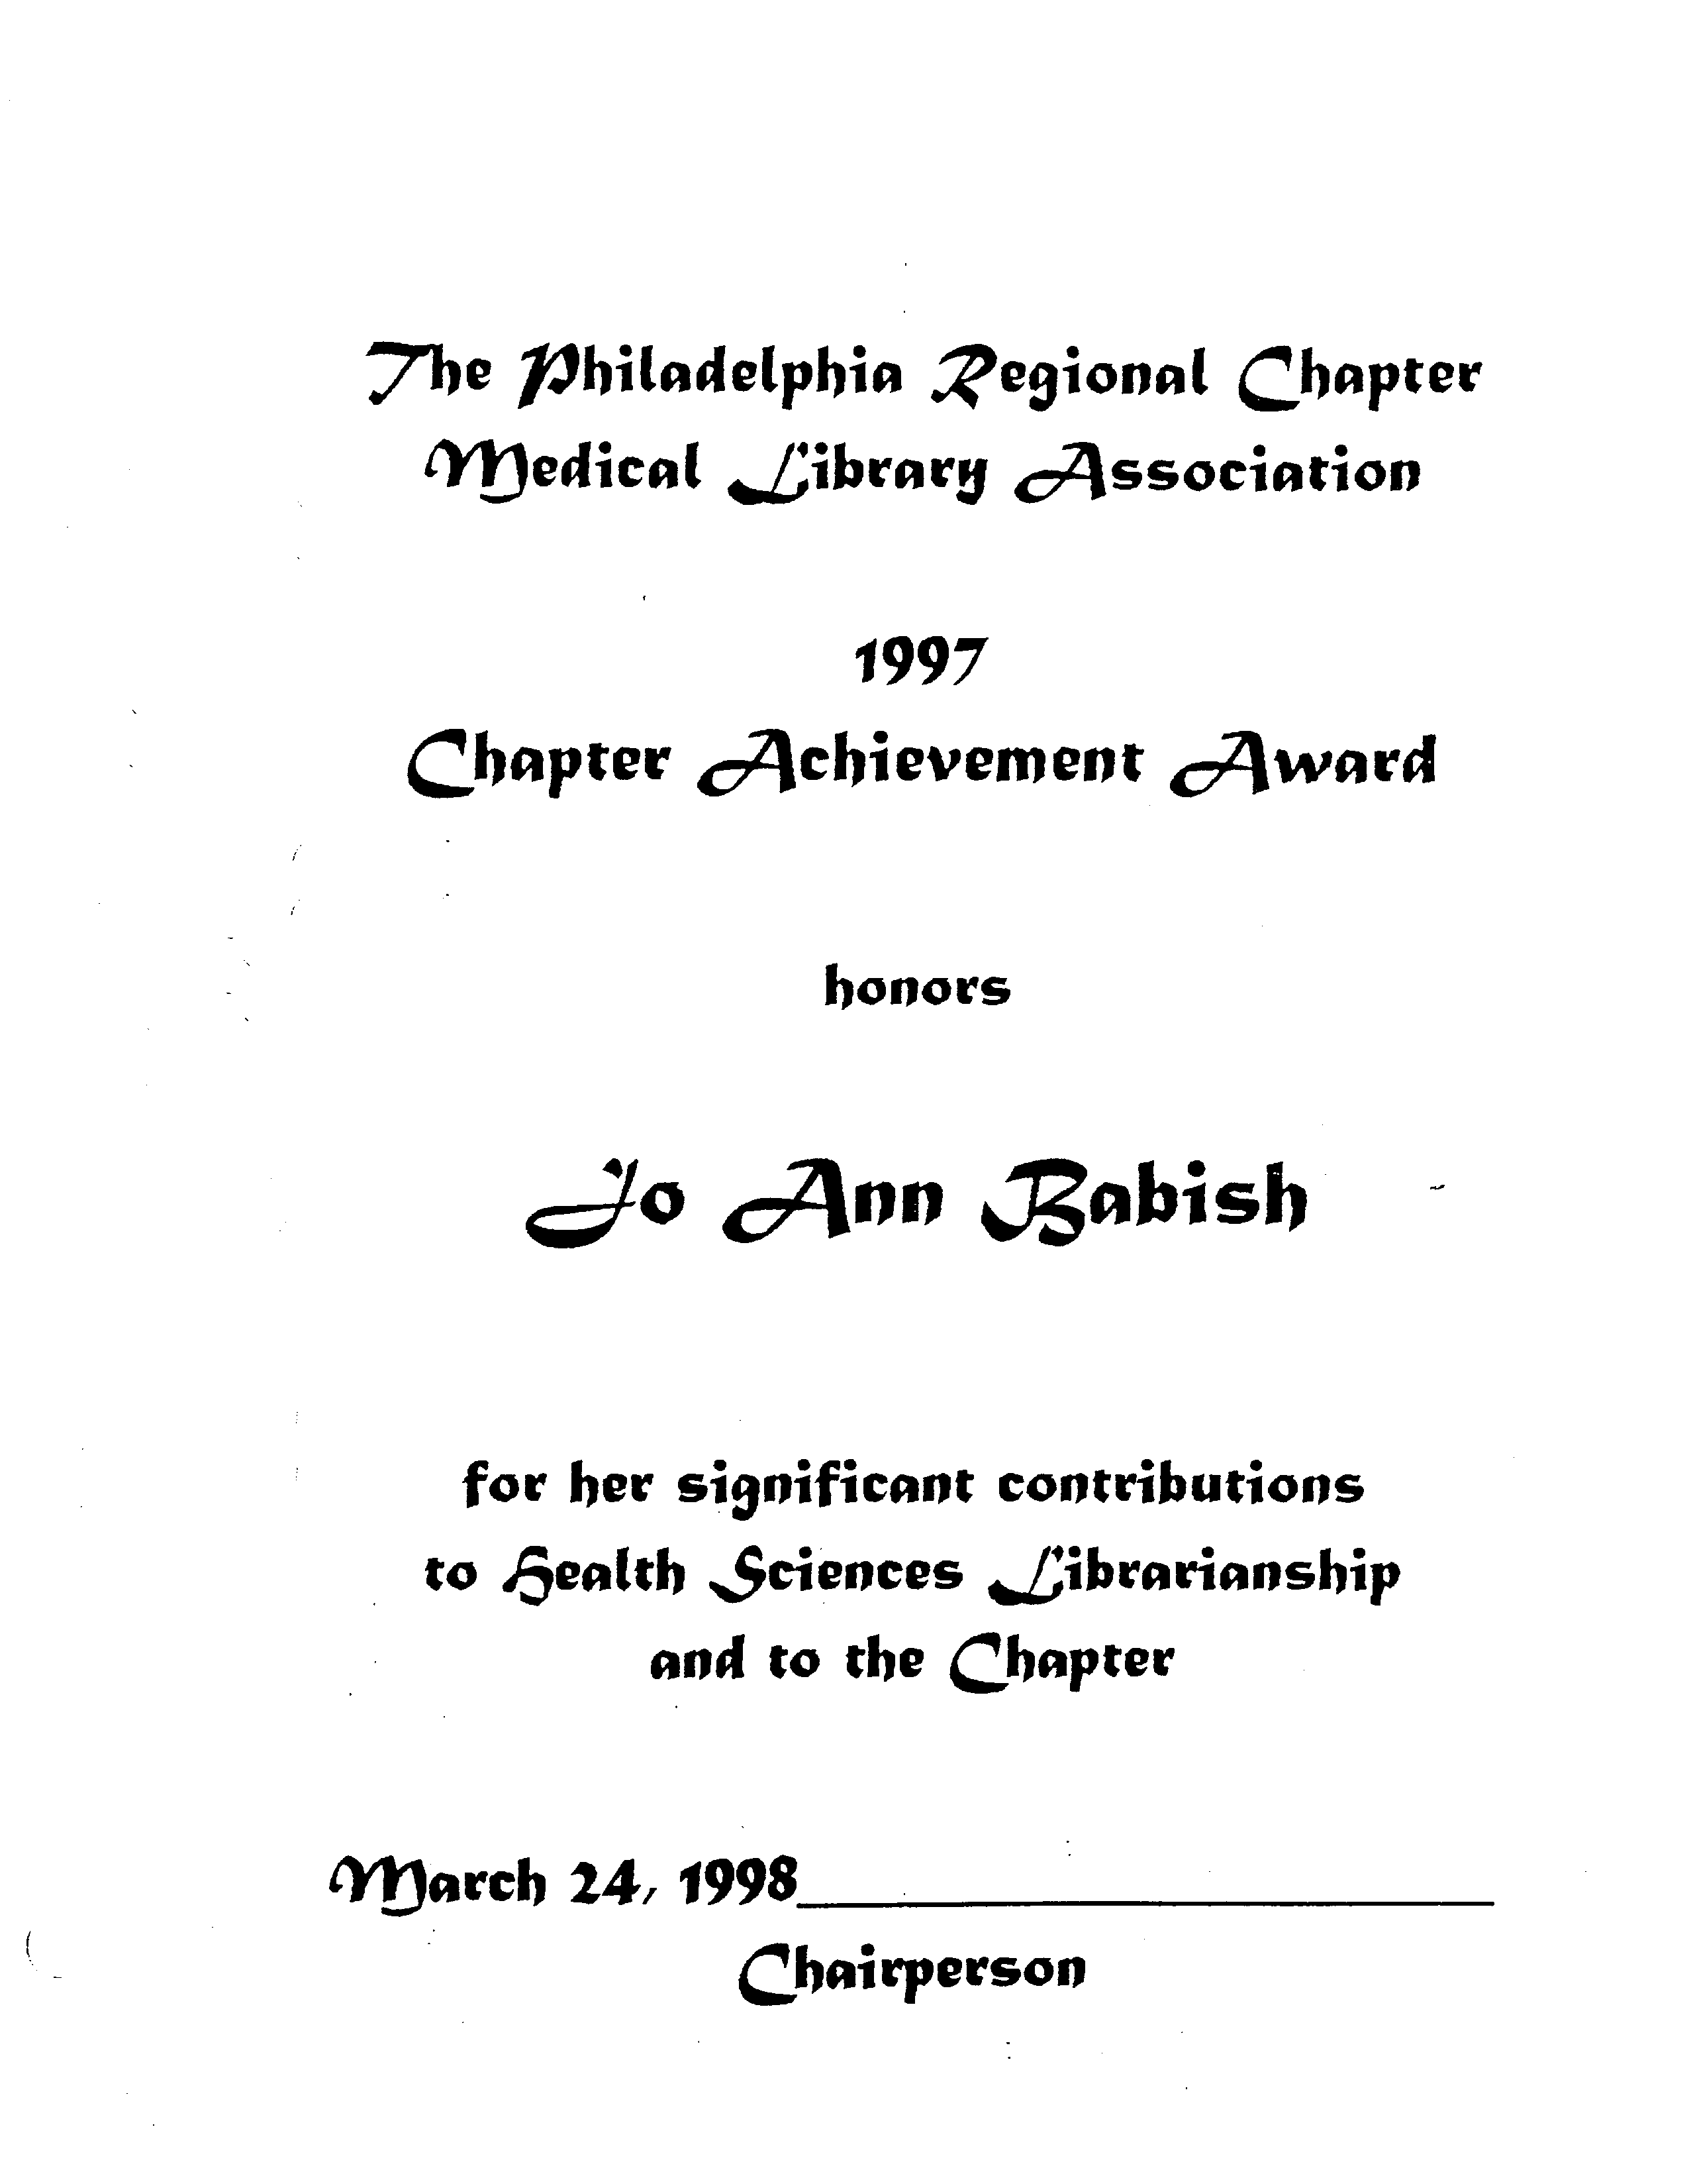
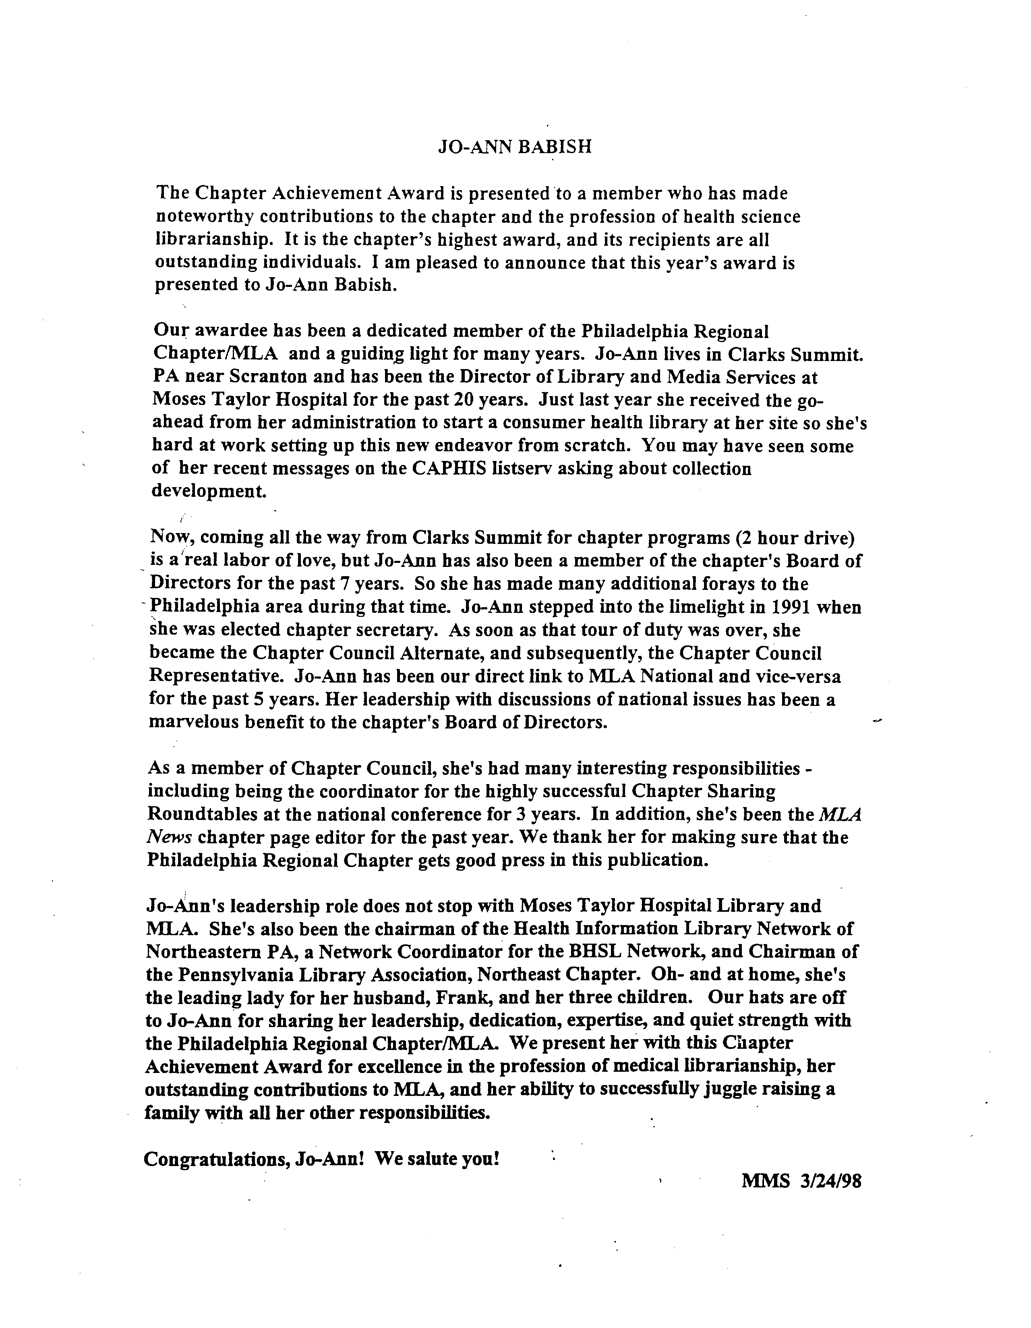
April 12, 2004
J. Robert Beck, M.D.
Chief Information Officer
Fox Chase Cancer Center
7701 Burholme Ave.
Philadelphia, PA 19111
Dear Dr. Beck,
On behalf of the Philadelphia Regional Chapter of the Medical Library Association (MLA-PHIL), I am pleased to announce that Karen Albert, Director of Library Services at the Fox Chase Cancer Center, has been chosen to receive the organization’s highest honor, The Chapter Achievement Award. Karen will be formally presented with the award during the Chapter’s Annual Business meeting on April 29, 2004.
This distinguished award is presented only when a qualified candidate who has made significant contributions to the chapter exists. Karen’s contributions have been exemplary and significant. She has chaired or co-chaired the following committees: Communications Committee, Hospitality Subcommittee for the 1998 MLA Annual Meeting, Planning Committee for the 1991 Joint Chapter Program, and Education and Credentialing Committee. For six years, Karen was co-editor of our Chapter’s newsletter, The Chronicle, and was instrumental in migrating it from a print to electronic publication. Karen was elected by her peers to represent us as Chapter Council Alternate and Representative to the Medical Library Association. Karen also served and participated in governing our association as a member of our Chapter’s Board of Directors.
Please join me in congratulating Karen on being recognized for such exemplary professional service.
Sincerely,
Eric P. Delozier, Chair
MLA-PHIL Nominating Committee and Awards Subcommittee

cc: Karen Albert

Certificate of Appreciation
Purpose: | The certificate of appreciation is given to a Chapter member who has done extensive work in a specific area; e.g. work on The Chronicle contributions to a committee, etc.
Guidelines: | - The award may be presented annually but it is to be presented only when a qualified candidate exists.  - Candidates must be a member of the Chapter but not necessarily a member of MLA, Inc.  - The recipient will receive a framed certificate signed by the Chairperson.  - The Award is announced at the Annual Meeting. (See example)  - The Awardee is notified of the award in advance of the Annual Meeting.  - The Employer, with permission of the Awardee, is notified of the award in advance of the Annual Meeting.

Honorary Lifetime Membership
Purpose: | A Chapter member may be given an honorary lifetime membership on his/her retirement in recognition of his/her contributions to the Chapter.
Guidelines: | - The award may be presented annually but it is to be presented only when a qualified candidate exists.  - The candidate must be a member of the Chapter but not necessarily of MLA, Inc.  - The candidate must be retiring from the profession.  - The candidate must have made significant contributions to the Chapter.  - The recipient will receive a framed certificate signed by the Chapter Chairperson. (See example)

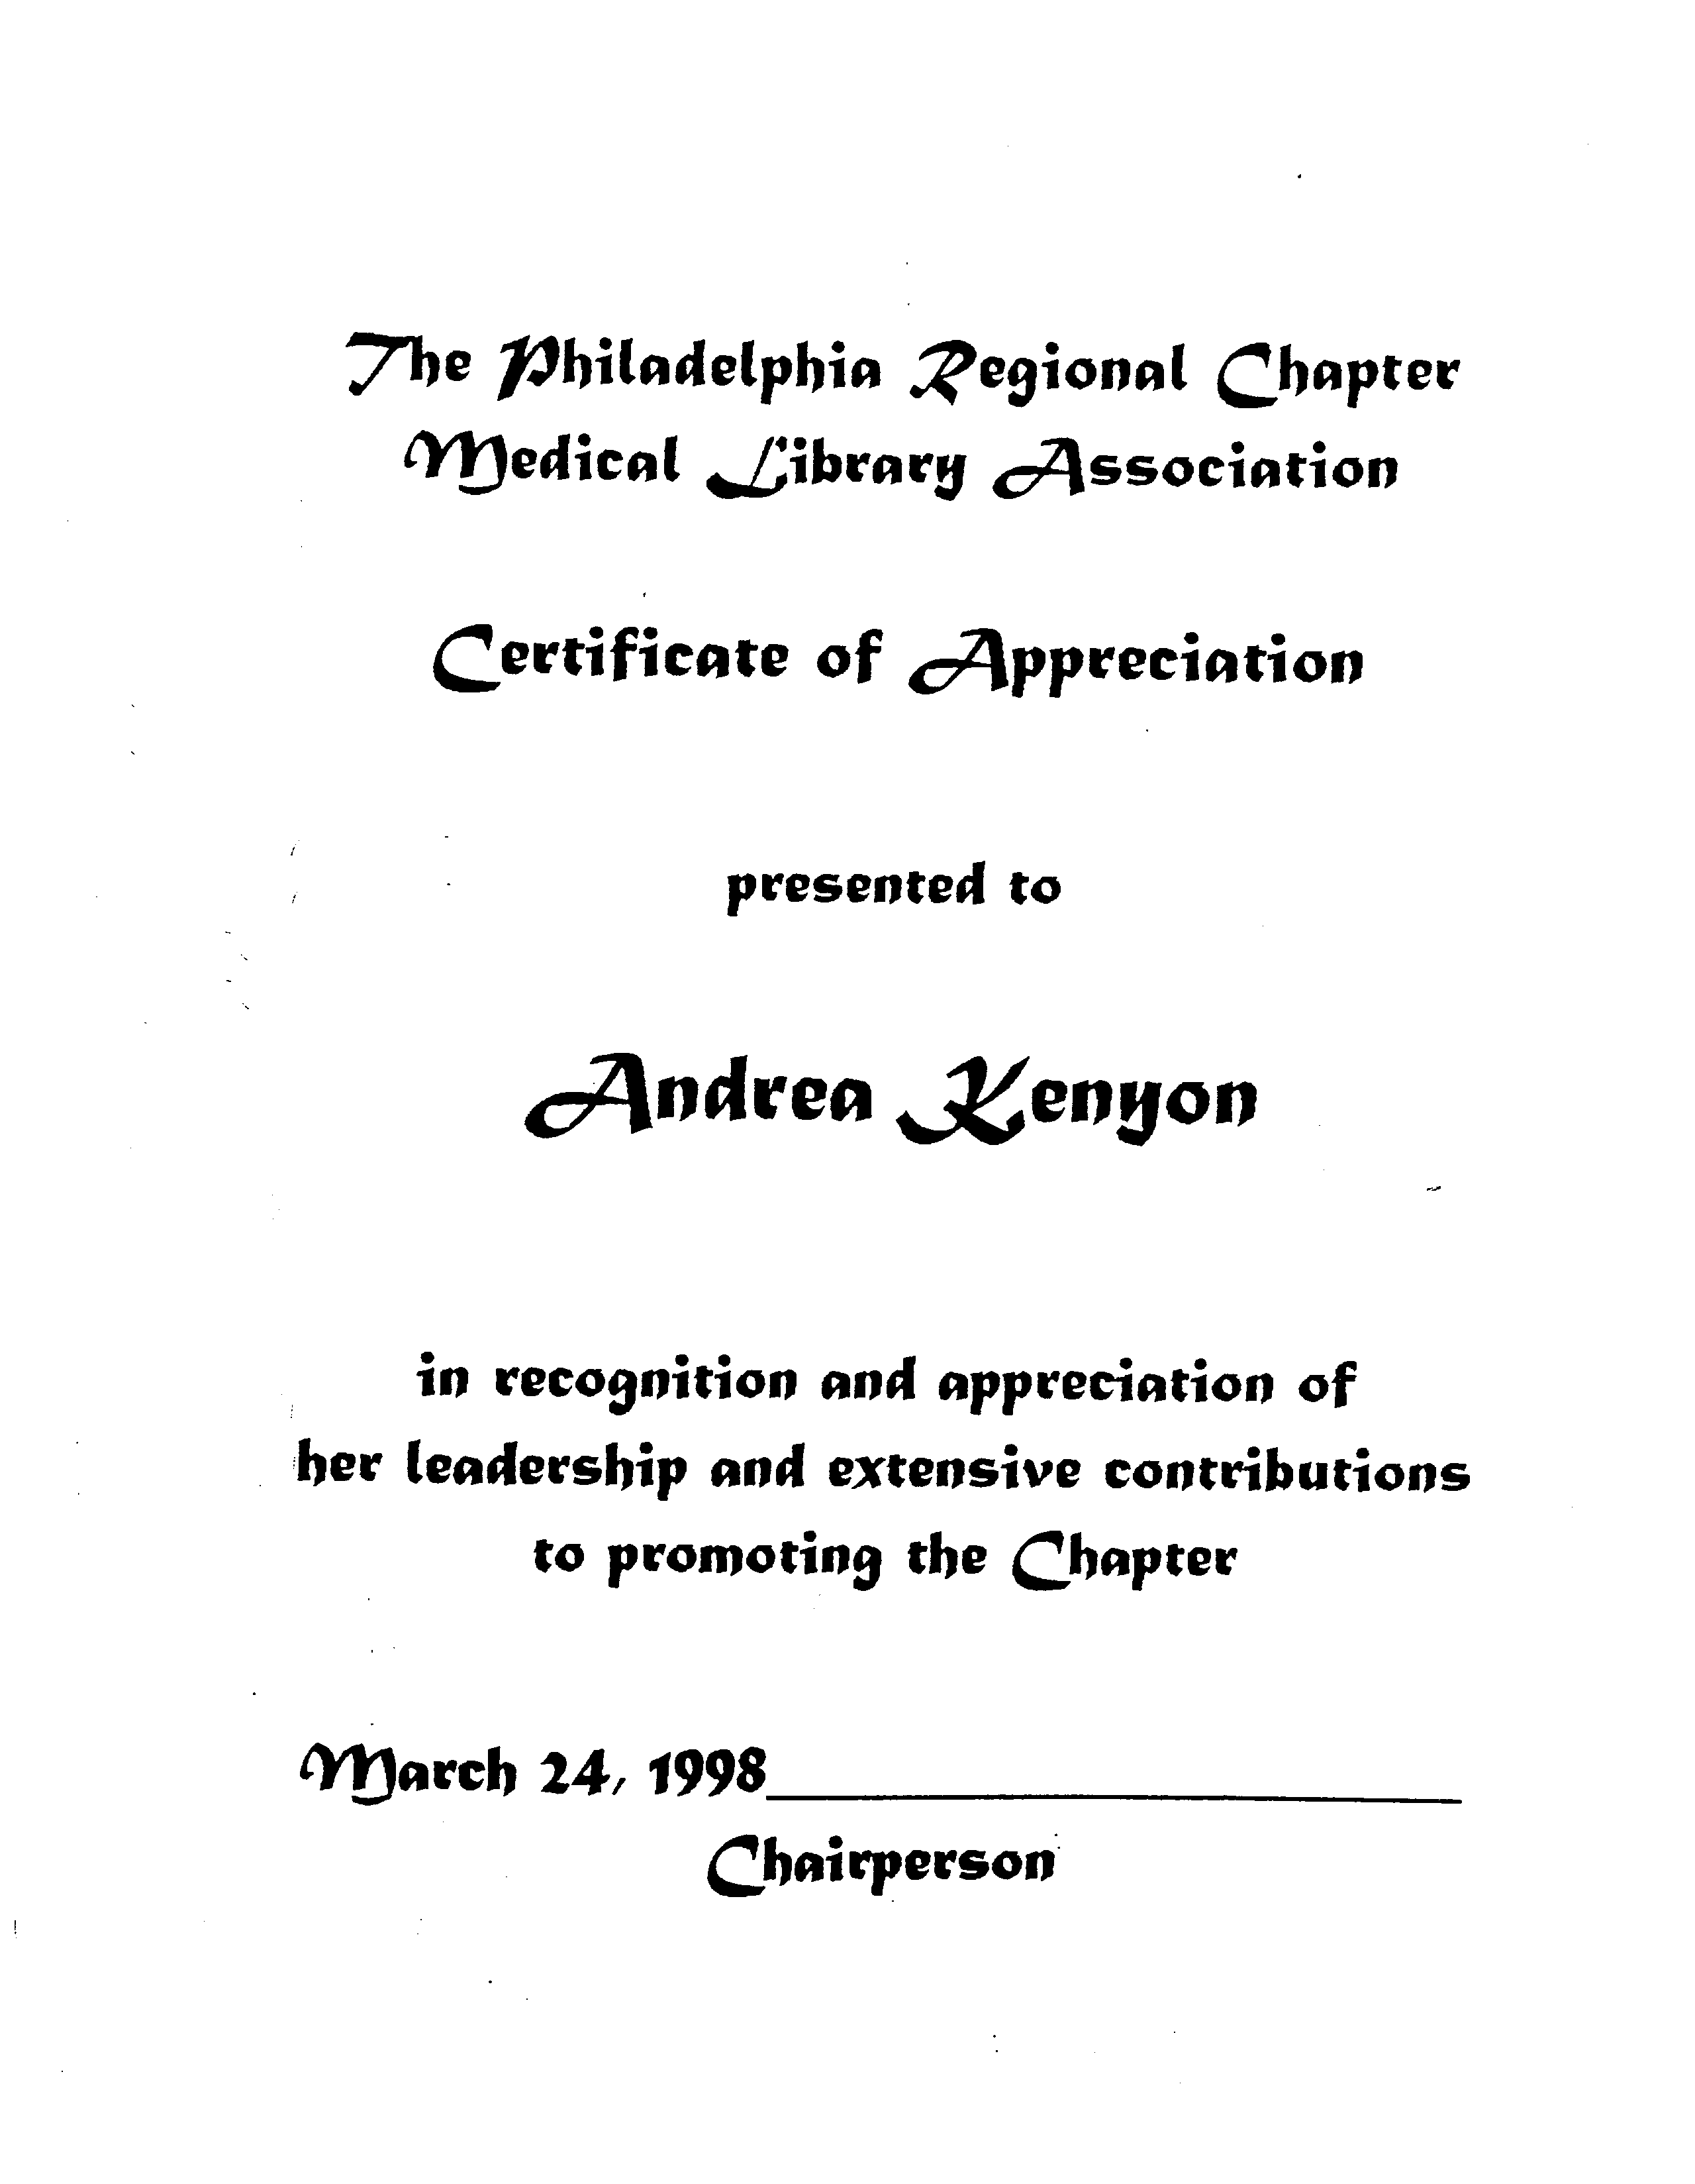
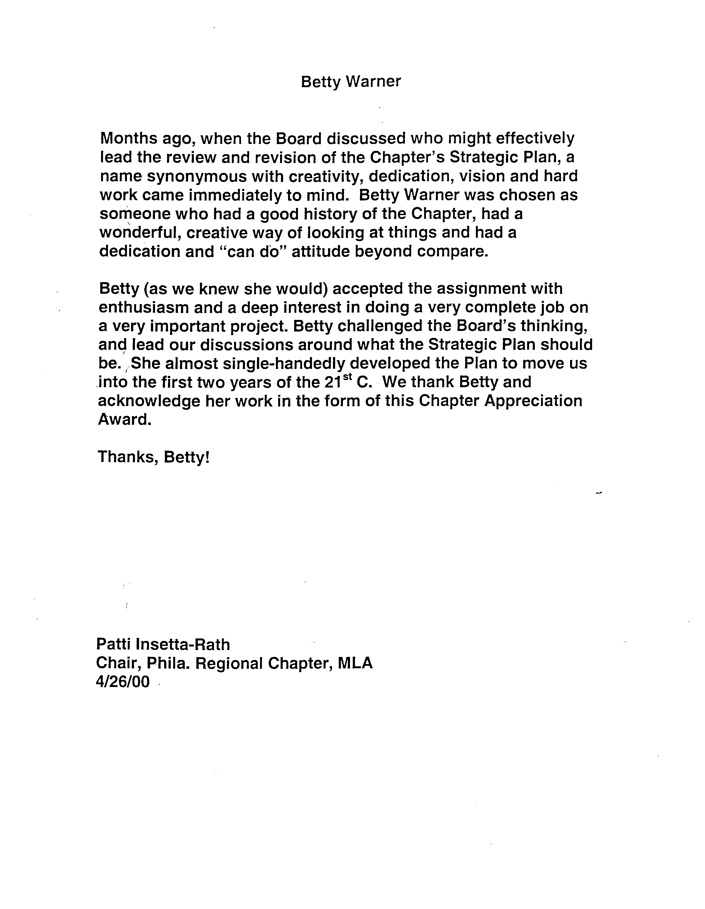
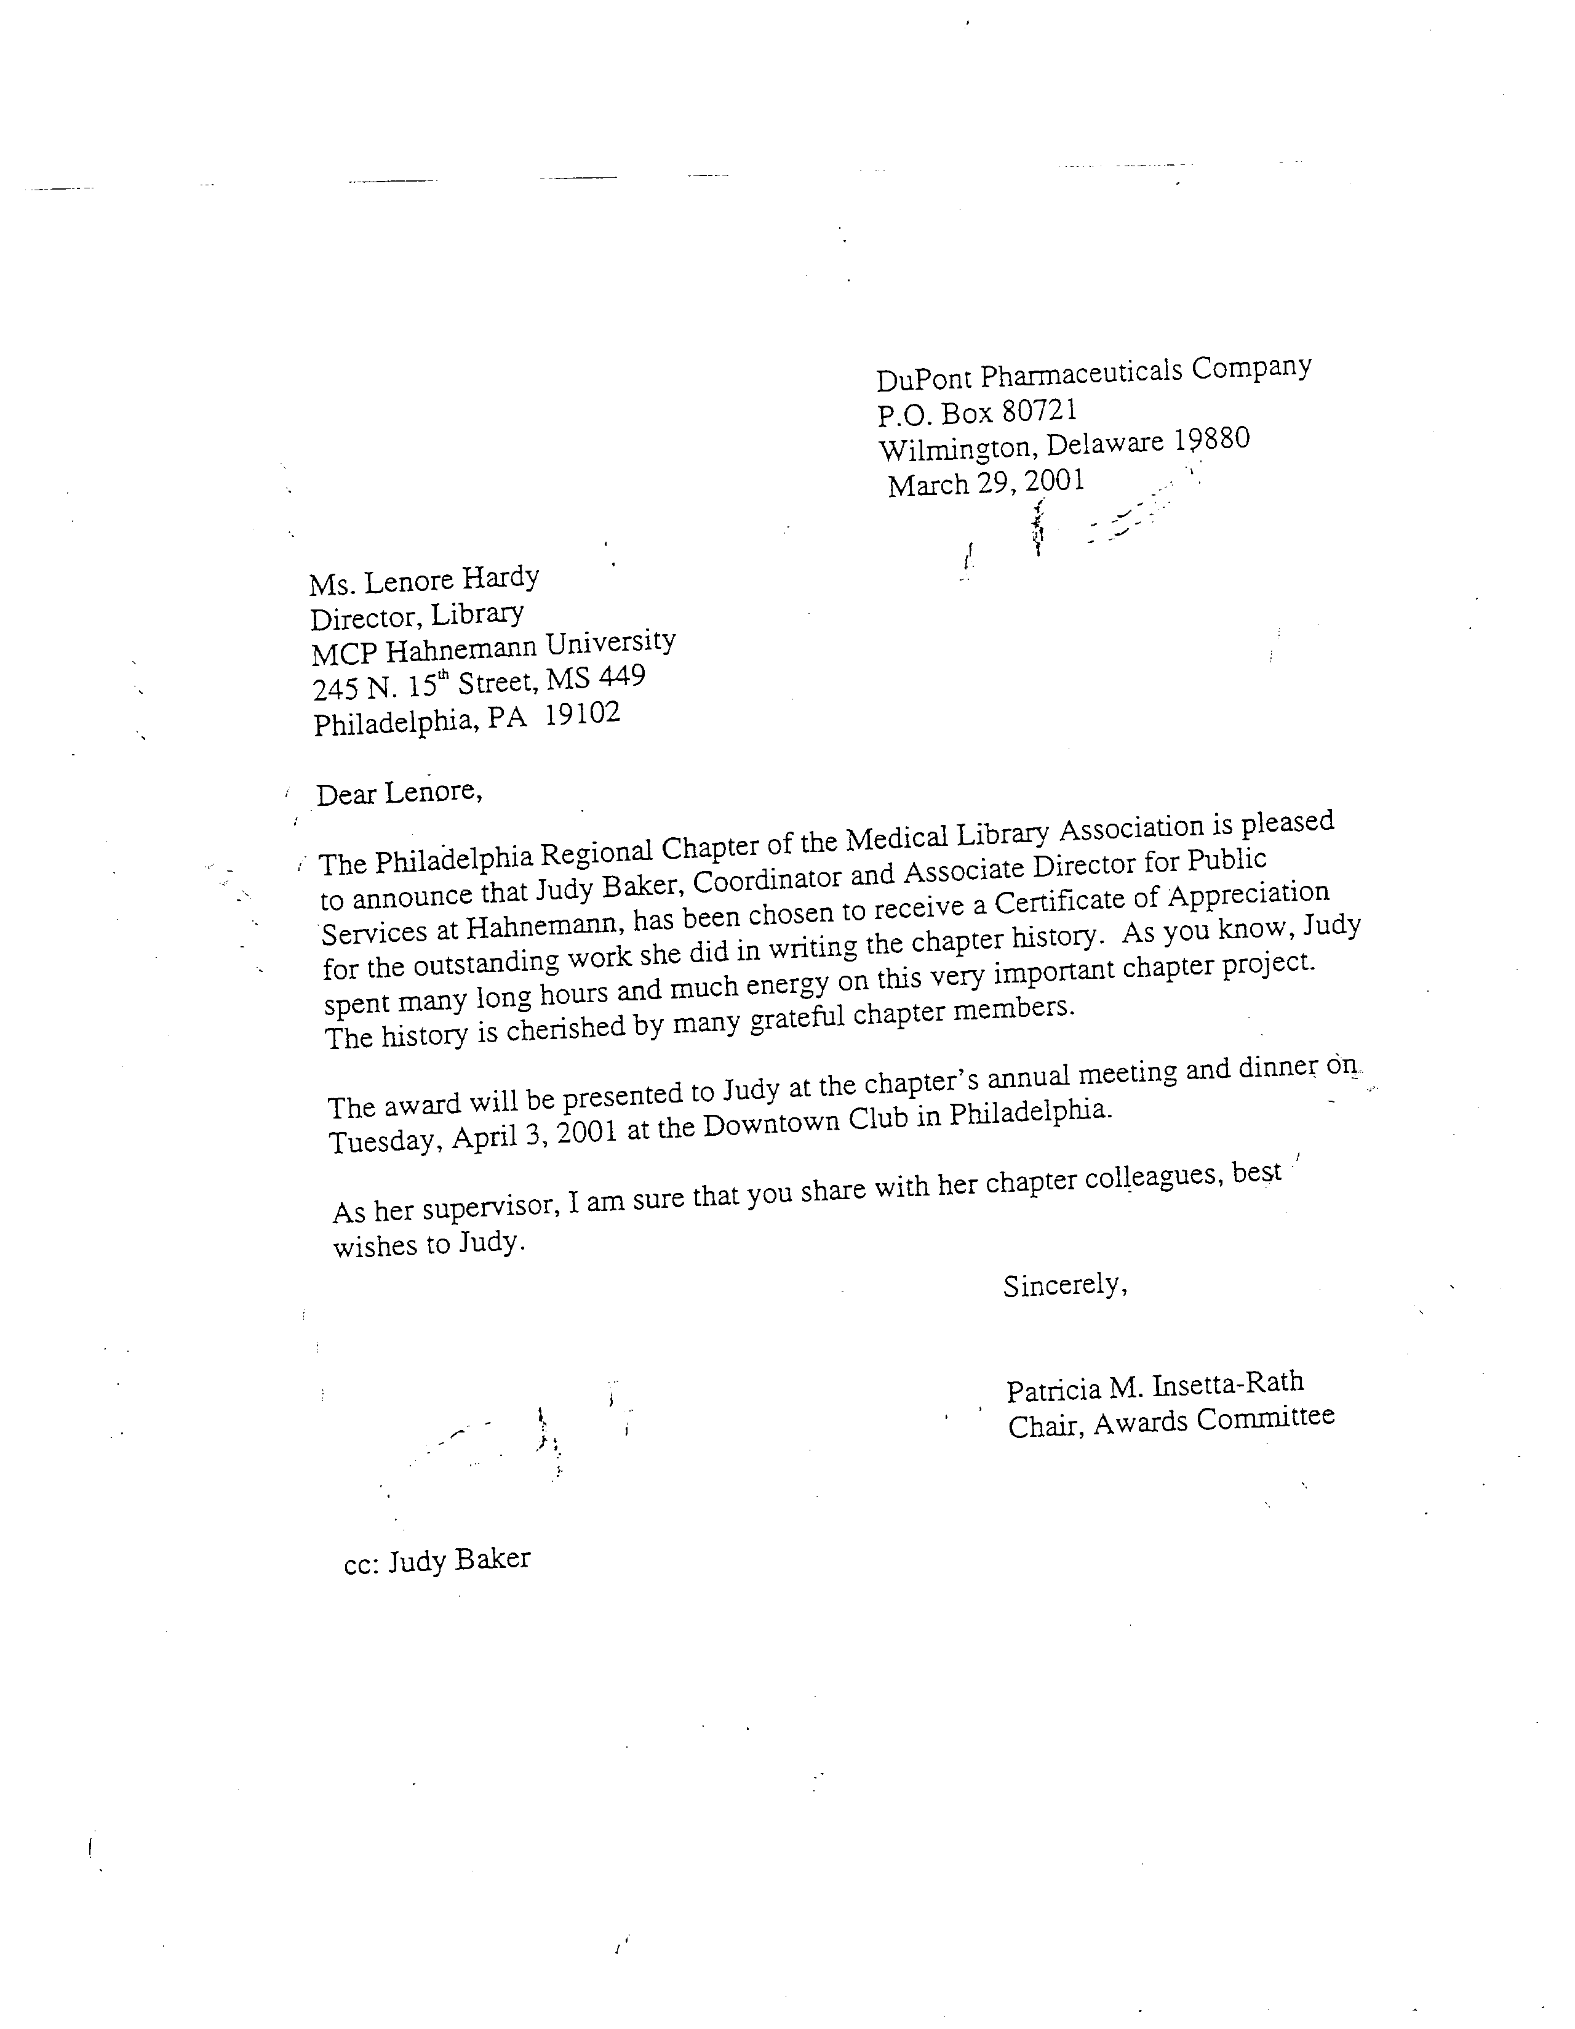
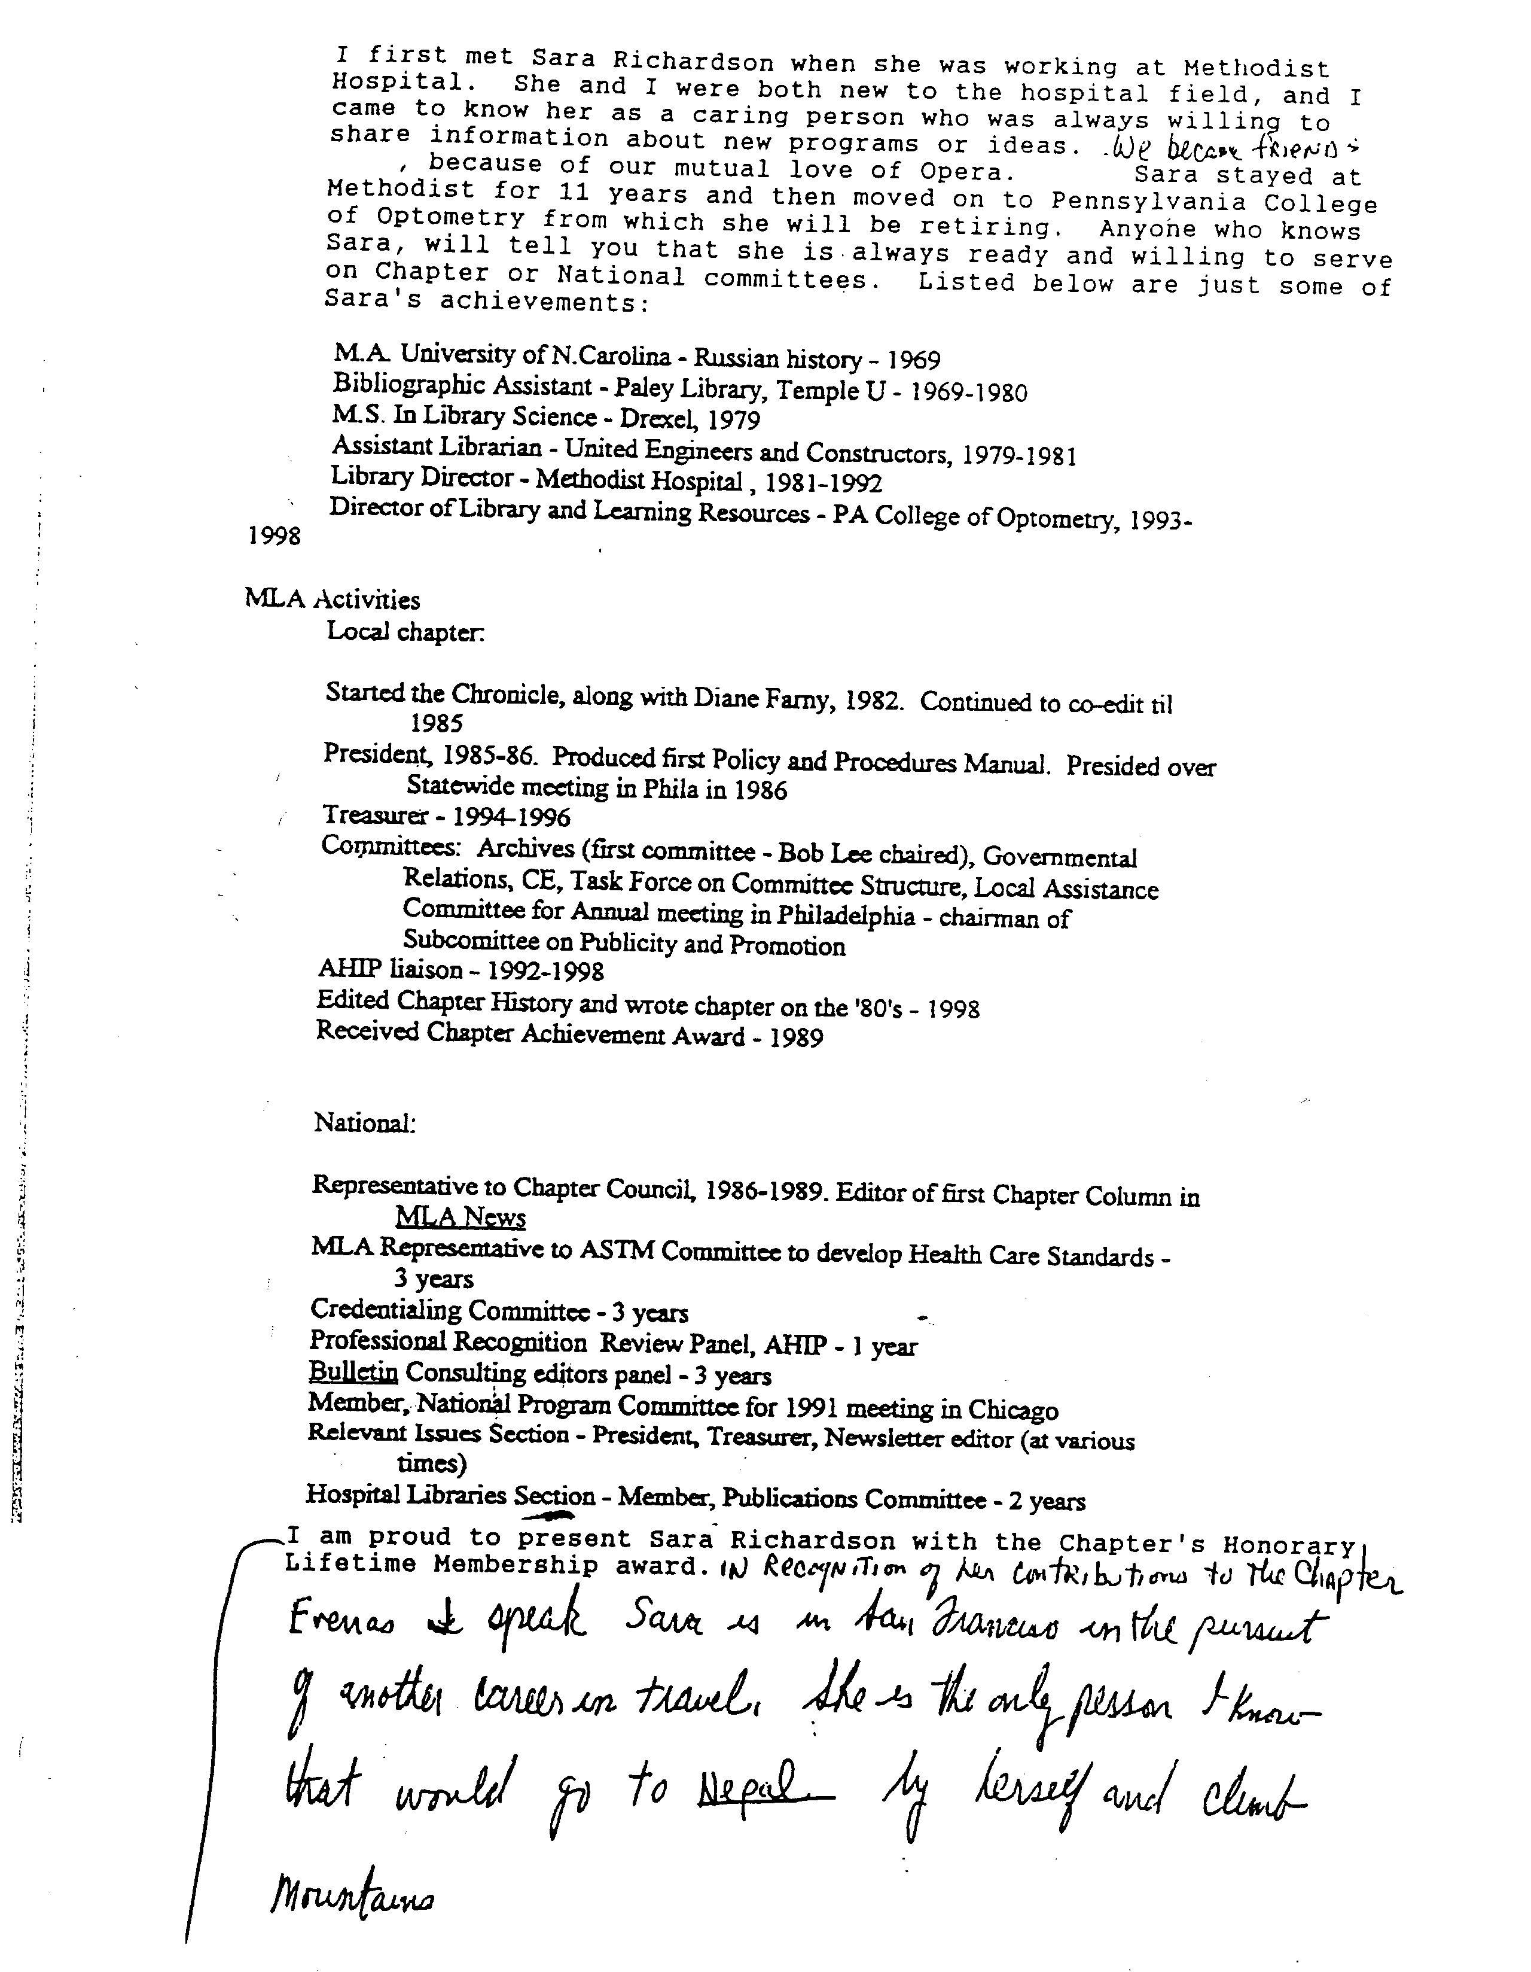

Robert Preston Lee Memorial Award
Purpose: | The Robert Preston Lee Memorial award will be given to an individual (or group of individuals) in recognition of his/her outstanding contribution in the application of technology to the delivery of technical services in one or more of these areas: collection development, collection management, cataloging and acquisitions, information services, information technology and information systems. The candidate or candidates must exhibit both theoretical and applied knowledge of technical services which may be evidenced by:  - introduction of innovative techniques, methods or systems.  - contributions to networking and the service oriented philosophy of resource sharing.  - longstanding contributions to the field of library and information science.  - commitment to performance excellence.  - enhancement of institutional program reputation.
Guidelines: | - The award may be presented annually, but it is to be presented only when a qualified candidate exists.  - Candidates must be a member of the Chapter; though not necessarily of MLA, Inc.  - A group of people working as a team may jointly receive the award. At least one member of the group must be a member of the Chapter to qualify.  - Each recipient will receive a paperweight and a framed certificate, signed by the Chapter Chairperson. The combined cost is not to exceed $150.00.

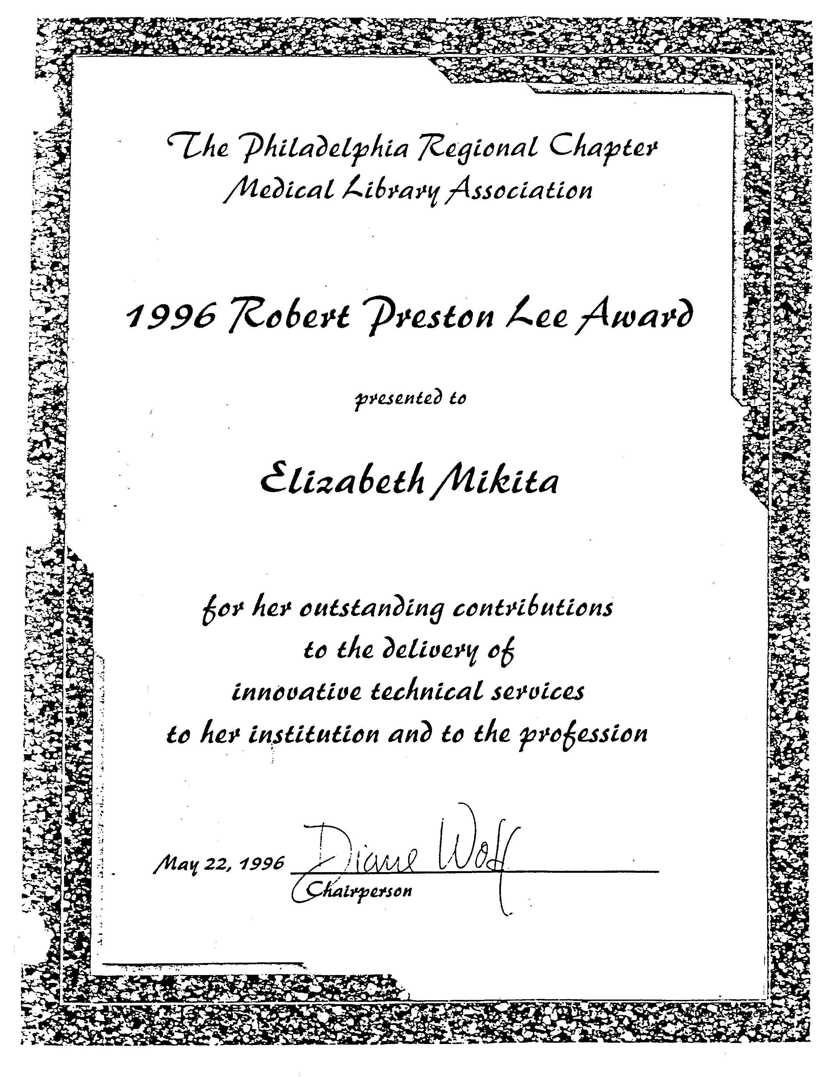
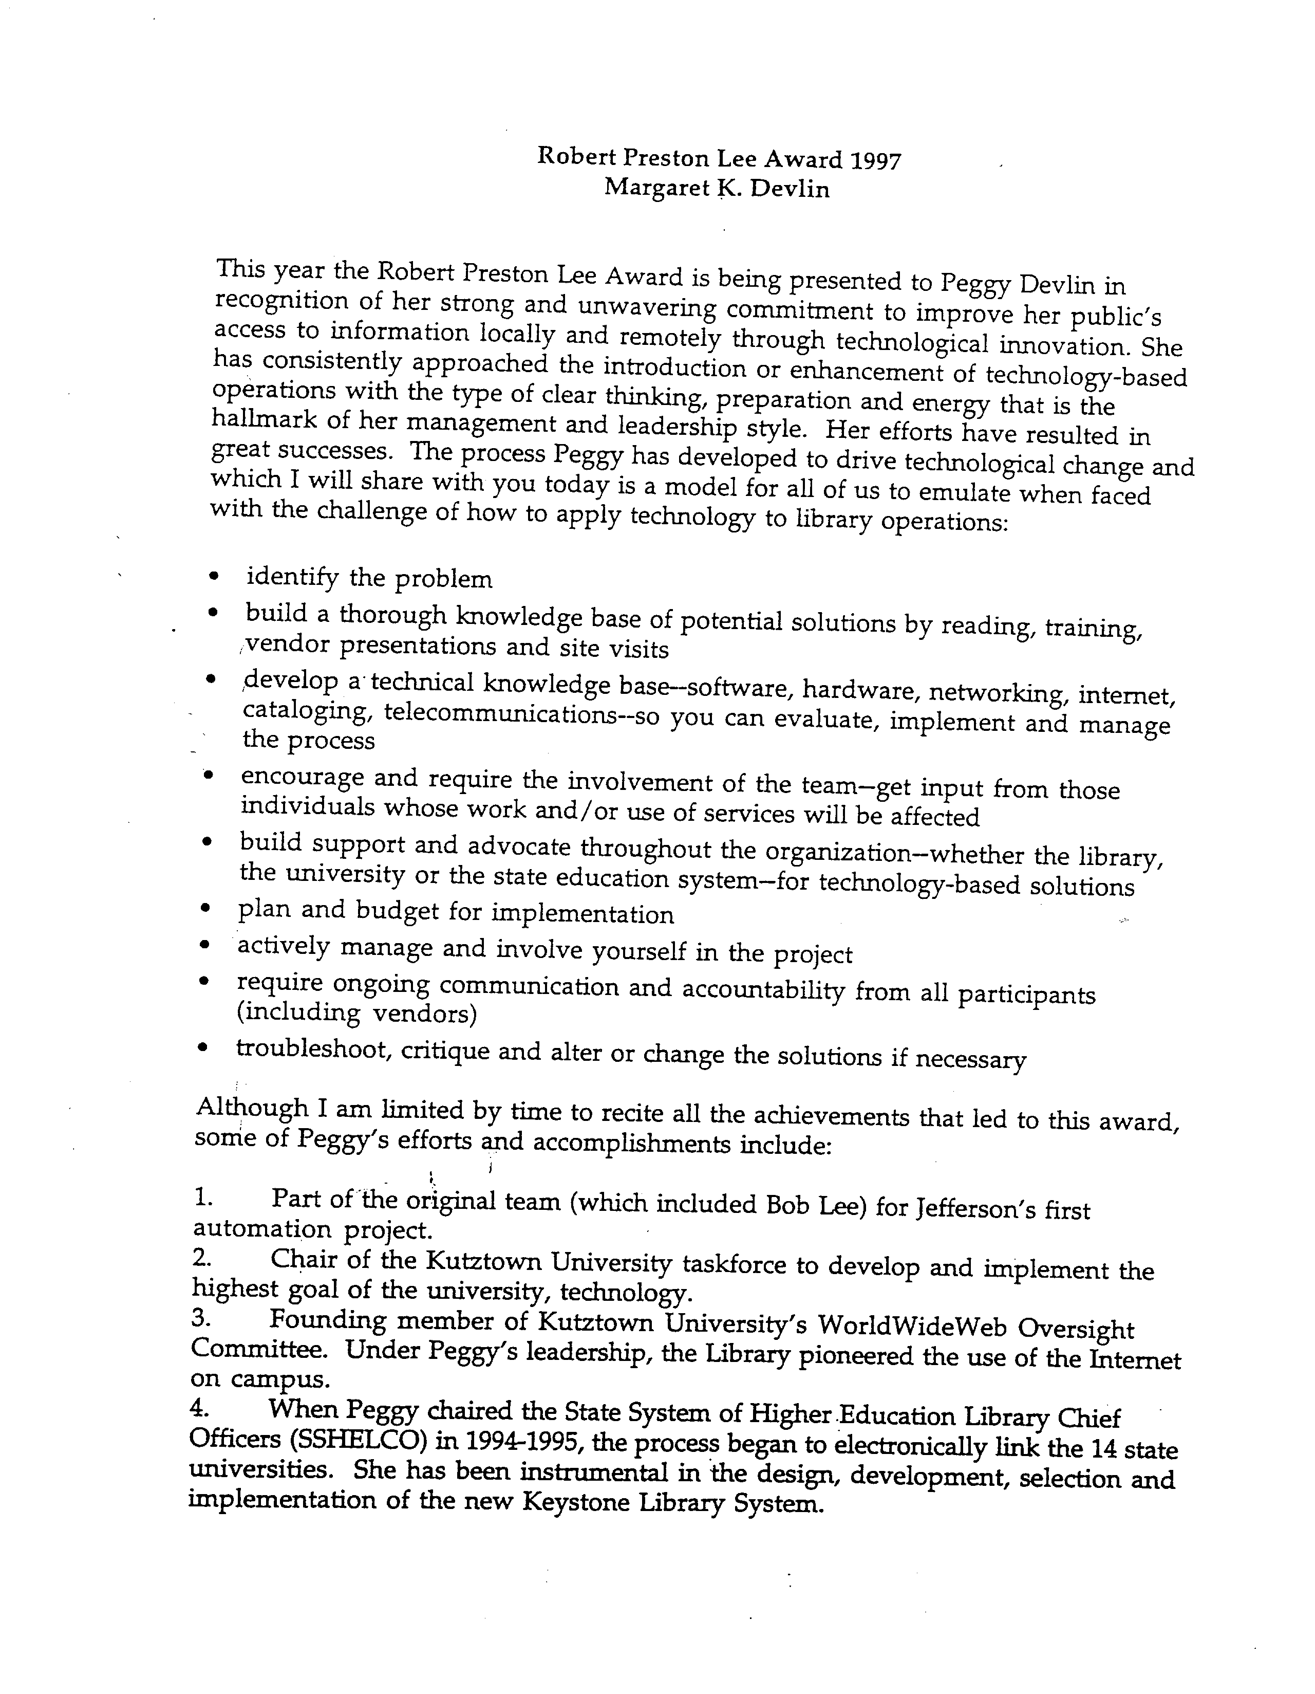
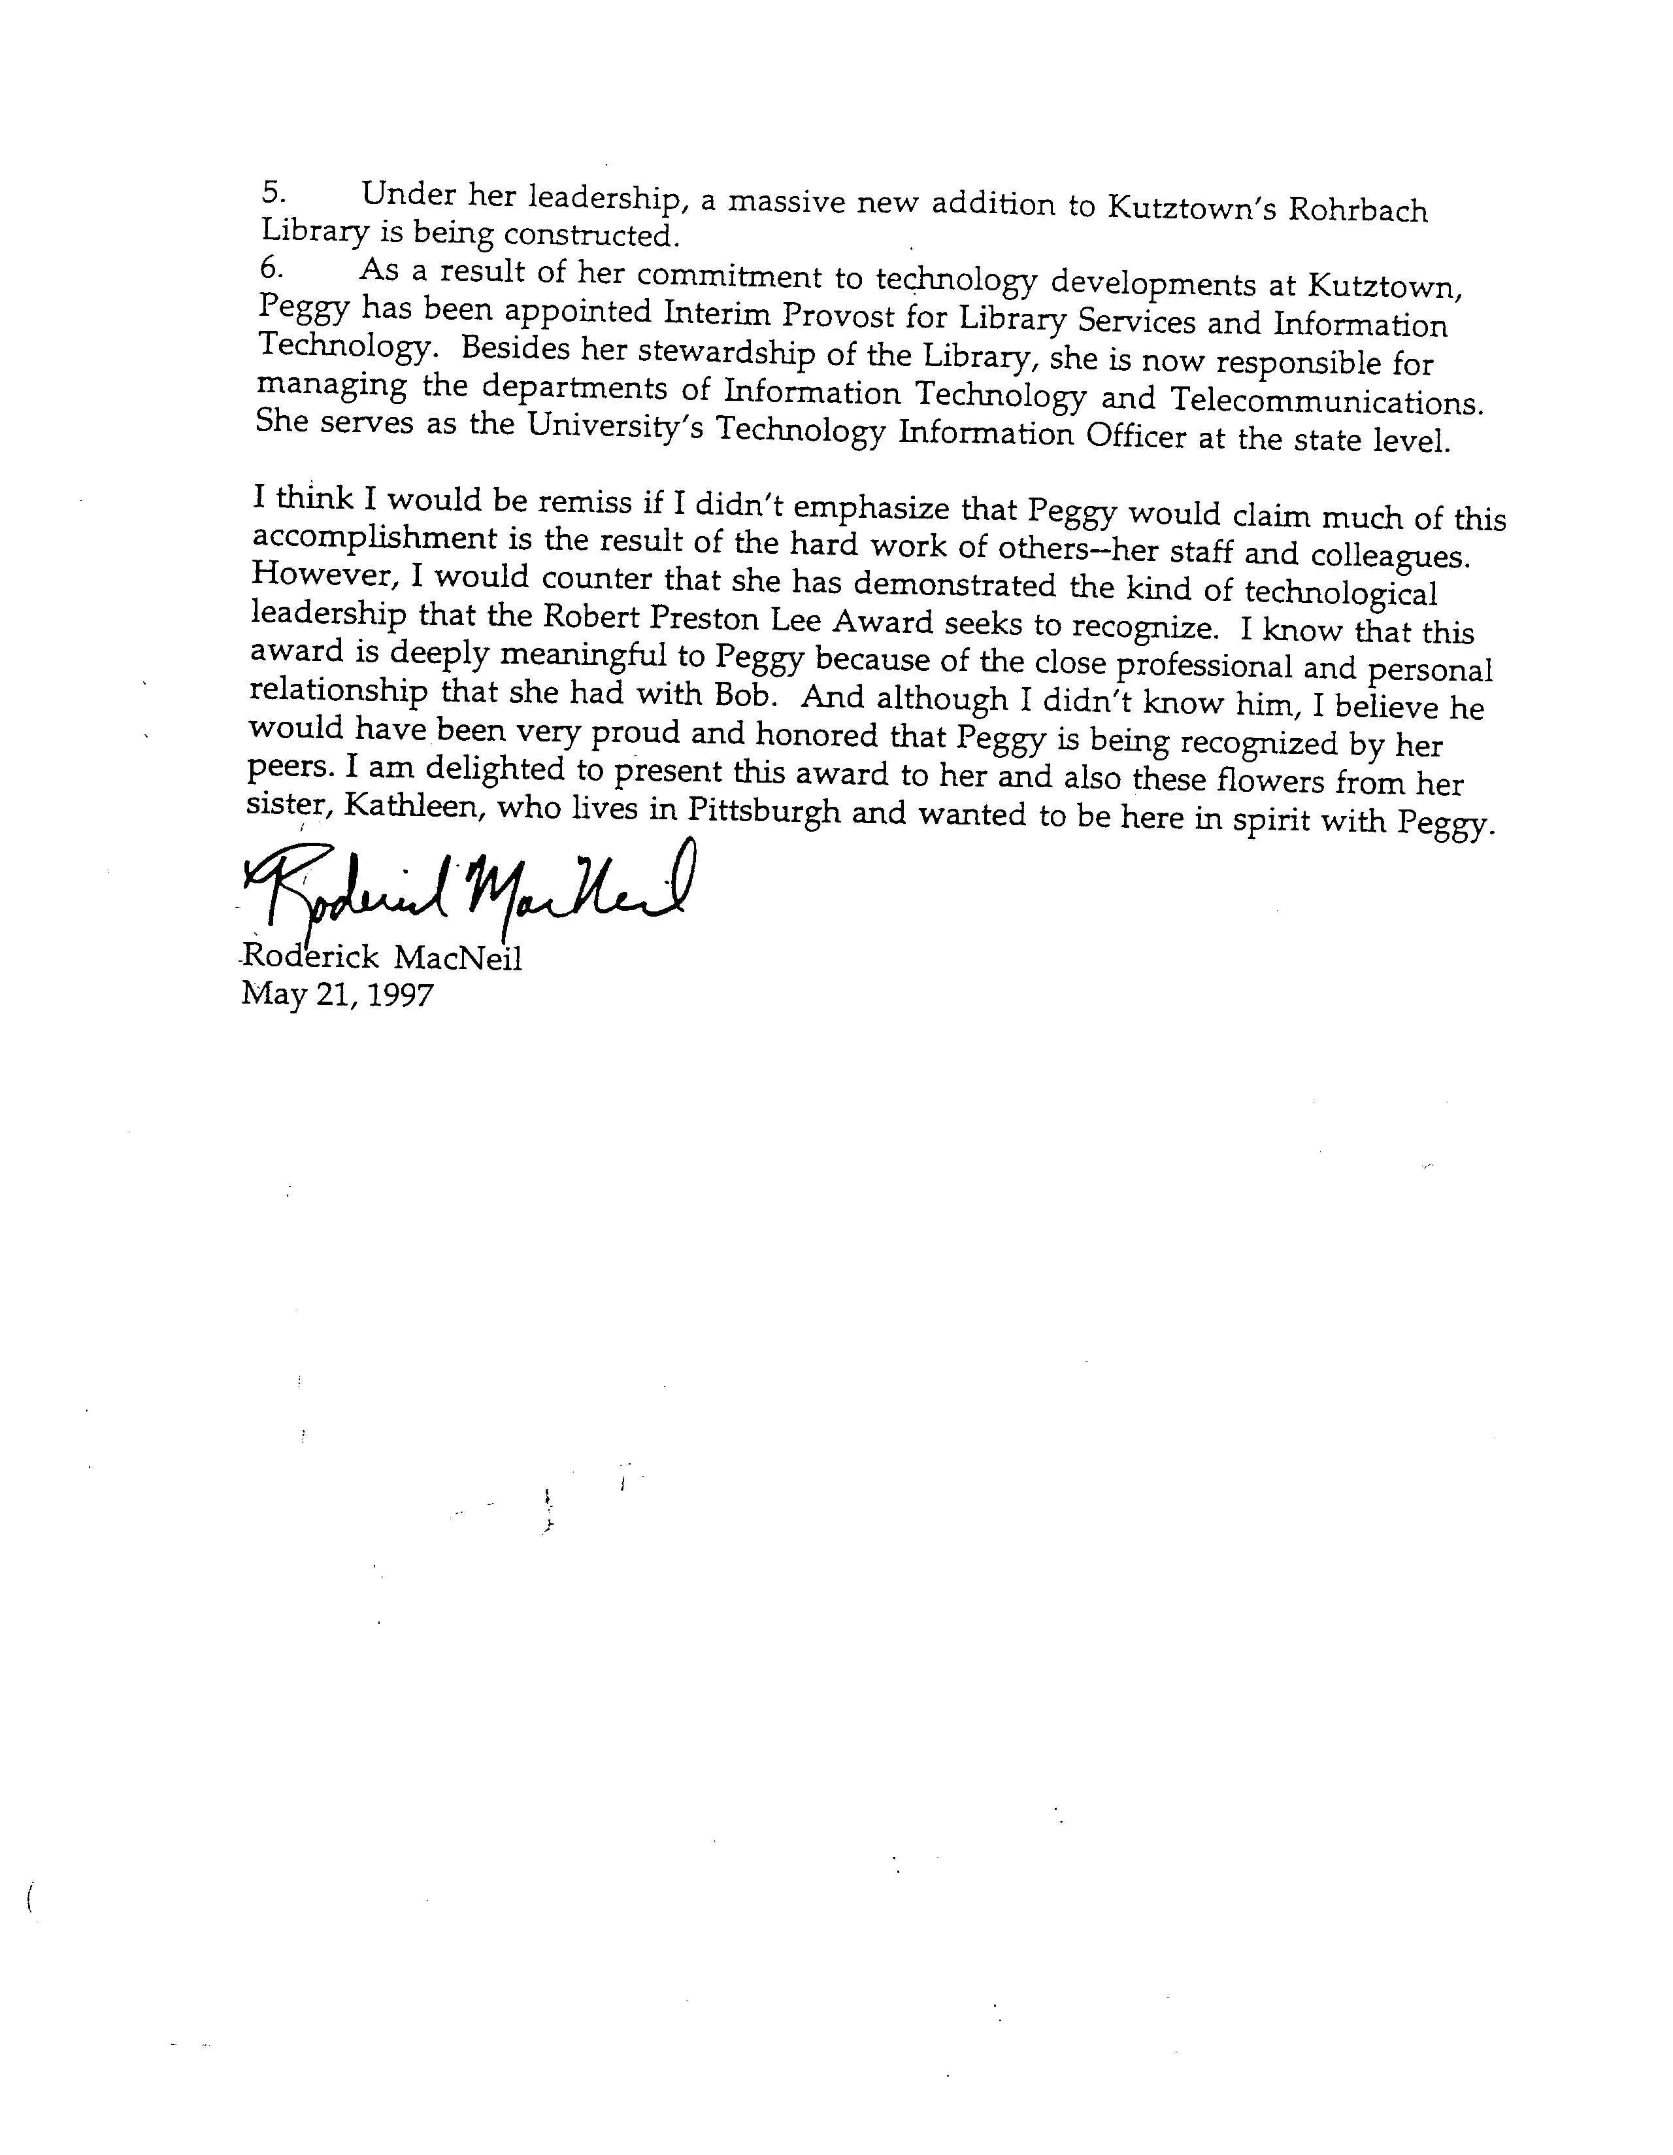

Recognition of Recently Retired Chapter Members
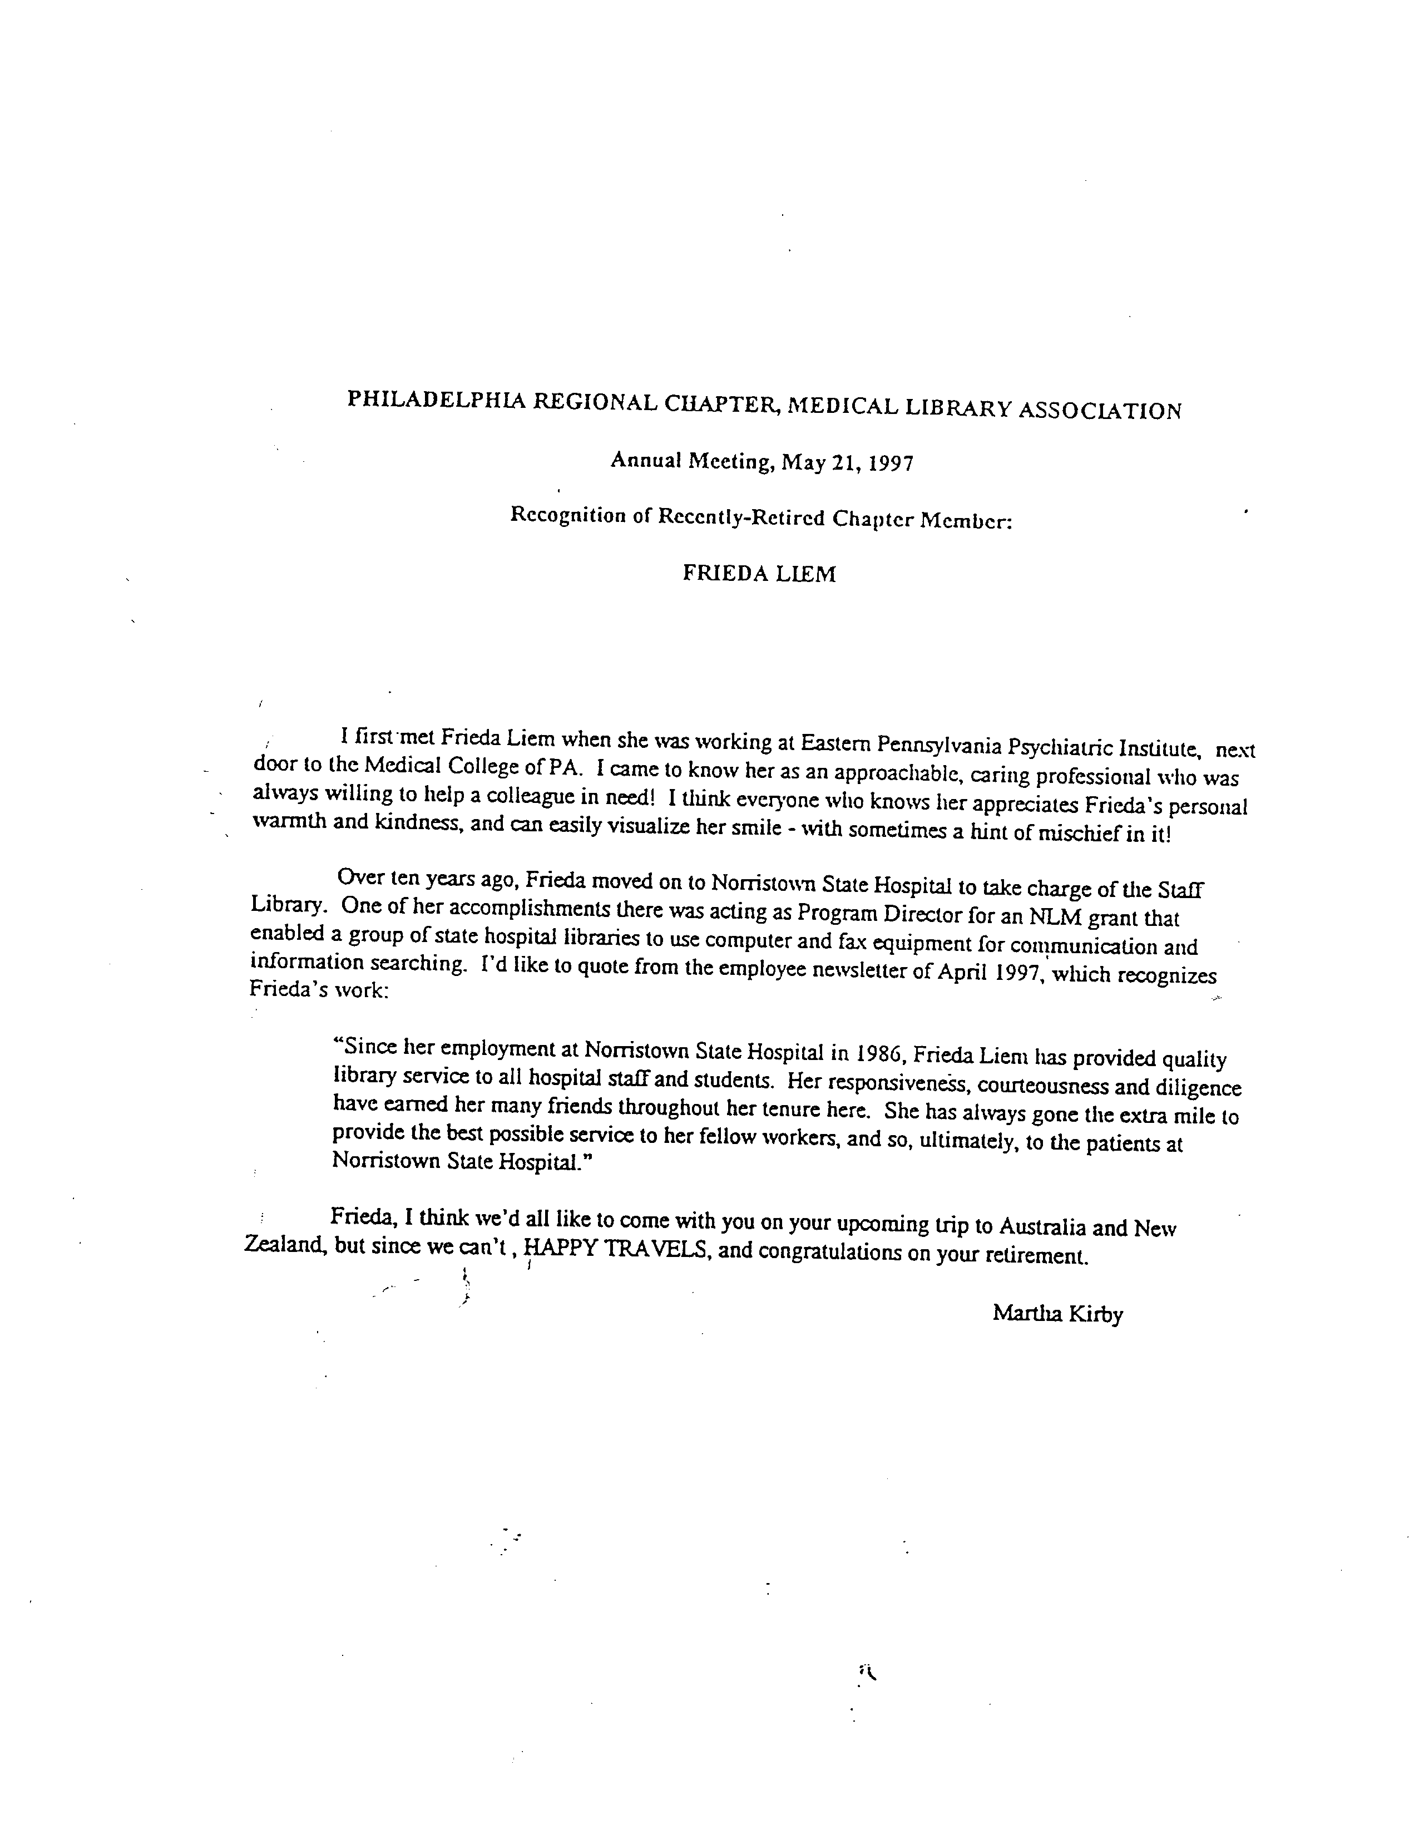

Beatrice Davis Education Award
Description: | The purpose of this award is to foster and encourage library students to pursue educational activities related to health sciences librarianship. These activities may include: formal course work in a degree program; a special program (e.g., workshop); or attending the Medical Library Association, Inc. Annual Meeting. This award is not intended for books, living expenses, commuting costs or other incidental costs related to the specified course. Award monies for annual conference attendance are restricted to conference registration; travel to and from the meeting and lodging. This award will not duplicate any grants or reimbursements from the applicant’s employer, school or other source. The recipient of the Beatrice Davis Award must use the award in the current or upcoming academic year. Upon completion of the course, special program, or conference, the awardee will submit proof that the terms of the grant have been met (e.g., transcript, CE certificate, receipts). If the recipient has failed to meet these terms, the grant amount must be refunded to the Chapter.
Frequency: | At least every other year the Philadelphia Regional Chapter/MLA will offer an award/grant of $600.00 to a Library school student who is pursuing a career in health science librarianship.
Eligibility: | Individuals who are enrolled in an ALA accredited masters degree program in Library and Information Science and are interested in pursuing a career in health science librarianship.
Application: | Applicants must submit a letter of application not to exceed two double-spaced typewritten pages with the following information: name, mailing address, phone number; a brief review of coursework taken toward the MLS, with an emphasis on that which relates to medical librarianship; a description of how the applicant became interested in medical librarianship; and a description of how the applicant intends to use the financial award. With the letter, applicants must submit a resume and a letter of recommendation. All materials must be submitted to the Chapter’s Nominating Committee Chair by February 28, of the given year.
Criteria: | The award is given to a stud with a high level of potential for and interest in medical librarianship.
Procedure: | The Nominating Committee will review applications and notify the recipient before the Chapter’s Annual Meeting. The award will be announced to the membership at the Chapter’s annual meeting.

MLA
Philadelphia Regional Chapter / Medical Library Association

March 30, 2004
Rebecca Rishar
2030 Cathill Rd.
Telford, PA 18969
Dear Rebecca,
I am pleased to inform you that you have been selected to receive the Beatrice Davis Scholarship award from the Philadelphia Regional Chapter of the Medical Library Association (MLA-PHIL). Enclosed is a check payable to you for $600. You may use the funds for: tuition, workshops, or conference expenses (registration, travel, lodging, etc.). The award is not to be used for books, living expenses, commuting costs, or other incidental costs related to your studies.
Scholarship recipients are required to submit evidence that the money was used for its intended purpose. Acceptable forms of evidence include copies of: conference registration receipts, workshop certificates, course transcripts, etc. Please submit your documentation of evidence within one year.
Congratulations on a successful scholarship application and best wishes for a productive career.
Sincerely,
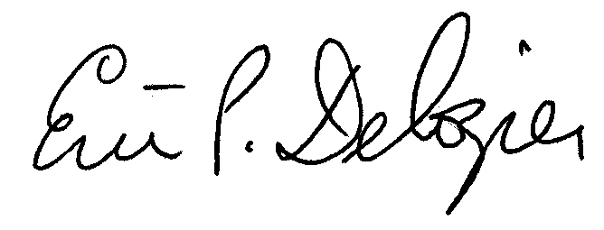
Eric P. Delozier, Chair
MLA-PHIL Nominating Committee and Awards Subcommittee
Enclosure (1)

MLA
Philadelphia Regional Chapter / Medical Library Association
Beatrice Davis Education Award
Application Form
Last Name |  | First Name
Current Address |  | Permanent Address
E-mail | Daytime Phone |  | Evening Phone |  | Best Time to Call
 |  |  |  |  | A.M. | P.M.
Library School | Graduate Program |  |  | Advisor
Employer’s Name |  | Employer’s Address
Please mark the documentation which accompanies this application:
Letter of Application
Letter of recommendation
Resume
Deadline: February 28, 2004.
Return application form and accompanying documentation to: Eric P. Delozier, Associate Librarian, Library, Penn State Harrisburg, 351 Olmsted Drive, Middletown, PA 17057.
I understand the conditions of the grant and will submit proof that the terms of the grant have been met upon the completion of the program. If I am unable to fulfill the terms of the grant, I will refund all monies received.
Signature of Applicant |  | Date

Grant Program for Professional Development
Description: | Twice a year, the Philadelphia Regional Chapter/MLA will offer one grant of up to $300.00 to a librarianlinformation scientist in order to pursue continuing education in the area of health science librarianship. Continuing education opportunities include registration fees for courses, programs, workshops, and conferences sponsored by graduate schools of library/information science, colleges and universities, and professional organizations.
Eligibility: | Members of the Philadelphia Regional Chapter who have a graduate degree in library/information science or information systems may apply. The grant will be awarded to a librarian who effectively demonstrates his/her need for continuing education in order to pursue institutional objectives and/or achieves professional growth.
Application: | Applicants must submit application form (see next page), resume, published description of the continuing education opportunity, statement explaining the reason(s) for applying for the grant and how this course will enhance the applicant’s pursuit of institutional objectives and/or professional development, and a letter of recommendation. The Chapter’s Nominating Committee Chair must receive applications by February 28 or August 28. The Awards Committee will determine the grant winners and notify all applicants of the decision one month after application due date. The award must be used within one year of announcement.
Restrictions: | This grant must be used for continuing education courses, programs, workshops, and conferences sponsored by the graduate schools of library/information science, colleges and universities, and professional organizations. Upon completion of the continuing education opportunity, the awardee will submit proof that the terms of the grant have been met (e.g., CE certificate or transcript).
Contact: | Nominating Committee Chair.

MLA
Philadelphia Regional Chapter / Medical Library Association
Grant Program for Professional Development
Application Form
Last Name |  | First Name
Work Address |  | Home Address
E-mail | Daytime Phone |  | Evening Phone | Best Time to Call
 |  |  |  | A.M. | P.M.
Course/Program/Workshop/Conference Name, Number, Brief Description:
Institution/Organization Name, Address, Telephone:
Describe the tuition assistance policy at your institution:
Signature of Employer |  | Date
Please Check the documentation which accompanies this application:
Resume
Published description of continuing education opportunity
Statement explaining reasons for applying for grant
Letter of recommendation
Deadlines: February 28 and August 28. Applicants will be notified one month after application due date.
Return application form and accompanying documentation to: Eric P. Delozier, Associate Librarian, Library, Penn State Harrisburg, 351 Olmsted Drive, Middletown, PA 17057.
Signature of Applicant |  | Date

September 9, 2003
Rachel Resnick
Polisher Research Institute Library
Abramson Center for Jewish Life
1425 Horsham Rd
North Wales, PA 19454-1320
Dear Rachel,
I am pleased to inform you that you have been selected to receive the Grant Program for Professional Development award from the Philadelphia Regional Chapter of the Medical Library Association (MLA-PHIL). Enclosed is a check payable to you for $300. According to your grant application, the funds will used to help pay your expenses for attendance at the QuintEssential Conference and Copyright in the Digital Age workshop.
Grant recipients are required to submit evidence that the grant was used for its intended purpose. Acceptable forms of evidence include copies of: conference registration receipts, workshop certificates, course transcripts, etc. Please submit your documentation of evidence within one month after the conference and workshop has occurred.
Congratulations on a successful grant application and best wishes for a productive conference and workshop.
Sincerely,
Eric P. Delozier, Chair
MLA-PHIL Nominating Committee and Awards Subcommittee
Enclosure (1)

Program Committee
Established: | Before 1965
Revised: | 2004
Composition: | - One to ten members.  - Chair is Chairperson-Elect of the Chapter; must be a Voting Member of the MLA, Inc. and the Philadelphia Regional Chapter/MLA.  - Members appointed annually and serve two-year terms, with the option of reappointment subject to Board approval; must be voting member of the Chapter. Whenever possible, members should be representative of academic, hospital, or special types of health sciences libraries and varying geographical areas of the Chapter.  - Chapter Chairperson is ex officio.
Charge: | - Plans at least two general meetings a year, including contacting speakers, selecting facilities, arranging for refreshments, and preparing and mailing meeting invitations.  - Tries to arrange a joint meeting with another library association at least every two years.  - Communicates program plans to the membership.  - Identifies needs and wishes of the membership for particular types of programs.  - Serves as an advisory body to the Board on program needs, effectiveness, and popularity.  - Submits annual objectives, draft and final budgets, and annual reports.  - Copies official correspondence and reports to the Archives.

Meetings
Policy: | - The Chapter will hold at least two meetings each year; one in the fall and another in early spring (Board Minutes, 11/90). The spring meeting will be the Annual Meeting of the Chapter and a quorum of the membership will be required to transact business (Board Minutes, 11/90). Additional meetings may be scheduled at the discretion of the Board. It is recommended that one be a joint meeting with another library association. The programs should reflect the general interest and objectives of the Philadelphia Regional Chapter/MLA and the Association.  - The program, speaker(s), and location for the meetings shall be the responsibility of the Program Committee. The Program Committee shall arrange to schedule meetings throughout its geographical boundaries.  - Written invitations of meetings shall be sent via the USPS, e-mail, or both to each member of the Chapter.  - None of the meetings shall conflict in time with a meeting of MLA, Inc.  - The Annual Meeting is to be held in the Philadelphia area (Board Minutes, 7/97).
Procedure: | - The Program Committee shall meet in the late spring or early summer and plan the program meeting schedule for the year. At this time, the details for the fall meeting should be finalized and approximate dates, speakers, and locations of other meetings discussed. The Program Chair brings the schedule of programs and program budgets to the Board for approval. Scheduling should take into account possible conflicts with religious holidays.  - Each member of the Committee may be assigned responsibility for one meeting.  - The section of this manual on Honoraria and Expenses should be consulted when appropriate: Vendors may be approached for contributions toward meeting expenses.  - An appropriate invitation announcing the program topic, speaker, date, location, time, and cost will be prepared and mailed for receipt at least thirty days before the meeting. The invitation should include a tear-off indicating intention to attend. Include a name, e-mail address, and telephone number of the Program Committee member liaison. The person taking reservations should make sure that the registration checks are mailed or hand delivered to the Treasurer immediately after the program.  - After the program, the Program Chair shall see that thank you letters are sent to speakers, and other pertinent individuals who have been particularly helpful in organizing the program, e.g. institution providing facilities or individual creating invitations.  - The Program Chair should consider submitting information about the program to:  - The Chronicle  - Chapter LISTSERV (mla-phil@hslc.org)  - Chapter Web Site (http://www.mlaphil.org/)  - Central PA Health Sciences Library Association LISTSERV (cphsla-l@lists.psu.edu)  - MLA News  - Other regional organizations (PARLIE, SLA, PaLA, and ASIS)  - Due dates for submission of articles or announcements vary from publication to publication. Please check with the appropriate organization.

Guidelines for Programs
Accessibility: | Every effort will be made to select and give priority to a facility that complies with the ADA Title III accommodation guidelines, including: restrooms, parking, and meeting rooms. Invitations should ask if the registrant has special needs, e.g., wheel chair accessibility, sign language interpreters, dietary needs, etc.
Pricing: | The cost of each meeting shall be recovered through the fee charged to attend; however, in special cases the Board may elect to pay for certain costs out of the treasury (Board Minutes, 9/87). The fee for nonmembers should be cost of the meeting plus the membership fee to provide an incentive for joining the Chapter. Early Bird price differentials may be helpful in getting registrations in faster. Library school students should be charged half price (Board Minutes, 3/92). A draft budget should be prepared for each program and submitted to the Board for approval. Included in the estimate should be: speaker honoraria and expenses, facility rental, equipment rental, refreshments, and postage for mailing invitations.
Payment: | Problems with collection of Program/Continuing Education fees can be handled with a friendly note sent from the Program/Continuing Education Committee chair as a reminder. The Treasurer will provide a draft of this letter (Board Minutes, 7/94).
Cancellations: | Registration fees may be refunded so long as the Chapter does not have out-of-pocket costs (such as meals that must be paid for). The registration form should carry a statement; Refunds may be made only until (date when a firm figure must be given to caterer). Those who call to make a reservation too late to mail a check should be reminded that they will be liable for payment whether or not they attend (Board Minutes, 4/93).
Mailing: | Even though an invitation and registration form may appear in the Chapter newsletter, a separate mailing for each program should be made via the USPS and e-mail. An additional reminder should be sent to the Chapter LISTSERV (mla-phil@hslc.org). The meeting announcement and invitation should be posted to the Chapter Web site as well.
Location: | Both in scheduling and choosing locations, the Committee should be sensitive to members who travel long distances, are dependent upon public transportation or carpooling, or have religious commitments. It is recommended that the Annual Meeting take place in the Philadelphia area for maximum participation (Board Minutes, 1/91). One meeting a year should be scheduled outside of Philadelphia, either in Delaware or Central Pennsylvania.

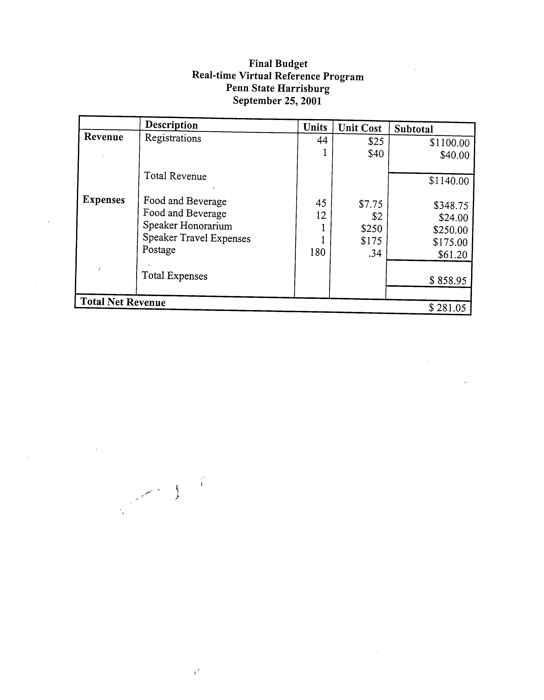

Joint Program Meeting Guidelines
The Chapter should seek to present meetings in cooperation with other professional organizations for the benefit of the membership. Joint meetings should be planned with incorporated, fiscally sound organizations. General guidelines for planning joint meetings include:
- A substantial lead time (2-3 years)
- Formal letters of agreement which detail the obligations of the cooperating groups and the sharing of losses/gains
- A joint finance committee for the meeting with a separate bank checking account
- Calculations based on worst-case scenarios (projecting the highest costs and the lowest income)
- Generate sufficient profit to provide seed money for future joint meetings (Note: seed money provided by cooperating organizations is NOT to be considered income)
- Fund raising from vendors through donations and exhibit fees and assertive collections of vendor commitments
- Pricing to be set as close to the event as possible to allow for the best possible projection of costs and fund raising.

Honoraria and Expenses
Policy: | - The standard offer of honorarium for a course instructor shall be $350.00 for a full day, subject to negotiation by the instructor. There will be no difference in payment between MLA, Inc. members or non-members. (Board Minutes 11/84)  - For any program or continuing education course, the Program Committee and Education and Credentialing Committee shall be permitted expenses not to exceed $500 for program or speaker honoraria and $1500 for total expenses. (Board Mm. 9/88)  - Deviation from stated honoraria or expenses may be made at the discretion of the Board.  - The Chapter will pay the travel expenses of the Chapter Council Representative and the Chapter Council Alternate to the MLA, Inc. Annual Meeting.
Procedure: | - The Committee Chair or Committee member responsible for the event (i.e. program, continuing education class) will make arrangements with the Treasurer to have a check ready for the speaker on the day of the program/course or arrange to have check mailed to the speaker/instructor.  - The meeting registration fee for the speaker/instructor is waived.  - When hotel reservations are necessary for the speaker/instructor they are generally made by the Committee member responsible for organizing the program/course. One night’s accommodations will be offered, with exceptions to be approved by the Executive Board. (Board Minutes 11/87) Receipts for all expenses must be submitted by the speaker/instructor to the Committee Chair responsible for the event. Upon review and approval, receipts are submitted to the Treasurer for payment.

Archives Committee
Established: | 1986
Revised: | 2004
Composition: | - One to ten members (Board Minutes 9/94)  - Chair is selected from the Committee when possible and serves two-year term with option of reappointment subject to approval by the Executive committee; must be a Voting Member of MLA, Inc. and the Philadelphia Regional Chapter/MLA.  - Members appointed annually and serve two-year terms with option of reappointment subject to Board approval; must be voting members of the Chapter.  - Chapter Chairperson is ex officio.
Charge: | - Ensures that Officers and Committee Chairs send designated records to the Chapter’s Archives including:  - CE Registration lists and CE credits for Chapter activities.  - Lists of Chapter committee members and their terms.  - Electronic copy of Policy and Procedures Manual.  - Develops and revises Archive Collection Policy. (Chapter Minutes 11/89)  - Files records according to the adopted filing system.  - Maintains the files and the filing system.  - Evaluates the physical condition of the Archives and investigates the use of acid- free paper. (Board 7/90) Develops policy for storage of electronic media. Monitors electronic media to ensure that documents are stored in a format compatible with current technology.  - Provides access to the records in the Archives.  - Communicates to the membership information about the Archives.  - Identifies areas of need for the Archives.  - Serves as advisory body to the Board on matters involving the Archives.  - Coordinates Chapter oral history program — Supplies interview permission form (to be designed) and maintains list of questions. (Board Minutes 1/90)  - Promotes the recording of chapter events via photography including a group photograph of the Board. (Board Minutes 11/88)  - Writes history page for the Membership Directory (Board Minutes 1/93)  - Sends copies of Board of Directors meeting minutes and The Chronicle issues to MLA, Inc. Headquarters for Archives.  - Submits annual objectives, budget, and annual reports.

Archives Policy
Policy: | The Archives provides the documentary record of the Chapter’s history: its organization and development, its functions and its activities. The documents are organized and maintained in logically arranged and easily retrievable files.
Procedures: | - Securing Records. It is the responsibility of all Officers and Committee Chairs to forward to the Archives one copy of all official correspondence, reports, publications and other documents listed under materials retained. The original copy of every document is always preferred. The Archives Committee regularly inventories the receipt of materials and issues reminders to Officers and Committee Chairs when necessary.  - Filing and Weeding. Filing is done promptly as the records are received in accordance with the accepted filing scheme. Only material relating to the Chapter and of genuine historical importance will be included in the Archives; all other material will be discarded.  - Material Retained. One copy, preferably the original, of the following documents is retained, filed in reverse chronological order.  - Bylaws (current and all past versions)  - Annual reports from the Chairperson to MLA, Inc.  - Annual objectives  - Chairperson’s correspondence sent and received  - Board meeting agendas, minutes, and lists of officers  - Meeting announcements, registration lists and minutes, including statewide and other joint meetings  - Continuing education course listings and registration lists  - Annual membership lists  - The Chronicle  - Treasurer’s reports  - Treasurer’s records (prior to current two years)  - cancelled checks  - Log sheets  - Receipts  - Bank statements  - Audit reports  - Chapter council Representatives’ papers (prior to current term)  - Committee papers (prior to current two years)  - Annual reports to the Executive Board  - Official correspondence  - Miscellaneous working papers of historical importance  - Policy and Procedures Manual  - Photographs  - Access. When providing access to the Archives, two basic factors must be evaluated: the right of the inquirer to the information, and insuring return of the material to its proper place. In general, material should be accessible to Chapter members. Requests from outsiders should be considered carefully. If any question arises as to the consultation of particular materials by particular individuals, the Committee Chair should ask the Executive Board for guidance or a decision. Archival material; does not circulate. Photocopies may be made at the discretion of the Committee Chair and the Executive Board.

Submission of Documents to the Archives
Procedures: | - Archives should be “cc’d” directly on all official correspondence. (Board Minutes 5/88)  - Use 8 “x 11” size paper, not legal size paper.  - Be sure that each page has an identifying label on it including name of organization  - If there is more than one page, please state 1 of<#> pages.  - Include the date.  - Remember your signature and title.  - Indicate if there is any restriction on use. (Board Minutes 9/91)

Oral History Program
Interview Candidates | Jacqueline Bastille | Margaret Palmer
 | Lou Cohen | Jacqueline Rustigian
 | Ruth Yarger Diamond | Marion Silverman
 | June Fulton | Carol Spencer
 | Eugene Garfield | Helen St. Clair
 | Helen Lake | Barbara Williams
 | Past chairpersons and officers are other possible subjects.
Procedure | - Develop a release form for granting permission to be interviewed.  - Identify interview participants; credentials.  - Review interview participants’ publications.  - Develop a list of questions. (See below)

Snapshots in Time (Questions for Oral History Interviews)
Archives Committee - PRC/MLA
2/11/1998

- When was your term of office?
- Please describe the major issues of your platform or agenda ... Do you think you accomplished them?
- Please describe the relationship between MLA National and Philadelphia Regional Chapter during your term.
- Please describe the issues you faced as a Chairperson/Committee Chair/Board Member.
- Please describe the level of support given to you at your work institution for your professional chapter activities.
- Please describe the response of the general membership to the issues during your term.
- Please describe the Chapter’s relationships with other organizations (NY-NJ MLA Chapter, Pittsburgh MLA, Consortia)
- Please describe the activities of the committees on your board.
- Please describe the highlights of your term.
  - One major highlight
  - Other aspects
- How did you feel about the issues at the time, and now in retrospect?

Archives Files
Series 1. Official Documents | 1. Resolution on Organization (incl. note on first meeting) 1951  2. Bylaws (including drafts & changes)  3. Policy and procedures manual  4. Chapter incorporation papers
Series 2. Records of General Meetings | (including minutes, programs, announcements, and registration lists)
Series 3. Records of Chairperson and Board of Directors | 1,. Annual report of Chairperson to MLA  2. Midwinter Reports of the Chairperson to MLA  3. Annual goals and objectives  4. Chairperson’s Correspondence  5. Board of Directors Membership Lists  6. Board of Directors Meeting Agendas  7. Board of Directors Meeting Minutes
Series 4. Financial Records | 1. Financial Statements (Treasurer’s Reports)  2. Audit Reports  3. IRS/Tax status material  4. Miscellaneous financial material
Series 5. Records of Standing Committees | 1. Archives Committee  2. Bylaws Committee  3. Education and Credentialing Committee (including course listings and descriptions, and registration/attendance lists)  4. Governmental Relations Committee  5. Membership Committee (including Chapter lists & directories)  6. Nominating Committee (including slates of officers, MLA Nominating Committee, recommendations for honors and awards, descriptions of both recommendations for honors and awards, descriptions of both national & regional awards)  7. Program Committee  8. Publications Committee  9. Resource Sharing Committee (including Directory of Microcomputers)
Series 6. Ad Hoc Committees and Task Force Records | 1. Ad Hoc Committee on MLA Library Student Grant  2. Ad Hoc Committee on Hon. Awards  3. Emerg. Committee for Hospital Library Standards in Pa.  4. Hospital Library Self-Study  5. Focus Group 1990  6. Task Force on Committees  7. Task Force on Dues (MLA Dues Survey/Structure)  8. Strategic Planning Committee  9. Task Force to Explore the Continuation of MERMLS Committee Activities  10. Task Force on 1984 JIM List
Series 7. MLA Chapter Council Records (including Compliance)
Series 8. Special Meetings / Events
Series 9. Chapter History and Biography
Other items: | Chronicle  MERMLS contract  MERMLS News  Photographs

Bylaws Committee
Established: | Prior to 1964
Revised: | 1997
Composition | - One to ten members.  - Chairperson serves a two-year term with option of reappointment subject to approval by the Executive Committee; must be a Voting Member of MLA, Inc. and the Philadelphia Regional Chapter/MLA; may also service as Parliamentarian.  - Members appointed annually and serve two-year terms with option of reappointment subject to Board approval; must be voting members of the Chapter.  - Parliamentarian (if appointed) and Chapter Chairperson are ex officio.
Charge: | - Serves as an advisory body to the Board on matters involving the Bylaws.  - Identifies areas of the Bylaws in need of change or revision.  - Revises Chapter Bylaws in compliance with MLA, Inc. Bylaws.  - Receives proposals for Bylaws changes and/or revisions from the Board.  - Makes editorial changes to the Bylaws in accordance with Roberts Rules of Order without bringing it to vote of the membership (Board Minutes 7/91).  - Prepares drafts of Bylaws changes and/or revisions for consideration by the Board.  - Communicates (by mail) the final, Board approved, proposed Bylaws change or revision to the membership thirty (30) days prior to any meeting of the Chapter.  - Presents the final, Board approved, proposed Bylaws change or revision.  - Submits final membership approved revisions to the MLA, Inc. Bylaws Committee for approval.  - Submits copy of approved Bylaws to: Membership Chair for inclusion in the Membership Directory the Immediate Past Chairperson for inclusion in the Chapter’s Policy and Procedure Manual and the Archives Chair for the Archives.  - Submits annual objectives, budget and annual reports.  - Copies official correspondence and reports to the Archives.  - 13. Chair acts as Parliamentarian in the absence of the Parliamentarian or if none is appointed. (Board Minutes 5/97)

Communications Committee
Established: | Prior to 1984
Revised: | 2004
Composition: | - One to ten members. (Board Minutes 1/90)  - Chair selected from committee when possible and serves two-year term with option of reappointment subject to approval by the Executive Committee; must be a voting member of MLA, Inc. and the Philadelphia Regional Chapter/MLA; may be the Editor of the Chronicle.  - Members appointed annually and serve two-year terms with the option of reappointment subject to Board approval; must be voting members of the Chapter.  - Editor of the Chronicle (if not also Communications Committee Chair), MLA-PHIL Listserv owner, Chapter Web Site Webmaster, and Chapter Chairperson are ex officio.
Charge: | - Serves as the public relations body and information channel for the Chapter.  - Oversees the publication of the chief information organ of the Chapter, The Chronicle.  - Oversees Chapter LISTSERV: MLA-PHIL.  - Oversees the Chapter Web site.  - Communicates to the Chapter membership information about publication activities, both print and electronic.  - Identifies areas of need for communications and publication preparation.  - Serves as an advisory body to the Board on matters involving publications and communications.  - Makes regular reports to the Board regarding annual objectives and activities.  - Provides official correspondence, reports and publications to the Archives.

The Chronicle
Policy: | - The Chronicle is the official newsletter of the Philadelphia Regional Chapter, MLA. It is published three times a year, following deadlines set by the Editor(s) approximately four months apart. It is available to Chapter members on the Chapter web page in PDF and HTML formats. Notification of the availability of new issues is via e-mail. Print copies are mailed to members upon request. Extra copies are retained by the Editor(s) for archival purposes and special distribution. Fifteen copies are sent to MLA Headquarters. (Twelve for MLA, Inc. Board Members, one for MLA, Inc. Headquarters, and two for MLA Archives). (Board Minutes 7/92)  - The Chronicle will accept thoughtful criticism of the actions in an official capacity of officials in the local or any other Chapter; it will not accept any other type of criticism, nor will it accept criticism of any other identifiable individual members, or of any institution represented in the local chapter, except to the extent that the activities of theses institutions impinge upon the business of the Chapter.  - The Editor(s) is (are) appointed by the Chapter Chairperson and retain(s) final responsibility for publishing The Chronicle and has the final authority in settling editorial questions. Contributions will not be substantially altered without consultation with and permission of the author.  - The Editor(s) may appoint Co-Editors and column editors.  - Regular participants in the production of The Chronicle are members of the Communications Committee.
Procedure: | - Information for inclusion is gathered via mail, electronic mail, etc. from Chapter Newsletter Committee members, Committee Chairs, Chapter members, other MLA Chapters, MLA, Inc. members, and other newsletter editors. The Chronicle editor(s) reserves the right to correct, reject or otherwise amend contributions.  - The Editor(s) set(s) exact dates of publication and holds the responsibility for contacting contributors. Unsolicited material will be accepted for consideration.  - The Editor(s) shall make known to the Membership the deadline for contributing to the next issue, in the preceding issue. Contributors should have adequate notice to respond. Material submitted after these dates may be included at the discretion of the Editor(s). The Editor(s) will make every reasonable effort to assure accuracy and timeliness of published material; however, the Editor(s) and the Chapter do not accept responsibility for the inaccuracy of contributions.  - Corrections in grammar and style will be made in accordance with accepted standards of writing. The authority manual is the Chicago Manual of Style.  - Complaints from an author or any member of the Chapter regarding The Chronicle should first be addressed to the Editor(s). Complaints not settled to the satisfaction of both parties may then receive consideration by the Board.  - Contributions will be acknowledged, when appropriate, by crediting the author.  - Items from other Chapter newsletters will be printed only with prior permission.  - Format and Contents:  - The letterhead contains the title of the newsletter and the Chapter name.  - Alterations in format and contents may be made at the discretion of the Editor(s). The Board has the responsibility for approving major changes. The Chronicle shall contain a calendar of events in every issue. The calendar will outline the meetings of the year and date when new officers assure their duties. (Board Minutes 1/91) The ordering of contributions is at the discretion of the Editor(s). The schedule includes dates and locations of official events of the Chapter and other events of professional interest to Chapter members. (Board Minutes 9/8 8) There are no restrictions on the time period covered. However, the Chronicle takes no responsibility for changes in time or place of an event if it has not received timely notice of change.  - The masthead includes the names and addresses of the Editor(s) and the Committee members.  - The newsletter will usually include the following: Chairperson’s column; regional or statewide information of importance to health sciences librarians and other information professionals; reports of standing and special Chapter committees; actions taken by the Board; activities of MLA, Inc.; proposed policy changes within the Chapter; member and library news; letters to the Editor; job availabilities; list of Board of Directors; Board meeting locations, dates and times; editorials; special features; reports of meetings and conferences; and lists of new members. (Board Minutes 11/90) The Editor(s) retain(s) the right to add or delete features.  - The Chronicle does not advertise professional librarian positions with salaries below the minimum published by the Pennsylvania Library Association. (Board Minutes 3/90; 1/9 1)  - Production:  - The Editor(s) is (are) responsible for collecting and editing contributions. Word processing and formatting may be contracted out.  - All proofreading at any phase of the process is the responsibility of the Editor(s) or designees.  - The electronic version of The Chronicle is prepared in PDF and HTML format and is published to the Chapter web site.  - E-mail addresses of members are supplied by the Chapter Membership Committee, and members are notified by e-mail of the new issue of The Chronicle.  - The Chronicle staff mails a print copy to members who request it.  - The Chapter Treasurer will reimburse or pay for all appropriate costs.  - Relationship of The Chronicle to the Chapter Web site: Starting with the Summer 2000 issue (v. 18, no. 2), The Chronicle will be available on the Chapter web site.

MLA-PHIL List Owner
Function: | The MLA-PHIL List Owner shall oversee the day-to-day operation of the Chapter’s list according to policies set by the Board. S/he will be proactive in encouraging and promoting the List as a means of Chapter communication. The List Owner reports to the Communications Committee Chair.
Requirements: | The MLA-PHIL List Owner should be a Voting Member of MLA, Inc. and a member of the Philadelphia Regional Chapter/MLA. S/he must have an Internet account and experience with networking resources. (Board Minutes 4/94)
Selection: | The List Owner is appointed by the Chapter Chairperson on the recommendation of the Communications Committee Chair.
Term: | One year, renewable for one year.
Duties: | - Monitors the Chapter’s List daily, noting and resolving problems.  - Reports technical problems promptly to the host computer personnel.  - Answers questions about the list and responds quickly to requests for help.  - Publicizes the List and encourages lively discussions on it.  - Develops creative ideas for serving the Chapter membership and encourages members to submit information.  - Encourages Board members and the Communications Committee to post Chapter news and business, such as updates of the list of Board members, calendar activities, and new chapter members.  - Posts LISTSERV guidelines on the MLA-PHIL List.  - Serves on the Communications Committee as an ex-officio member.  - Makes regular reports to the Communications Committee chair regarding activities.

Chapter LISTSERV: MLA-PHIL@HSLC.ORG
Description: | MLA-PHIL is the official electronic mailing list of the Philadelphia Regional Chapter of the Medical Library Association, Inc. Its primary purpose is to complement the quarterly publication of The Chronicle by allowing immediate communication across the Chapter membership. Anyone may subscribe to this list. (Board Minutes 9/93)
Guidelines: | - Announce imminent Chapter activities.  - Distribute time-sensitive MLA documents.  - Share issues and decisions of the Board with Chapter members.  - Provide a forum for discussion of relevant issues among Chapter members.  - Broadcast other appropriate items of general interest to Chapter members such as job openings and changes.  - No commercial advertisements are to be posted to this list.  - Personal messages should be addressed directly to the individuals involved rather than disseminated broadly via this list.  - All postings should be governed by professionalism and be reflective of the Chapter.  - Subscribers who fail to comply with these guidelines may be removed from the list.  - The List owner and the Communications Chair have ultimate authority for determining appropriateness of postings.
Subscribing: | To subscribe to MLA-PHIL, send an Internet mail message to: LISTSERV@HSLC.ORG. Leave the subject line blank. In the body of the message, type: SUBSCRIBE MLA-PHIL your first name your last name.
Posting: | To post messages for all MLA-PHIL subscribers to read, send to: MLA PHIL@HSLC.ORG.
Commands: | SIGNOFF MLA-PHIL | Remove yourself from the list.
 | REVIEW MLA-PHIL | Obtain a list of subscribers.
 | QUERY MLA-PHIL | Return subscription options.
 | SET MLA-PHIL NOMAIL | Temporarily stop receiving messages.
 | SET MLA-PHIL MAIL | Resume receiving messages.
 | SET MLA-PHIL CONCEAL | Conceal your e-mail address.
 | SET MLA-PHIL NOCONCEAL | Turn of CONCEAL
 | SET MLA-PHIL REPRO | Receive copies of your own postings.
 | SET MLA-PHIL NOREPRO | Turn off receiving copies of postings.
 | LIST | Return a list of mailing lists hosted by the server
 | HELP | Return the LISTSERV help file.
Note: | All commands are entered as the body of an e-mail and addressed to the HSLC LISTSERV (listserv@hslc.org).

Chapter Web Site
Address: | http://www.mlaphil.org
Launch Date: | May 22, 1996
Webmasters: | Frank Campbell, 1996-1997  Eric Delozier, 1997-2001  Kevin Block, 2002-
Description: | The Webmaster shall oversee the operation of the Chapter Web site according to policies set by the Board, and under the direction of the Communication Committee Chair, to whom the Webmaster reports. The Webmaster shall be responsible for publishing additions and updates to the Web Site.
Requirements: | The Webmaster should be a voting member of MLA, Inc. and a member of the Philadelphia Regional Chapter/MLA. S/he must have experience with web organization, design, etc
Selection: | The Webmaster is appointed by the Chapter Chairperson on the recommendation of the Communications Committee Chair.
Term: | Two years, renewable at the discretion of the Communications Committee Chair and the Board.

Web Policy/Guidelines
Content: | The Web will focus on promoting the Philadelphia Regional Chapter of MLA, offering information about the Chapter such as how to join, continuing education courses, Chapter programs, Chapter history, current and past board members, committee information, bylaws, grants and awards, the Chapter LISTSERV, etc. The Web will NOT attempt to duplicate the content of the Chapter’s Policy and Procedural manual. This would require too much maintenance and the extent of information in the Manual would not be the typical information most people would be looking for on the Web. The pages will link to pertinent sites such as MLA National, other library associations, etc. The pages will not link directly to other MLA Chapters, since those links are provided by MLA National. The pages will allow access to selected material published by the Chapter in Portable Document Format (PDF). The Chronicle will also be available in this manner, as well as in linkable format (HTML).
Design: | The Web will incorporate images and other advanced Web techniques. However, the design should not disallow or make excessively inconvenient use by members whose browsers may have limited capabilities. Images that are selected for inclusion will load quickly. The logo for the Web page will be the Chapter’s letterhead. The Web logo will appear on every Web page to denote ownership and to remind users “where they are” on the Internet. The Web colors will be green and buff, the Chapter’s colors. The logo will be in green, but the text of the Web pages will be in black. The green and buff colors will match those of The Chronicle and other Chapter publications. Navigational buttons will be used to quickly move throughout the Web environment. At the bottom of each page will be a link for comments to be sent to the Webmaster.
Maintenance: | The Chapter contracts with the “HSLC Web Page Service.” The Chapter Web pages are hosted by HSLC. The Webmaster will add to and update publications and documents on the Web site, with input from the Communications Committee and the Chapter Board. The Webmaster will interface with HSLC as needed.
Enhancements: | - Linking to Chapter member institutions homepages.  - Enhancing images, while maintaining a clean look.  - Expand information about committees. For example, the Nominating Committee might provide information about how to submit nominations, and the Membership Committee might provide information about the benefits of membership.

Education and Credentialing Committee
Established: | Before 1976
Revised: | 2004
Composition: | - One to ten members.  - Chair selected from the Committee when possible and serves two-year term with option of reappointment subject to approval by the Executive Committee; must be a Voting Member of MLA, Inc. and the Philadelphia Regional Chapter/MLA.  - Members appointed annually and serve two-year terms with option of reappointment subject to Board approval; must be voting members of the Chapter.  - Chapter Chairperson is ex officio.
Charge: | - Provides Continuing Education programs and/or workshops within the Chapter. A minimum number of four (4) courses will be offered per year, and it is advisable that courses be held throughout the year. (Board Minutes 9/94)  - Surveys Chapter membership concerning preferred types of courses and/or workshops.  - Proposes courses and/or workshops to the Board.  - Provides credentialing information for Chapter members.  - Obtains MLA, Inc. credentialing credit for regional courses.  - Administers all courses provided by the Chapter.  - Submits annual objectives, budget and annual reports.  - Copies official correspondence and reports to the Archives.  - The committee chair reserves the right to remove a committee member for failure to participate as requested.

Continuing Education Programs
Policy: | The Education and Credentialing Committee shall plan a minimum of four (4) continuing education courses each year, to be sponsored by the Chapter. It is advisable that the courses be held throughout the year. The courses must be approved by the MLA, Inc. for continuing education credit to be given.
Procedure: | - A course roster and approved instructor list should be requested from the MLA, Inc. Professional Development Department. In addition, course offerings of related groups such as ALA and SLA should be identified and evaluated for possible• inclusions in the list of CE courses offered by the Chapter. New courses may also be suggested by Chapter members and developed as the need arises.  - Courses and instructors are selected.  - Schedules of local groups (SLA, ASIS&T, etc.) and the Central Pennsylvania Health Sciences Library Association Group (CPHSLA) are checked to avoid duplication and conflicting dates. Programs should not be scheduled on major religious and/or ethnic holidays.  - Instructors are contacted to verify availability and terms of presentation (date, stipend, facilities and equipment required, hospitality, travel, per diem, cancellation policy, and other services desired). Although MLA, Inc. encourages consistency in stipends, certain factors may foster a range of stipends for any single course. Written confirmation should be received at least three months in advance. See “Honoraria and Expenses.”  - Possible host institutions are contacted. It is advisable to have a number of CE courses in Center City Philadelphia because of ease of accessibility. CE rooms should be large enough to accommodate attendees comfortably and allow for special equipment.  - A budget is developed, and a tuition charge is determined by the committee chair for each class. Fees must cover all expenses (room rental, instructor’s honorarium and expenses, MLA, Inc. course materials, equipment rental, publicity, mailings, refreshments, miscellaneous expenses). Any additional expenses must be approved by the Executive Committee. A differential rate is charged for members, students and non-members of the Chapter.  - The list of courses is submitted to the Board for approval.  - A Continuing Education Course Brochure is developed and distributed to the membership via e-mail and the USPS.  - For non-MLA approved programs, applications are submitted to MLA, Inc. for CE credit, using the procedure outlines below:  - Obtain the Criteria of Quality a booklet which explains the criteria used for evaluation and the Guide to Quality application form from the MLA, Inc. This form should be completed by the course instructor and Chair of the Continuing Education Committee.  - Mail completed form to:  - Kathleen Combs  - Professional Development Department  - Medical Library Association, Inc.  - 65 East Wacker Place #1900  - Chicago, IL 60601  - Send form to MLA, Inc. as soon as class is scheduled (2-3 months prior to scheduled date, if possible) to allow sufficient time for MLA, Inc. to review and process request. If response is not received by date of class, indicate on Certificate of Attendance that approval of continuing education credit is pending.  - Send a confirmation letter to each course Instructor, which includes the address of the class site and a map, if possible; information regarding hotel accommodations and transportation services available from the airport or the train. The Instructor is asked whether any special equipment is needed and whether the course guide should be distributed in advance.  - Provide The Chronicle editor with pertinent information about each course. Course information is also posted on Philadelphia Regional Chapter LISTSERV. Other local newsletter editors are contacted (SLA, ASIS&T, etc.).  - Send an announcement to MLA, Inc. for publication in the MLA News It must be received at MLA, Inc. by the first day of the month preceding publication. The course should be announced in the News one month before it is held. There is no charge for this service.  - Announcements and registration forms are mailed to the membership approximately eight weeks in advance. Additional copies of the announcement are retained in order to respond to inquiries and for submission to the Archives. Items to be included in the announcements are:  - Sponsoring organization(s) (Philadelphia Regional Chapter! MLA)  - Title of course(s) and brief description(s)  - Name(s) and affiliation(s) of instructor(s)  - Host institution and address  - Date, time, registration time (usually 1/2 hour prior to meeting)  - Fees for Chapter members, students, non-members, and retirees/in-between jobs.  - Registration deadline (2 weeks prior to meeting)  - Cancellation notice due to low registration or inclement weather  - Make check payable to Philadelphia Regional Chapter/MLA  - Mail check to: (Name, address, telephone number of contact person)  - Form returned to CE Chair or CE Committee member should include: Attendee’s name, business address, telephone number, and electronic mail address for processing of CE credits. The form should also indicate the amount to be enclosed along with an indication of whether the registrant is a chapter member, student, nonmember, or retiree/in-between jobs.  - Checks should be made payable to the Philadelphia Regional Chapter/MLA and returned to a designated member of the CE Committee. Checks are photocopied and forwarded, along with copies of registration forms to the Treasurer.  - There is a fee for course guides which must be ordered from MLA, Inc. at least 30 days prior to the course. MLA, Inc. will send a form upon request. Only the number of guides needed should be ordered. Extra copies are not returnable. In addition to the course guides, each “class set includes” MLA, Inc. course evaluation forms, MLA, Inc. Certificates of Attendance, and an attendance roster. Class materials should arrive from MLA, Inc. at least one week prior to the course. They can be sent directly to the host institution, if appropriate.  - Arrangements are made for rental of equipment needed for Chapter sponsored CE courses; and a refreshment break in the morning and in the afternoon.  - Copies of all bills and receipts are made and the originals are sent to the Treasurer.  - If no lunch arrangements are made, a list of area restaurants is prepared.  - Security and coat check facilities are investigated.  - Name tags are made for attendees and instructors. Institutional affiliations should be included.  - Certificates of attendance should include:  - Attendee’s name, the title and number of the course, the instructor’s name, the date and number of CE credits.  - It should be signed by the Instructor and/or Chair of the Education Committee.  - Example:  - PHILADELPHIA REGIONAL CHAPTER  - MEDICAL LIBRARY ASSOCIATION  - THIS IS TO CERTIFY THAT  - (title of attendee)  - HAS ATTENDED THE CONTINUING EDUCATION COURSE  - (title of course)  - ON  - (date)  - APPROVED BY THE MEDICAL LIBRARY ASSOCIATION  - FOR ____ CONTACT HOURS  - Instructor  - During the week prior to the course, the CE Chair contacts the person responsible at the host institution and checks to see that: the meeting is posted and the information desk is aware of the program; tables, chairs and equipment, if needed, will be set up; and any other last minute details are taken care of.  - On the day of the class the CE Chair or a committee member should arrive early to ensure that everything is running smoothly. A registration desk should be set up at a convenient place near the classes. A sign-up sheet or registration list should be passed around and signed by attendees. Course guides, name tags, evaluation forms and/or other materials are handed out at this time.  - At the end of the class, Certificates of Attendance are distributed. Evaluation forms are collected at this point and given to a CE Committee member or the CE Chair. The CE Chair or Committee member copies the evaluations and sends one set to the Instructor and another set to MLA, Inc.  - A list of attendees is sent to MLA, Inc. Headquarters. Name, affiliation and social security number must be included.  - MLA, Inc. will automatically award CE credits. Although they keep records of participation, it is advisable for attendees to keep their own records of courses attended.  - Records of attendance should be placed in the Archives.  - The CE Chair or CE Committee member writes a thank you letter of thanks to each instructor and to each host institution.

Government Relations Committee
Established: | Prior to 1981
Revised: | 2004
Composition: | - One to ten members.  - Chair selected from committee when possible and serves a two-year term with option of reappointment subject to approval by the Executive Committee; must be a Voting Member of MLA, Inc. and the Philadelphia Regional Chapter/MLA.  - Members appointed annually and serve two-year terms with option of reappointment subject to Board approval; must be voting members of the Chapter.  - Chapter Chairperson is ex officio.
Charge: | - Monitors relevant legislative activity at local, state and national levels.  - Reports legislative activities to the Board.  - Recommends action in response to relevant issues. May include correspondence with legislators.  - Maintains and utilizes legislative action alert network using electronic communications media (such as email and fax). Legislative alerts are to be sent out to the Chapter membership only when an issue is specifically relevant to medical libraries. (Board Minutes 9/93)  - Encourages membership to take action where relevant.  - Publishes articles of interest in The Chronicle.  - Designates a member of this Committee to join the Pennsylvania Library Association. Note: PaLA and DLA membership paid for by the Chapter. (Board Minutes 7/92)  - Submits annual objectives, budget, and annual reports.  - Copies official correspondence and reports to the Archives.

Membership Committee
Established: | 1963
Revised: | 2001
Composition: | - One to four members  - Chair selected from committee when possible and serves a two year term with the option of reappointment subject to Board approval; must be a Voting Member of MLA, Inc. and the Philadelphia Regional Chapter/MLA  - Members appointed annually and serve two-year terms with the option of reappointment subject to Board approval; must be voting members of the Chapter.  - Chapter Chairperson is ex officio.
Appointment: | The Chair shall select him/herself or another Membership Committee member to represent the chapter on the MLA, Inc. Membership Committee.
Charge: | - Reviews, produces and distributes the Chapter’s membership application form to all active members each year.  - Reviews, produces and distributes a membership brochure.  - Recruits new members for the Chapter.  - Communicates information about new members to the membership; announces new members in The Chronicle.  - Sends welcome emails to new members; organizes a colleague connection for new Chapter members at chapter programs/meetings.  - Maintains an up-to-date membership database and mailing list for the Chapter. Selective membership database information will be relayed to the Chapter web site to provide online accessibility to Chapter members.  - Serves as an advisory body to the Board on matters involving Chapter membership.  - Submits annual objectives, budgets and annual reports.  - Attends the Membership table of the Chapter Sharing Roundtables at MLA, Inc. Annual Meeting or sends representative from the Membership Committee.  - Sends changes in members’ addresses, phone numbers, etc. to the Chapter Board and Webmaster via email in a timely fashion.  - Prints membership labels for Chapter mailings and at the request of the Chapter Chairperson. Labels are provided to other MLA chapters and library organizations for meetings of mutual interest. Neither electronic nor surface mail addresses of members will be supplied to companies or individuals who are not Chapter members. (Board minutes, 12/96) Vendors may join the Chapter and create their own mailing lists from the directory.  - Copies official correspondence and reports to the Chapter Archives.

Membership Recruitment
Policy: | A descriptive brochure with attach renewal application form/dues invoice for membership renewal will be produced each year and mailed or emailed to all active Chapter members in late October. Chapter membership recruitment Brochures and membership applications will also be distributed annually to health science librarians within the Chapter boundaries who are not current Chapter members.
Dues: | - Annual dues are collected from the Membership in an amount determined by the Board which cannot exceed the Regular Member dues of MLA, Inc. (Bylaws of the MLA, Inc, Article X., Section 7) Current dues of $15.00 are collected from the membership (Board minutes 11/90) A discounted rate of $7.50 is offered to students. Dues are mailed to Membership Chair with renewal or new application form and are transferred to Chapter Treasurer by the next Board meeting after receipt.
 | - The membership year is the calendar year, beginning January 1 and ending December 31 annually. Dues are payable on January 1. Dues received after September 1 are credited to the following calendar year.
 | - If annual dues are not paid by Feb 15, membership in the Chapter lapses and the member’s name is removed from the Membership database, online member directory, Chapter LISTSERV and the Chapter mailing list.
Procedure: | - The membership brochure should be periodically reviewed for accuracy of the statements of membership benefits, description of the Chapter and its officers and committees; and any other relevant or new information.
 | - The new or renewal application form will include space for name, title, institution, business address and home address, telephone number, amount of dues, where to send dues, new member or renewal, type of affiliation, electronic mail address, fax number and state and federal legislative districts (Board minutes, 1/92)
 | - A renewal application form/dues invoice is mailed to all current dues paying Chapter member in late October of each year. A second and third renewal mailing will be distributed respectively in November and December followed up by phone calls from Membership Committee members in January to those who don’t respond to the mailings. A final mailing is distributed in late January accompanied by a letter from the Membership Chair stating that they will be removed from the membership list unless dues are rec’d by February 15. (Board minutes, 9/87)
 | - A recruitment brochure and new member application form will be distributed annually to non-chapter members within the Chapter’s boundaries.
- Non-chapter member librarians located within the Chapter’s boundaries can be identified by:
  - Obtaining membership list from MLA, Inc. for the Chapter’s geographic boundaries
  - Central Pa Health Sciences Library Consortia
  - Consortium for Health Information and Library Services
  - Cooperating Hospital Libraries of Lehigh Valley Area
  - Delaware Valley Information Consortium
  - Health Sciences Library Consortium
  - Wilmington Area Biomedical Library Consortium
  - Health Information Library Network NE Pa
 | - When new and renewal forms and dues are received by the Membership Chair, the membership list/database is updated and the checks are forwarded to the Treasurer.
 | - New members’ names are submitted to the Editor of The Chronicle and the Chapter Board.
 | - Selective database information is sent to the Chapter webmaster for inclusion in the online membership directory and Chapter listserv whenever additions, deletions, or changes are made in membership information.
 | - A welcome message and chapter introductory package is distributed to new members by the Membership Chair via email or regular mail.
 | - Honorary Lifetime Chapter members’ information will be included in membership database, online membership directory, Chapter LISTSERV and any mailing lists.

Membership Application
Available on the Web (http://www.mlaphil.org/membapp.html)

AHIP Representative
Function: | The AHIP Representative acts as a liaison between the MLA, Inc. Credentialing Committee and the Chapter Board of Directors.
Requirements: | The AHIP Representative shall be a Voting Member of MLA, Inc., a member of AHIP, and a member of the Philadelphia Regional Chapter/MLA.
Selection: | The AHIP Representative is appointed by the Chapter Chairperson.
Term: | Two years, renewable at the discretion of the Chapter Chairperson..
Duties: | - Assists Chapter members in the process of applying for AHIP credentialing on an individual basis by holding workshops and/or giving presentations.  - Attends Chapter Board of Directors’ meetings.  - Attends National Credentialing Committee meetings at MLA, Inc. national conferences.

Development Coordinator
Function: | The function of the Development Coordinator is to solicit contributions from local vendors and other appropriate sources to support Philadelphia Regional Chapter/MLA activities and functions. The Development Coordinator serves as a voting member of the Board of Directors.
Requirements: | The Development Coordinator shall be a Voting Member of MLA, Inc. and the Philadelphia Regional Chapter/MLA.
Selection: | The Development Coordinator is appointed by the Chapter Chairperson with approval of the Board of Directors.
Term: | Two years with the option of reappointment.
Duties: | - To investigate levels of potential funding that might be received from library-related vendors in support of Chapter programs and functions and to work in conjunction with the Membership Committee, Program Committee, and Continuing Education Committee Chairs.  - To develop a plan for soliciting the Philadelphia Region’s vendor community and other sources, to present that plan to the Board for approval and to implement the approved solicitation plan.  - To oversee collection and deposit of the funds donated to the Chapter’s bank account.  - To alert chapter membership of vendor support through the chapter LISTSERV and the chapter newsletter.  - To provide vendor recognition at the Annual Meeting.

